RISK MANAGEMENT PLAN
DECEMBER/JANUARY SCHOOL HOLIDAYS 2022
IN-CENTRE DETAILS
Date(s) of in-centre | FRIDAY 16/12/2022 | Departure & arrival times |  | NA
Excursion destination | N/A
Proposed activities | In-Centre: Water Balloons and Icy Poles  Today we are starting off the school holidays with a water balloon day! We'll finish off this first day with icy poles for everyone! |  |  | WATER HAZARDS? NO
Method of transport, including proposed route | N/A
Name of excursion coordinator | NA
Contact number of excursion coordinator | (SCC MOBILE) 0413 170 223 |  | (INCURSION NUMBER) N/A
Number of children attending | 50 (expected) | Number of educators/parents/volunteers |  | 6/7
Educator to child ratio  1 : 10 |  | Does this excursion warrant a higher ratio?  If yes, please provide details. |  | No
EXCURSION CHECKLIST
- First Aid Kit |  | - List of adults participating in the excursion
- List of Children attending the excursion |  | - Contact information for each adult
- Contact information for each child |  | - Mobile phone/ other means of communicating with the service & emergency services
- Medical Information for each child |  | - Other items, please list

Risk Assessment
Activity | Hazard identified | Risk Assessment  (Use matrix) | Elimination / control measures |  | Who | When
Water balloons | Children injuring themselves during the activity | Low | - Staff are there to support and assist children if needed  - Children are divided into smaller groups when completing the activity to ensure adequate supervision and staff can monitor interactions and safety levels.  - Staff will supervise the water balloon making process  - When engaging in a water balloon ‘fight’ children will be separated into age-appropriate groups with high levels of supervision to minimize the risk of injury |  | All Educators | During Water Balloon Activity
Icy poles | Allergies | Low | - All allergies were taken into consideration by parents who have enrolled their child for this in-centre day  - Qualified first aider is on duty at all times and first aid kit, action plans, emergency contacts, epi pens and anaphylaxis forms are accessible at all times |  | All staff members  Qualified staff members | At all times during this activity
Plan prepared by | Jared Teo |  | Prepared in consultation with: | Rafael Banzon
Communicated to: | All staff members on duty |  | Venue and safety information reviewed and attached | Yes / No  Comment if needed:
Reminder: Monitor the effectiveness of controls and change if necessary. Review the risk assessment if an incident or significant change occurs.

IN-CENTRE DETAILS
Date(s) of in-centre | MONDAY 19/12/2022 | Departure & arrival times |  | NA
Excursion destination | N/A
Proposed activities | In-Centre: Christmas Mugs  Today we are enjoying the festive season and decorating our very own Christmas mugs! |  |  | WATER HAZARDS? NO
Method of transport, including proposed route | N/A
Name of excursion coordinator | NA
Contact number of excursion coordinator | (SCC MOBILE) 0413 170 223 |  | (INCURSION NUMBER) N/A
Number of children attending | 50 (expected) | Number of educators/parents/volunteers |  | 6/7
Educator to child ratio  1 : 10 |  | Does this excursion warrant a higher ratio?  If yes, please provide details. |  | No
EXCURSION CHECKLIST
- First Aid Kit |  | - List of adults participating in the excursion
- List of Children attending the excursion |  | - Contact information for each adult
- Contact information for each child |  | - Mobile phone/ other means of communicating with the service & emergency services
- Medical Information for each child |  | - Other items, please list

Risk Assessment
Activity | Hazard identified | Risk Assessment  (Use matrix) | Elimination / control measures |  | Who | When
Christmas Mugs | Children injuring themselves during the craft | Low | - Staff are there to support and assist children if needed  - risk of injury is low due to child safe ceramic pens  - Children are divided into groups smaller groups when completing the craft to ensure adequate supervision and staff can monitor interactions and safety levels |  | All Educators | During Mug Making Activity
Plan prepared by | Jared Teo |  | Prepared in consultation with: | Rafael Banzon
Communicated to: | All staff members on duty |  | Venue and safety information reviewed and attached | Yes / No  Comment if needed:
Reminder: Monitor the effectiveness of controls and change if necessary. Review the risk assessment if an incident or significant change occurs.

IN-CENTRE DETAILS
Date(s) of activity | TUESDAY 20/12/2022 | Departure & arrival times |  | NA
Excursion destination | NA
Proposed activities | In-Centre: Christmas Hampers  We are helping families in need by making Christmas Hampers for St Vincent de Paul, complete with a personal Xmas cards. |  |  | WATER HAZARDS? NO
Method of transport, including proposed route | NA
Name of excursion coordinator | Rafael Banzon
Contact number of excursion coordinator | (SCC MOBILE) 0413 170 223 |  | (EXCURSION NUMBER) NA
Number of children attending | 50 (expected) | Number of educators/parents/volunteers |  | 6/7
Educator to child ratio  1 : 10 |  | Does this excursion warrant a higher ratio?  If yes, please provide details. |  | No
EXCURSION CHECKLIST
- First Aid Kit |  | - List of adults participating in the excursion
- List of Children attending the excursion |  | - Contact information for each adult
- Contact information for each child |  | - Mobile phone/ other means of communicating with the service & emergency services
- Medical Information for each child |  | - Other items, please list

Risk Assessment
Activity | Hazard identified | Risk Assessment  (Use matrix) | Elimination / control measures |  | Who | When
Christmas Hampers and personal cards | Children injuring themselves during the activity | Low | - Staff are there to support and assist children if needed  - risk of injury is low due to child safe ceramic pens  - Children are divided into groups smaller groups when completing the craft to ensure adequate supervision and staff can monitor interactions and safety levels |  | All Educators | During hamper and card making activity
Plan prepared by | Jared Teo |  | Prepared in consultation with: | Rafael Banzon
Communicated to: | All staff members on duty |  | Venue and safety information reviewed and attached | Yes / No  Comment if needed:
Reminder: Monitor the effectiveness of controls and change if necessary. Review the risk assessment if an incident or significant change occurs.

INCURSION DETAILS
Date(s) of activity | WEDNESDAY 21/12/2022 |  | Activity time |  |  | 10AM – 1PM
Excursion destination |  | NA
Proposed activities |  | Incursion: Inflatable Obstacle Course  Today, we are bringing the fun to the centre with an Inflatable obstacle course, plus a surprise guaranteed to make you laugh! |  |  |  |  | WATER HAZARDS? NO
Method of transport, including proposed route |  | NA
Name of excursion coordinator |  | Rafael Banzon
Contact number of excursion coordinator |  | (SCC MOBILE) 0413 170 223 |  |  | (INCURSION NUMBER) NA
Number of children attending |  | 50 (expected) |  | Number of educators/parents/volunteers |  |  | 6/7
Educator to child ratio  1 : 10 |  |  |  | Does this excursion warrant a higher ratio?  If yes, please provide details. |  |  | No
EXCURSION CHECKLIST
- First Aid Kit |  |  |  | - List of adults participating in the excursion
- List of Children attending the excursion |  |  |  | - Contact information for each adult
- Contact information for each child |  |  |  | - Mobile phone/ other means of communicating with the service & emergency services
- Medical Information for each child |  |  |  | - Other items, please list

Risk Assessment
Activity | Hazard identified | Risk Assessment  (Use matrix) | Elimination / control measures |  | Who | When
Member of public entering the centre | Unknown person | Low | - Has been requested that incursion personnel have a working with children’s card  - Will report to supervisor to check and record their working with children’s card  - Supervisor will assess if they are in a state fit to be around children |  | Nominated Person in Charge (Supervisor) | Before the incursion begins
Inflatable obstacle course | Injury | Low | - Children will be encouraged to follow the centre’s safety rules and briefed on the rules of the incursion. Children will be in smaller groups to avoid injury and increase supervision. |  | All Educators | During incursion
Plan prepared by | Jared Teo |  | Prepared in consultation with: | Rafael Banzon
Communicated to: | All staff members on duty |  | Venue and safety information reviewed and attached | Yes / No  Comment if needed:
Reminder: Monitor the effectiveness of controls and change if necessary. Review the risk assessment if an incident or significant change occurs.

INCURSION DETAILS
Date(s) of activity | THURSDAY 22/12/2022 | Activity time |  | 1PM – 3PM
Excursion destination | N/A
Proposed activities | Incursion: Game Vault  The people at Game Vault are back to bring us some exciting video games and Just Dance to play and enjoy! |  |  | WATER HAZARDS? NO
Method of transport, including proposed route | N/A
Name of excursion coordinator | Rafael Banzon
Contact number of excursion coordinator | (SCC MOBILE) 0413 170 223 |  | (INCURSION NUMBER) 0419 903 922
Number of children attending | 50 (expected) | Number of educators/parents/volunteers |  | 6/7
Educator to child ratio  1 : 10 |  | Does this excursion warrant a higher ratio?  If yes, please provide details. |  | No
EXCURSION CHECKLIST
- First Aid Kit |  | - List of adults participating in the excursion
- List of Children attending the excursion |  | - Contact information for each adult
- Contact information for each child |  | - Mobile phone/ other means of communicating with the service & emergency services
- Medical Information for each child |  | - Other items, please list

Risk Assessment
Activity | Hazard identified | Risk Assessment  (Use matrix) | Elimination / control measures |  | Who | When
Member of public entering the centre | Unknown person | Low | - Has been requested that incursion personnel have a working with children’s card  - Will report to supervisor to check and record their working with children’s card  - Supervisor will assess if they are in a state fit to be around children |  | Nominated Person in Charge (Supervisor) | Before the incursion begins
Game Vault Video Games | Injury or misuse of equipment | Low | - Children will be encouraged to follow the centre’s safety rules and briefed on the rules of the incursion. Children will be in smaller groups to avoid injury and increase supervision. |  | All Educators | During incursion
Plan prepared by | Jared Teo |  | Prepared in consultation with: | Rafael Banzon
Communicated to: | All staff members on duty |  | Venue and safety information reviewed and attached | Yes / No  Comment if needed:
Reminder: Monitor the effectiveness of controls and change if necessary. Review the risk assessment if an incident or significant change occurs.

IN-CENTRE DETAILS
Date(s) of activity | FRIDAY 23/12/2022 | Activity time |  | NA
Excursion destination | N/A
Proposed activities | In-Centre: Gingerbread Cookies  Today is our last day before the Xmas break, so we are putting on our chef hats and making delicious gingerbread cookies. |  |  | WATER HAZARDS? NO
Method of transport, including proposed route | N/A
Name of excursion coordinator | Rafael Banzon
Contact number of excursion coordinator | (SCC MOBILE) 0413 170 223 |  | (INCURSION NUMBER) NA
Number of children attending | 50 (expected) | Number of educators/parents/volunteers |  | 6/7
Educator to child ratio  1 : 10 |  | Does this excursion warrant a higher ratio?  If yes, please provide details. |  | No
EXCURSION CHECKLIST
- First Aid Kit |  | - List of adults participating in the excursion
- List of Children attending the excursion |  | - Contact information for each adult
- Contact information for each child |  | - Mobile phone/ other means of communicating with the service & emergency services
- Medical Information for each child |  | - Other items, please list

Risk Assessment
Activity | Hazard identified | Risk Assessment  (Use matrix) | Elimination / control measures |  | Who | When
Making the gingerbread cookies | Injury | Low | - Children will participate in the baking activity in small, manageable, and highly supervised groups to ensure all baking equipment is being used safely and appropriately. |  | All Staff | During Activity
 | Food poisoning | Low | - Staff will follow food safety protocols and ensure children are adhering to these procedures. |  | Staff facilitating the activity | During Activity
Plan prepared by | Jared Teo |  | Prepared in consultation with: | Rafael Banzon
Communicated to: | All staff members on duty |  | Venue and safety information reviewed and attached | Yes / No  Comment if needed:
Reminder: Monitor the effectiveness of controls and change if necessary. Review the risk assessment if an incident or significant change occurs.

EXCURSION DETAILS
Date(s) of activity | TUESDAY 03/01/2023 | Departure & arrival times |  | 9:15AM – 2:00PM
Excursion destination | Progress Drive, Bibra Lake 6163
Proposed activities | Incursion: Bibra Lake Playground  Today we are off to Bibra Lake Regional Playground to play on the flying fox, trampolines and aerial rope walk! |  |  | WATER HAZARDS? NO
Method of transport, including proposed route | 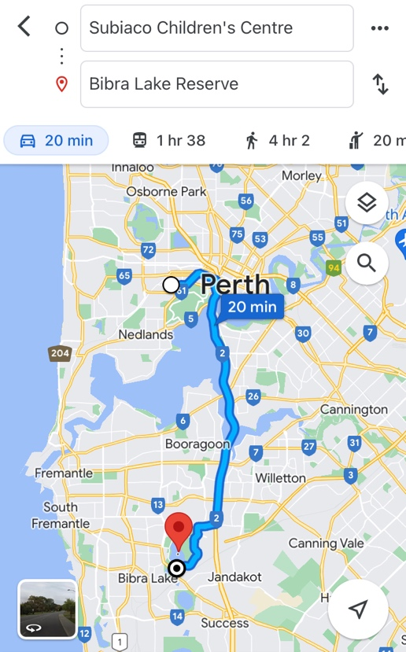  Chartered Bus from BusWest with seatbelts:  - Seats up to 57 passengers  - Bus drops at the front of Bibra Lake Playground  - Children are not required to cross any major roads  - Children are supervised whilst in the carpark area
Name of excursion coordinator | Rafael Banzon
Contact number of excursion coordinator | (SCC MOBILE) 0413 170 223 |  | (EXCURSION NUMBER) NA
Number of children attending | 50 (expected) | Number of educators/parents/volunteers |  | 6/7
Educator to child ratio  1 : 10 |  | Does this excursion warrant a higher ratio?  If yes, please provide details. |  | No
EXCURSION CHECKLIST
- First Aid Kit |  | - List of adults participating in the excursion
- List of Children attending the excursion |  | - Contact information for each adult
- Contact information for each child |  | - Mobile phone/ other means of communicating with the service & emergency services
- Medical Information for each child |  | - Other items, please list

 | Risk Assessment
 | Activity |  | Hazard identified |  | Risk Assessment  (Use matrix) |  | Elimination / control measures |  |  | Who |  | When
Playing in the playground |  | Children wandering off  Children injuring themselves or others  Heat Stroke |  | Low  Low  Low |  | - High supervision levels will be kept by educators, and all children will be wearing a high-vis vest for easy identification.  - Head counts are performed every 30 minutes by educators.  - Children will be split into smaller groups to be monitored by specific educators for greater supervision levels.  - Children and educators will be given safety instructions to follow regarding areas of the playground that can and cannot be accessed to lower risk of injury.  - Children will be monitored and encouraged to play in areas that match their outdoor play skills, e.g., not climbing too high.  - A qualified first aider is always on site should an injury occur. The first aid kit, action plans, emergency contacts and anaphylaxis forms are always accessible.  - Children will have brought their own water bottles or will have water provided to them if they have not brought them. Children will be kept out of direct sunlight during the middle of the day as much as reasonably possible, and will wear sun protective wear (e.g. hats, sunscreen). |  |  | All educators |  | Throughout excursion
Toilet Breaks |  | Stranger Danger  Children getting lost |  | Low |  | Children are escorted by educators in groups to toilets to avoid children being alone and in risk of danger. |  |  | All educators |  | During excursion
Transition from Centre to bus & bus  to excursion |  | Losing children  Children running across the road. |  |  |  | - Children wear high visibility vests, roll call is done on the mat before lining up in Centre with their partner for the bus.  - Head count is then conducted by at least two staff.  - Staff are dispersed between the line with one staff member in front and one at the back to lock the Centre after everyone leaves.  - Children are escorted to the bus along the footpath out to the public footpath where the bus is to be parked in the parking along the road.  - A staff member is sent up before any children to check the bus and move to the back.  - Headcount then takes place with one staff member doing a headcount on children as they move into the bus.  - For every 10 children the nominated staff counts, another staff member is let onto the bus to keep ratio.  - Children fill up the bus from the back to the front and children are to fasten seatbelts as they sit down which is double-checked by all staff moving throughout the bus.  - A headcount is then repeated with all staff and children on the bus and once everyone has their seatbelts fastened, the bus driver is told he can proceed.  - Transitioning off the bus, a headcount is performed and staff from the back of the bus is let out last in order to ensure no children/ lost property remains on the bus.  - Once we have reached our excursion destination, roll call is done and educators are assigned groups in order to ensure high levels of supervision throughout the excursion.  - bCharted bus fitted with seatbelts
 | Plan prepared by |  | Jared Teo |  |  |  | Prepared in consultation with: | Rafael Banzon
 | Communicated to: |  | All staff members on duty |  |  |  | Venue and safety information reviewed and attached | Yes / No  Comment if needed:
 | Reminder: Monitor the effectiveness of controls and change if necessary. Review the risk assessment if an incident or significant change occurs.

EXCURSION DETAILS
Date(s) of Excursion | WEDNESDAY 04/01/2023 | Departure & arrival times |  | 9:10AM – 1PM
Excursion destination | N/A
Proposed activities | Excursion: Mini Golf  We are heading to Wanneroo Botanical Gardens to enjoy and play some Mini Golf together! |  |  | WATER HAZARDS? NO
Method of transport, including proposed route | 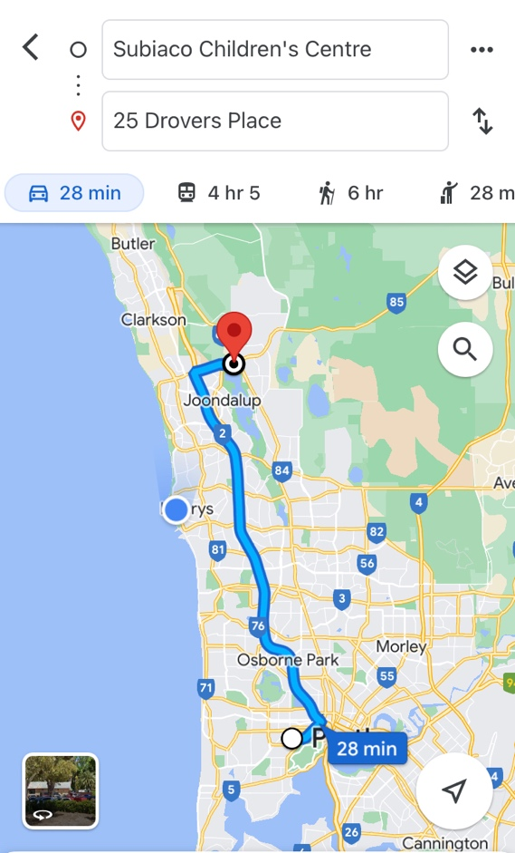  Chartered Bus from BusWest with seatbelts:  - Seats up to 57 passengers  - Bus drops at the front of Wanneroo Botanical Gardens  - Children are not required to cross any major roads  - Children are supervised whilst in the carpark area
Name of excursion coordinator | Rafael Banzon
Contact number of excursion coordinator | (SCC MOBILE) 0413 170 223 |  | (EXCURSION NUMBER) 08 9405 1475
Number of children attending | 50 (expected) | Number of educators/parents/volunteers |  | 6/7
Educator to child ratio  1 : 10 |  | Does this incursion warrant a higher ratio?  If yes, please provide details. |  | No
INCURSION CHECKLIST
- First Aid Kit |  | - List of adults participating in the excursion
- List of Children attending the excursion |  | - Contact information for each adult
- Contact information for each child |  | - Mobile phone/ other means of communicating with the service & emergency services
- Medical Information for each child |  | - Other items, please list

 | Risk Assessment
 | Activity |  | Hazard identified |  | Risk Assessment  (Use matrix) |  | Elimination / control measures |  |  | Who |  | When
Transition from Centre to bus & bus to Botanical Gardens  Bus ride |  | Losing children  Children running across the road  Traffic Incident |  | Low  Low  Low |  | - Children wear high visibility vests, roll call is done on the mat before lining up in the Centre with their partner for the bus  - Head count is then conducted by two staff  - Staff are dispersed between the line with one staff member in front and one at the back to lock the Centre after everyone leaves  - Children are escorted to the bus along the footpath out to the public footpath where the bus is to be parked in the parking along the road  - A staff member is sent up before any children to check the bus and move to the back  - Headcount then takes place with one staff member doing a headcount on children as they move into the bus  - For every 10 children the nominated staff counts, another staff member is let onto the bus to keep ratio  - Children are seated from the back of the bus to the front and children are to fasten seatbelts as they sit down which is double-checked by all staff moving throughout the bus.  - A headcount is then repeated with all staff and children on the bus and once everyone has their seatbelts fastened, the bus driver is told he/she can proceed  - Transitioning off the bus, a headcount is performed and staff from the back of the bus is let out last in order to ensure no children/ lost property remains on the bus.  - Once we have reached our excursion destination, roll call is done and staff are assigned groups in order to ensure high levels of supervision throughout the excursion.  - Charted bus fitted with seatbelts |  |  | All staff |  | Leaving for excursion and whilst on the bus.
 | Toilet Breaks and walking around |  | Stranger danger  Children wander off  Injury from game/equipment  Heat Stroke |  | Low  Low  Low  Low |  | - Staff will brief the children about the rules around walking around, and asking staff if they need the toilet, SCC staff will be put into groups to ensure sufficient supervision  - Florescent bibs for easy visibility of children under our care and uniforms are worn by staff members to ensure children can easily identify them  - Head count and roll call is to be done upon arrival and before departure  - Children are escorted by staff member and in groups to toilets to avoid children being alone and in risk of danger  - Headcount is done outside the toilet area before returning to ensure all children are accounted for. Ratio is always kept during all excursion activities.  - Children are closely supervised throughout the movie and if an emergency occurs, we have a first aider on duty and first aid kit  - Children are closely supervised throughout the activities and if an injury occurs, we have a first aider on duty and first aid kit, contact list and emergency contacts on hand at all times  - Children will be split into smaller groups for this activity.  - Children will be reminded of safety rules regarding animals and using other equipment on the excursion.  - Children will have brought their own water bottles or will have water provided to them if they have not brought them. Children will be kept out of direct sunlight during the middle of the day as much as reasonably possible, and will wear sun protective wear (e.g. hats, sunscreen). |  |  | All staff members  By qualified staff |  | At all times during this excursion  At all times during this activity
 | Plan prepared by |  | Jared Teo |  |  |  | Prepared in consultation with: | Rafael Banzon
 | Communicated to: |  | All staff members on duty |  |  |  | Venue and safety information reviewed and attached | Yes / No  Comment if needed:
 | Reminder: Monitor the effectiveness of controls and change if necessary. Review the risk assessment if an incident or significant change occurs.

INCURSION DETAILS
Date(s) of activity | THURSDAY 05/01/2023 | Activity time |  | 9:30AM-12:30PM
Excursion destination | N/A
Proposed activities | Incursion- Toonworld  Today the lovely people at ToonWorld are helping us put on our creative hats and produce some amazing cartoons. |  |  | WATER HAZARDS? NO
Method of transport, including proposed route | N/A
Name of excursion coordinator | Rafael Banzon
Contact number of excursion coordinator | (SCC MOBILE) 0413 170 223 |  | (INCURSION NUMBER) 0423 548 146
Number of children attending | 50 (expected) | Number of educators/parents/volunteers |  | 6/7
Educator to child ratio  1 : 10 |  | Does this excursion warrant a higher ratio?  If yes, please provide details. |  | No
EXCURSION CHECKLIST
- First Aid Kit |  | - List of adults participating in the excursion
- List of Children attending the excursion |  | - Contact information for each adult
- Contact information for each child |  | - Mobile phone/ other means of communicating with the service & emergency services
- Medical Information for each child |  | - Other items, please list

Risk Assessment
Activity | Hazard identified | Risk Assessment  (Use matrix) | Elimination / control measures |  | Who | When
Member of public entering the centre | Unknown person | Low | - Has been requested that incursion personnel have a working with children’s card  - Will report to supervisor to check and record their working with children’s card  - Supervisor will assess if they are in a state fit to be around children |  | Nominated Person in Charge (Supervisor) | Before the incursion begins
Drawing cartoons | Injury | Low | - Children will be encouraged to follow centre’s safety rules (e.g. no running) and will be briefed on the incursion rules. Children will be separated into 2 smaller groups to avoid injury and increase supervision. |  | All Educators | During incursion
Plan prepared by | Jared Teo |  | Prepared in consultation with: | Rafael Banzon
Communicated to: | All staff members on duty |  | Venue and safety information reviewed and attached | Yes / No  Comment if needed:
Reminder: Monitor the effectiveness of controls and change if necessary. Review the risk assessment if an incident or significant change occurs.

IN-CENTRE DETAILS
Date(s) of In-Centre | FRIDAY 06/01/2023 | Departure & arrival times |  | NA
Excursion destination | NA
Proposed activities | In-Centre: Water Play Day  Bring your super soakers and bathers for the annual Water Play Day! Paired with a dunking station and Slip n Slide for a day of fun! |  |  | WATER HAZARDS? YES
Method of transport, including proposed route | NA
Name of excursion coordinator | Rafael Banzon
Contact number of excursion coordinator | (SCC MOBILE) 0413 170 223 |  | (INCURSION NUMBER) NA
Number of children attending | 50 (expected) | Number of educators/parents/volunteers |  | 6/7
Educator to child ratio  1 : 10 |  | Does this incursion warrant a higher ratio?  If yes, please provide details. |  | No
INCURSION CHECKLIST
- First Aid Kit |  | - List of adults participating in the excursion
- List of Children attending the excursion |  | - Contact information for each adult
- Contact information for each child |  | - Mobile phone/ other means of communicating with the service & emergency services
- Medical Information for each child |  | - Other items, please list

Risk Assessment
Activity | Hazard identified | Risk Assessment  (Use matrix) | Elimination / control measures |  | Who | When
Member of public entering the centre | Unknown person | Low | - Has been requested that incursion personnel have a working with children’s card  - Will report to supervisor to check and record their working with children’s card  - Supervisor will assess if they are in a state fit to be around children |  | Nominated Person in Charge (Supervisor) | Before the in-centre begins
Dunking Station | Injury | Low | - Children will be encouraged to follow centre’s safety rules (e.g. no running) and will be briefed on the rules of the dunking station. Children will be separated into smaller groups to avoid injury and increase supervision.  - First Aiders will be present with first aid kits |  | All Educators | During activity
Slip ‘n Slide | Injury | Low | - Children will be encouraged to follow centre’s safety rules (e.g. no running) and will be briefed on the rules of the dunking station. Children will be separated into smaller groups to avoid injury and increase supervision.  - First Aiders will be present with first aid kits |  | All Educators | During activity
Plan prepared by | Jared Teo |  | Prepared in consultation with: | Rafael Banzon
Communicated to: | All staff members on duty |  | Venue and safety information reviewed and attached | Yes / No  Comment if needed:
Reminder: Monitor the effectiveness of controls and change if necessary. Review the risk assessment if an incident or significant change occurs.

EXCURSION DETAILS
Date(s) of activity | MONDAY 09/01/2023 | Departure & arrival times |  | 9:10AM – 1:15PM
Excursion destination | Grand Cinemas Warwick, 639 Beach Road, Warwick WA 6024
Proposed activities | Excursion: Puss in Boots 2 at the Cinema  We are off to the cinemas to watch Puss in Boots: The Last Wish! Get ready for popcorn, drinks and a lot of fun! |  |  | WATER HAZARDS? NO
Method of transport, including proposed route | 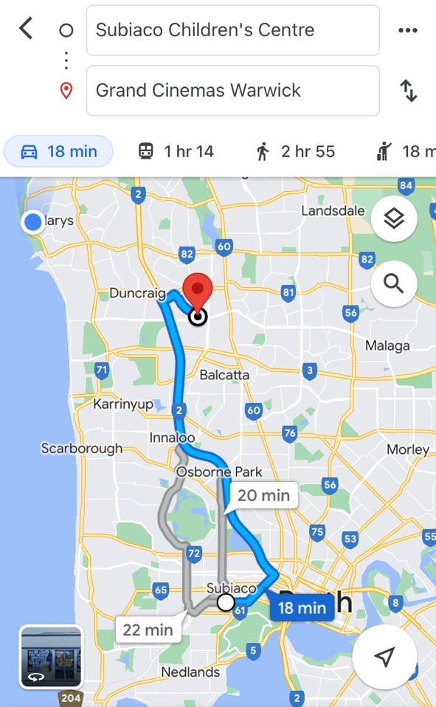  Chartered Bus from BusWest with seatbelts:  - Seats up to 57 passengers  - Bus drops at the front of the Grand Cinemas Warwick  - Children are not required to cross any major roads  - Children are supervised whilst in the carpark area
Name of excursion coordinator | Rafael Banzon
Contact number of excursion coordinator | (SCC MOBILE) 0413 170 223 |  | (INCURSION NUMBER) 08 9247 7488
Number of children attending | 50 (expected) | Number of educators/parents/volunteers |  | 6/7
Educator to child ratio  1 : 10 |  | Does this excursion warrant a higher ratio?  If yes, please provide details. |  | No
EXCURSION CHECKLIST
- First Aid Kit |  | - List of adults participating in the excursion
- List of Children attending the excursion |  | - Contact information for each adult
- Contact information for each child |  | - Mobile phone/ other means of communicating with the service & emergency services
- Medical Information for each child |  | - Other items, please list

 | Risk Assessment
 | Activity |  | Hazard identified |  | Risk Assessment  (Use matrix) |  | Elimination / control measures |  |  | Who |  | When
Transition from Centre to bus & bus to Cinemas  Bus ride |  | Losing children  Children running across the road  Traffic Incident |  | Low  Low  Low |  | - Children wear high visibility vests, roll call is done on the mat before lining up in the Centre with their partner for the bus  - Head count is then conducted by two staff  - Staff are dispersed between the line with one staff member in front and one at the back to lock the Centre after everyone leaves  - Children are escorted to the bus along the footpath out to the public footpath where the bus is to be parked in the parking along the road  - A staff member is sent up before any children to check the bus and move to the back  - Headcount then takes place with one staff member doing a headcount on children as they move into the bus  - For every 10 children the nominated staff counts, another staff member is let onto the bus to keep ratio  - Children are seated from the back of the bus to the front and children are to fasten seatbelts as they sit down which is double-checked by all staff moving throughout the bus.  - A headcount is then repeated with all staff and children on the bus and once everyone has their seatbelts fastened, the bus driver is told he/she can proceed  - Transitioning off the bus, a headcount is performed and staff from the back of the bus is let out last in order to ensure no children/ lost property remains on the bus.  - Once we have reached our excursion destination, roll call is done and staff are assigned groups in order to ensure high levels of supervision throughout the excursion.  - Charted bus fitted with seatbelts |  |  | All staff |  | Leaving for excursion and whilst on the bus.
 | Popcorn and drinks handed out at the movie |  | Allergies |  | Low |  | - All allergies were taken into consideration by parents who have enrolled their child for this excursion  - Qualified first aider is on duty at all times and first aid kit, action plans, emergency contacts, epi pens and anaphylaxis forms are accessible at all times |  |  | All staff members  Qualified staff members |  | At all times during this activity
 | Watching The movie & Toilet Breaks |  | Stranger danger  Children wander off  Injury |  | Low  Low  Low |  | - Staff from the cinema, spread across the rows and on the outskirts of the rows to ensure no children wander off and ensure adequate supervision  - Staff will brief the children about the rules around watching the movie and asking staff if they need the toilet, SCC staff will be put into groups in order to ensure sufficient supervision  - Florescent bibs for easy visibility of children under our care and uniforms are worn by staff members to ensure children can easily identify them  - Head count and roll call is to be done upon arrival and before departure  - Children are escorted by staff member and in groups to toilets in order to avoid children being alone and in risk of danger  - Headcount is done outside the toilet area before returning to the cinema to ensure all children are accounted for. Ratio is kept at all times during all excursion activities.  - Children are closely supervised throughout the movie and if an emergency occurs, we have a first aider on duty and first aid kit |  |  | All staff members  By qualified staff |  | At all times during this excursion  At all times during this activity
 | Plan prepared by |  | Jared Teo |  |  |  | Prepared in consultation with: | Rafael Banzon
 | Communicated to: |  | All staff members on duty |  |  |  | Venue and safety information reviewed and attached | Yes / No  Comment if needed:
 | Reminder: Monitor the effectiveness of controls and change if necessary. Review the risk assessment if an incident or significant change occurs.

INCURSION DETAILS
Date(s) of activity | TUESDAY 10/01/2023 | Activity Time |  | 10AM – 12PM
Excursion destination | N/A
Proposed activities | Incursion: WestOz Wildlife  Today we are bringing the zoo to us with WestOz Wildlife! Come prepared to see and touch some incredibly interesting animals. |  |  | WATER HAZARDS? NO
Method of transport, including proposed route | N/A
Name of excursion coordinator | Rafael Banzon
Contact number of excursion coordinator | (SCC MOBILE) 0413 170 223 |  | (INCURSION NUMBER) 0420 570 432
Number of children attending | 50 (expected) | Number of educators/parents/volunteers |  | 6/7
Educator to child ratio  1 : 10 |  | Does this excursion warrant a higher ratio?  If yes, please provide details. |  | No
EXCURSION CHECKLIST
- First Aid Kit |  | - List of adults participating in the excursion
- List of Children attending the excursion |  | - Contact information for each adult
- Contact information for each child |  | - Mobile phone/ other means of communicating with the service & emergency services
- Medical Information for each child |  | - Other items, please list

Risk Assessment
Activity | Hazard identified | Risk Assessment  (Use matrix) | Elimination / control measures |  | Who | When
Member of public entering the centre | Unknown person | Low | - Has been requested that incursion personnel have a working with children’s card  - Will report to supervisor to check and record their working with children’s card  - Supervisor will assess if they are in a state fit to be around children |  | Nominated Person in Charge (Supervisor) | Before the incursion begins
Being in the prescence of wildlife | Injury due to animals | Low | - Children and staff will be briefed around the rules of holding the animals and handling the activities. The staff will supervise and ensure these rules are being followed  - Children are escorted by staff member to toilets to avoid children wandering off  - Children are closely supervised throughout the activity and if an emergency occurs, we have a first aider on duty and first aid kit |  | All Educators | During incursion
Plan prepared by | Jared Teo |  | Prepared in consultation with: | Rafael Banzon
Communicated to: | All staff members on duty |  | Venue and safety information reviewed and attached | Yes / No  Comment if needed:
Reminder: Monitor the effectiveness of controls and change if necessary. Review the risk assessment if an incident or significant change occurs.

IN-CENTRE DETAILS
Date(s) of activity | WEDNESDAY 11/01/2023 | Activity time |  | NA
Excursion destination | N/A
Proposed activities | In-Centre: Mosaics  We are getting creative today by and making our own stunning mosaic tiles to take home and cherish! |  |  | WATER HAZARDS? NO
Method of transport, including proposed route | N/A
Name of excursion coordinator | Rafael Banzon
Contact number of excursion coordinator | (SCC MOBILE) 0413 170 223 |  | (INCURSION NUMBER) NA
Number of children attending | 50 (expected) | Number of educators/parents/volunteers |  | 6/7
Educator to child ratio  1 : 10 |  | Does this excursion warrant a higher ratio?  If yes, please provide details. |  | No
EXCURSION CHECKLIST
- First Aid Kit |  | - List of adults participating in the excursion
- List of Children attending the excursion |  | - Contact information for each adult
- Contact information for each child |  | - Mobile phone/ other means of communicating with the service & emergency services
- Medical Information for each child |  | - Other items, please list

Risk Assessment
Activity | Hazard identified | Risk Assessment  (Use matrix) | Elimination / control measures |  | Who | When
Making the Mosaics | Children injuring themselves during the craft | Low | - Staff are there to support and assist children if needed  - risk of injury is low due to child safe ceramic pens  - Children are divided into groups smaller groups when completing the craft to ensure adequate supervision and staff can monitor interactions and safety levels |  | All Educators | During Mosaic Making Activity
Plan prepared by | Jared Teo |  | Prepared in consultation with: | Rafael Banzon
Communicated to: | All staff members on duty |  | Venue and safety information reviewed and attached | Yes / No  Comment if needed:
Reminder: Monitor the effectiveness of controls and change if necessary. Review the risk assessment if an incident or significant change occurs.

EXCURSION DETAILS
Date(s) of activity | THURSDAY 12/01/2023 | Departure & arrival times |  | 9:10AM – 1:00PM
Excursion destination | Manning Rd &, Burton St, Cannington WA 6107
Proposed activities | Excursion: Zone Bowling  We are heading to Zone Bowling for a great time competing against each other in a fun game of bowling! |  |  | WATER HAZARDS? NO
Method of transport, including proposed route | Chartered Bus from BusWest with seatbelts:  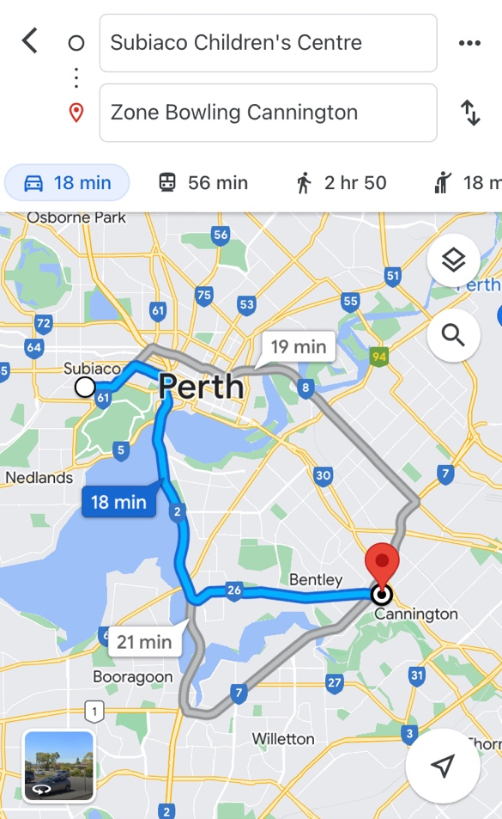  - Seats up to 57 passengers  - Bus drops at the front of Zone Bowling  - Children are not required to cross any major roads  - Children are supervised whilst in the carpark area
Name of excursion coordinator | Rafael Banzon
Contact number of excursion coordinator | (SCC MOBILE) 0413 170 223 |  | (EXCURSION NUMBER) 08 7701 9752
Number of children attending | 50 (expected) | Number of educators/parents/volunteers |  | 6/7
Educator to child ratio  1 : 10 |  | Does this excursion warrant a higher ratio?  If yes, please provide details. |  | No
EXCURSION CHECKLIST
- First Aid Kit |  | - List of adults participating in the excursion
- List of Children attending the excursion |  | - Contact information for each adult
- Contact information for each child |  | - Mobile phone/ other means of communicating with the service & emergency services
- Medical Information for each child |  | - Other items, please list

Risk Assessment
Activity | Hazard identified | Risk Assessment  (Use matrix) | Elimination / control measures |  | Who | When
Transition from Centre to bus, and bus to Zone Bowling  Bus ride | Losing children  Children running across the road  Traffic incident | Low  Low  Low | - Children wear high visibility vests, roll call is done on the mat before lining up in the Centre with their partner for the bus  - Head count is then conducted by two staff  - Staff are dispersed between the line with one staff member in front and one at the back to lock the Centre after everyone leaves  - Children are escorted to the bus along the footpath out to the public footpath where the bus is to be parked in the parking along the road  - A staff member is sent up before any children to check the bus and move to the back  - Headcount then takes place with one staff member doing a headcount on children as they move into the bus  - For every 10 children the nominated staff counts, another staff member is let onto the bus to keep ratio  - Children are seated from the back of the bus to the front and children are to fasten seatbelts as they sit down which is double-checked by all staff moving throughout the bus.  - A headcount is then repeated with all staff and children on the bus and once everyone has their seatbelts fastened, the bus driver is told he/she can proceed  - Transitioning off the bus, a headcount is performed and staff from the back of the bus is let out last in order to ensure no children/ lost property remains on the bus.  - Once we have reached our excursion destination, roll call is done and staff are assigned groups in order to ensure high levels of supervision throughout the excursion.  - Charted bus fitted with seatbelts |  | All Educators | Leaving for excursion and whilst on the bus
Zone bowling & arcade games | Injuries | Low | - Qualified First aider will be on duty at all times & first aid kit will come on the excursion also |  | Qualified first aider | During bowling & arcade games
Lunch at Zone Bowling – children bring their own lunch | Allergies | Low | - Staff sit with children during the mealtime and supervise.  - Staff remind children that we don’t share our own food with others  - Qualified first aider is on duty at all times and first aid kit, action plans, emergency contacts, epi pens and anaphylaxis forms are accessible at all times |  | All staff members  Qualified first aider | During lunch
Toilet breaks | Stranger danger  Children wandering away | Low  Low | - Staff will remind children at the beginning of the excursion that they will need to come directly to a staff member if they need to use the bathroom and a staff member will go with them  - Staff are dispersed evenly across the bowling lanes & through the arcade to ensure a high level of supervision is maintained  - High visibility bibs are worn by the children so that we can easily identify our children  - Head count & roll call is done upon arrival and before departure  - A head count of children going to the toilet is done before & after to ensure that those who went in to the toilets have come back out  - Toilets are checked before children enter and staff ensure that they can still hear children whilst in the bathroom |  | All staff members | During toilet breaks & transition between activities
Plan prepared by | Jared Teo |  | Prepared in consultation with: | Rafael Banzon
Communicated to: | All staff members on duty |  | Venue and safety information reviewed and attached | Yes / No  Comment if needed:
Reminder: Monitor the effectiveness of controls and change if necessary. Review the risk assessment if an incident or significant change occurs.

INCURSION DETAILS
Date(s) of activity | FRIDAY 13/01/2023 | Departure & arrival times |  | 9:30AM – 12PM
Excursion destination | N/A
Proposed activities | Incursion: Bop til you Drop!  Bop til you Drop! are helping us put on our detective hats and solving the SCC Mystery! Followed by an hour of fun with a Silent Disco! |  |  | WATER HAZARDS? NO
Method of transport, including proposed route | N/A
Name of excursion coordinator | Rafael Banzon
Contact number of excursion coordinator | (SCC MOBILE) 0413 170 223 |  | (INCURSION NUMBER) 1300 130 313
Number of children attending | 50 (expected) | Number of educators/parents/volunteers |  | 6/7
Educator to child ratio  1 : 10 |  | Does this excursion warrant a higher ratio?  If yes, please provide details. |  | No
EXCURSION CHECKLIST
- First Aid Kit |  | - List of adults participating in the excursion
- List of Children attending the excursion |  | - Contact information for each adult
- Contact information for each child |  | - Mobile phone/ other means of communicating with the service & emergency services
- Medical Information for each child |  | - Other items, please list

Risk Assessment
Activity | Hazard identified | Risk Assessment  (Use matrix) | Elimination / control measures |  | Who | When
Member of public entering the centre | Unknown person | Low | - Has been requested that incursion personnel have a working with children’s card  - Will report to supervisor to check and record their working with children’s card  - Supervisor will assess if they are in a state fit to be around children |  | Nominated Person in Charge (Supervisor) | Before the incursion begins
Mystery Activity & Silent Disco | Injury | Low | - Children will be encouraged to follow centre’s safety rules (e.g. no running) and be briefed on the incursion rules. Children will be in smaller groups to avoid injury and increase supervision. |  | All Educators | During incursion
Plan prepared by | Jared Teo |  | Prepared in consultation with: | Rafael Banzon
Communicated to: | All staff members on duty |  | Venue and safety information reviewed and attached | Yes / No  Comment if needed:
Reminder: Monitor the effectiveness of controls and change if necessary. Review the risk assessment if an incident or significant change occurs.

INCURSION DETAILS
Date(s) of activity | MONDAY 16/01/2023 | Activity time |  | 10AM – 12PM
Excursion destination | N/A
Proposed activities | Incursion: CircusWA  Today we have CircusWA here to lead a workshop on all things circus with tricks and toys for everyone! |  |  | WATER HAZARDS? NO
Method of transport, including proposed route | N/A
Name of excursion coordinator | Rafael Banzon
Contact number of excursion coordinator | (SCC MOBILE) 0413 170 223 |  | (INCURSION NUMBER) 0435 374 492
Number of children attending | 50 (expected) | Number of educators/parents/volunteers |  | 6/7
Educator to child ratio  1 : 10 |  | Does this excursion warrant a higher ratio?  If yes, please provide details. |  | No
EXCURSION CHECKLIST
- First Aid Kit |  | - List of adults participating in the excursion
- List of Children attending the excursion |  | - Contact information for each adult
- Contact information for each child |  | - Mobile phone/ other means of communicating with the service & emergency services
- Medical Information for each child |  | - Other items, please list

Risk Assessment
Activity | Hazard identified | Risk Assessment  (Use matrix) | Elimination / control measures |  | Who | When
Member of public entering the centre | Unknown person | Low | - Has been requested that incursion personnel have a working with children’s card  - Will report to supervisor to check and record their working with children’s card  - Supervisor will assess if they are in a state fit to be around children |  | Nominated Person in Charge (Supervisor) | Before the incursion begins
Participate in the circus activities | Injury | Low | - Children are closely supervised throughout the activities and if an injury occurs, we have a first aider on duty and first aid kit, contact list and emergency contacts on hand at all times  - Children will be split into smaller groups for this activity.  - Children will be reminded of safety rules regarding activities in the centre and will be briefed on the rules of this incursion |  | All educators | During incursion
Plan prepared by | Jared Teo |  | Prepared in consultation with: | Rafael Banzon
Communicated to: | All staff members on duty |  | Venue and safety information reviewed and attached | Yes / No  Comment if needed:
Reminder: Monitor the effectiveness of controls and change if necessary. Review the risk assessment if an incident or significant change occurs.

EXCURSION DETAILS
Date(s) of activity | TUESDAY 17/01/2023 | Departure & arrival times |  | 9:10AM – 1:15PM
Excursion destination | 72 Robinson Ave, Belmont WA 6104
Proposed activities | Excursion: Rock Climbing  We are off to Adrenaline Vault Rock Climbing to go to new heights and work on our climbing skills. |  |  | WATER HAZARDS? NO
Method of transport, including proposed route | Chartered Bus from BusWest with seatbelts:  - Seats up to 57 passengers  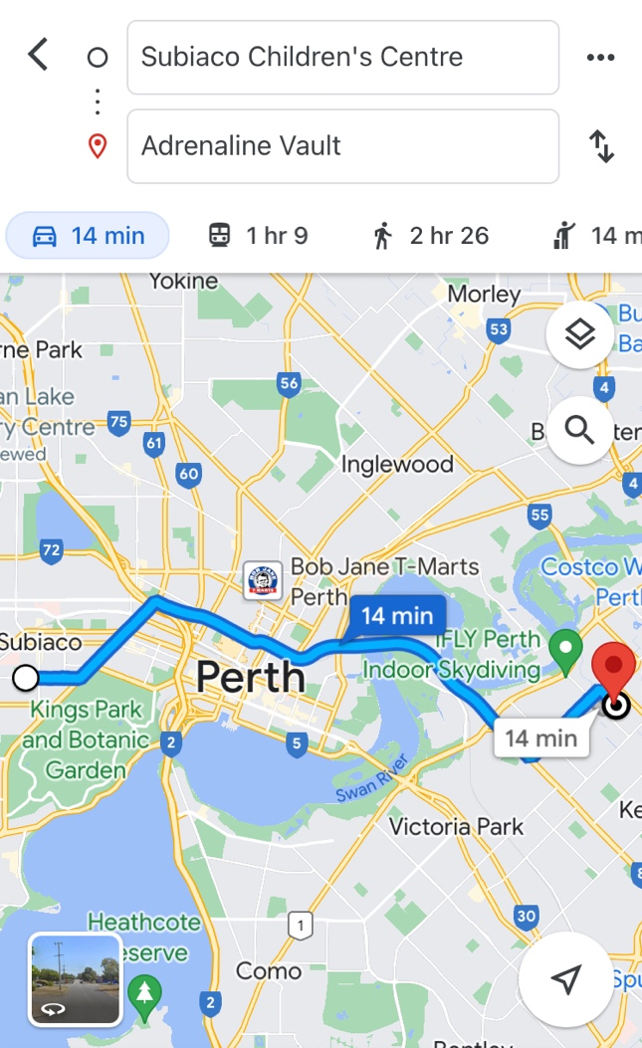  - Bus drops at the front of Adrenaline Vault  - Children are not required to cross any major roads  - Children are supervised whilst in the carpark area
Name of excursion coordinator | Rafael Banzon
Contact number of excursion coordinator | (SCC MOBILE) 0413 170 223 |  | (EXCURSION NUMBER) 08 6107 8359
Number of children attending | 50 (expected) | Number of educators/parents/volunteers |  | 6/7
Educator to child ratio  1 : 10 |  | Does this excursion warrant a higher ratio?  If yes, please provide details. |  | No
EXCURSION CHECKLIST
- First Aid Kit |  | - List of adults participating in the excursion
- List of Children attending the excursion |  | - Contact information for each adult
- Contact information for each child |  | - Mobile phone/ other means of communicating with the service & emergency services
- Medical Information for each child |  | - Other items, please list

Risk Assessment
Activity | Hazard identified | Risk Assessment  (Use matrix) | Elimination / control measures |  | Who | When
Rock Climbing  Transition from bus to centre  Arcade & Toilet breaks | Children injuring themselves  Losing children  Children running across the road  Traffic incident  Stranger danger | Low  Low  Low  Low  Low | - Staff are there to support and assist children if needed  - risk of injury is low due to Adrenaline Vault staff present and general rock climbing safety procedures  - Children are divided into smaller groups when engaging in the excursion  - Other activities are present for those uncomfortable to engage in rock climbing  - Children are to wear florescent bibs, roll call is done on the mat at the Centre, before lining up with their partner to proceed  - Head count is then conducted by two staff  - Staff are dispersed between the line with one staff member in front and one at the back to lock the Centre after everyone leaves  - Children are escorted to the bus along the footpath out to the public footpath where the bus is to be parked in the parking along the road  - A staff member is sent up before any children to check the bus and move to the back  - Headcount then takes place with one staff member doing a headcount on children as they move into the bus  - For every 10 children counted onto the bus, one new staff member is let onto the bus to keep ratio  - Children fill the bus up from the back to the front and children are to fasten seatbelts as they sit down which is double-checked by all staff moving throughout the bus.  - A headcount is then repeated with all staff and children on the bus and once everyone has their seatbelts fastened, the bus driver is told he can proceed  - Transitioning off the bus, a headcount is performed and staff from the back of the bus is let out last in order to ensure no children/ lost property remains on the bus.  - Once we have reached Adrenaline Vault, role call is done and staffs are assigned groups in order to ensure high levels of supervision throughout the excursion.  - Charted bus fitted with seatbelts  - Children escorted by educators in groups to toilets to avoid risk of children being alone and in risk of danger.  - Staff situated around the area in strategic locations to ensure maximum level of supervision  - Children will be gathered in one area with all staff during lunch  - Staffs are to observe other children’s lunch closely and remove any child away from high-risk area who are at risk of allergic reaction to allergens found.  - Qualified first aider is on duty at all times and first aid kit, action plans, emergency contacts, epi-pens and anaphylaxis forms are accessible at all times |  | All Educators | During active portions of the excursion
Plan prepared by | Jared Teo |  | Prepared in consultation with: | Rafael Banzon
Communicated to: | All staff members on duty and made available to all parent’s prior to booking |  | Venue and safety information reviewed and attached | Yes / No  Comment if needed:
Reminder: Monitor the effectiveness of controls and change if necessary. Review the risk assessment if an incident or significant change occurs.

INCURSION DETAILS
Date(s) of activity | WEDNESDAY 18/01/2023 | Activity time |  | 10AM – 12PM
Excursion destination | N/A
Proposed activities | Incursion: Hip Hop  CubeSports is here to teach us all things Hip Hop, so bring your best dance moves for a boppin' time! |  |  | WATER HAZARDS? NO
Method of transport, including proposed route | N/A
Name of excursion coordinator | Rafael Banzon
Contact number of excursion coordinator | (SCC MOBILE) 0413 170 223 |  | (INCURSION NUMBER) 1300 907 291
Number of children attending | 50 (expected) | Number of educators/parents/volunteers |  | 6/7
Educator to child ratio  1 : 10 |  | Does this excursion warrant a higher ratio?  If yes, please provide details. |  | No
EXCURSION CHECKLIST
- First Aid Kit |  | - List of adults participating in the excursion
- List of Children attending the excursion |  | - Contact information for each adult
- Contact information for each child |  | - Mobile phone/ other means of communicating with the service & emergency services
- Medical Information for each child |  | - Other items, please list

Risk Assessment
Activity | Hazard identified | Risk Assessment  (Use matrix) | Elimination / control measures |  | Who | When
Member of public entering the centre | Unknown person | Low | - Has been requested that incursion personnel have a working with children’s card  - Will report to supervisor to check and record their working with children’s card  - Supervisor will assess if they are in a state fit to be around children |  | Nominated Person in Charge (Supervisor) | Before the incursion begins
Hip Hop Dancing | Injury | Low | - Children are closely supervised throughout the activities and if an injury occurs, we have a first aider on duty and first aid kit, contact list and emergency contacts on hand at all times  - Children will be split into smaller groups for this activity.  - Children will be reminded of rules regarding the specific incursion |  | All educators | During incursion
Plan prepared by | Jared Teo |  | Prepared in consultation with: | Rafael Banzon
Communicated to: | All staff members on duty |  | Venue and safety information reviewed and attached | Yes / No  Comment if needed:
Reminder: Monitor the effectiveness of controls and change if necessary. Review the risk assessment if an incident or significant change occurs.

IN-CENTRE DETAILS
Date(s) of activity | THURSDAY 19/01/2023 | Departure & arrival times |  | NA
Excursion destination | NA
Proposed activities | In-Centre: Movie Day  Today we are bringing the movies to us with an In-Centre Movie Day! We will be making our own snacks and fun choosing some our favourite Disney movies. |  |  | WATER HAZARDS? NO
Method of transport, including proposed route | NA
Name of excursion coordinator | Rafael Banzon
Contact number of excursion coordinator | (SCC MOBILE) 0413 170 223 |  | (EXCURSION NUMBER) NA
Number of children attending | 50 (expected) | Number of educators/parents/volunteers |  | 6/7
Educator to child ratio  1 : 10 |  | Does this excursion warrant a higher ratio?  If yes, please provide details. |  | No
EXCURSION CHECKLIST
- First Aid Kit |  | - List of adults participating in the excursion
- List of Children attending the excursion |  | - Contact information for each adult
- Contact information for each child |  | - Mobile phone/ other means of communicating with the service & emergency services
- Medical Information for each child |  | - Other items, please list

Risk Assessment
Activity | Hazard identified | Risk Assessment  (Use matrix) | Elimination / control measures |  | Who | When
Popcorn | Food Allergy | Low | - Children’s food allergies will be cross checked with the ingredients of the popcorn. If the food contains an allergen, they will be provided with an alternative option.  - A qualified first aider is always on site should a reaction occur; they will follow the child’s medical plan and administer aid including epi-pens appropriately. The first aid kit, action plans, emergency contacts and anaphylaxis forms are accessible at all times.  - Parents have also considered their child’s allergies when enrolling them for this incursion. |  | All staff members | During the in-centre activity
Plan prepared by | Jared Teo |  | Prepared in consultation with: | Rafael Banzon
Communicated to: | All staff members on duty |  | Venue and safety information reviewed and attached | Yes / No  Comment if needed:
Reminder: Monitor the effectiveness of controls and change if necessary. Review the risk assessment if an incident or significant change occurs.

INCURSION DETAILS
Date(s) of activity | FRIDAY 20/01/2023 | Departure & arrival times |  | 10AM – 12PM
Excursion destination | N/A
Proposed activities | Incursion: Bricks4Kidz  Today is all about space and galaxies! We will be creating our very own galaxy slime and UFO's. We will be finishing off the day with a glow in the dark party. |  |  | WATER HAZARDS? NO
Method of transport, including proposed route | N/A
Name of excursion coordinator | Rafael Banzon
Contact number of excursion coordinator | (SCC MOBILE) 0413 170 223 |  | (INCURSION NUMBER) 0415 829 511
Number of children attending | 50 (expected) | Number of educators/parents/volunteers |  | 6/7
Educator to child ratio  1 : 10 |  | Does this excursion warrant a higher ratio?  If yes, please provide details. |  | No
EXCURSION CHECKLIST
- First Aid Kit |  | - List of adults participating in the excursion
- List of Children attending the excursion |  | - Contact information for each adult
- Contact information for each child |  | - Mobile phone/ other means of communicating with the service & emergency services
- Medical Information for each child |  | - Other items, please list

Risk Assessment
Activity | Hazard identified | Risk Assessment  (Use matrix) | Elimination / control measures |  | Who | When
Playing with Lego bricks  Member of public entering the centre | Choking  Unknown person | Low  Low | - Children to be supervised and managed in a controlled environment where incursion personnel and educators are aware of the children’s actions  - Has been requested that incursion personnel have a working with children’s card  - Will report to supervisor to check and record their working with children’s card  - Supervisor will assess if they are in a state fit to be around children |  | All Educators  Nominated Person in Charge (Supervisor) | During the incursion  Before the incursion begins
Plan prepared by | Jared Teo |  | Prepared in consultation with: | Rafael Banzon
Communicated to: | All staff members on duty |  | Venue and safety information reviewed and attached | Yes / No  Comment if needed:
Reminder: Monitor the effectiveness of controls and change if necessary. Review the risk assessment if an incident or significant change occurs.

EXCURSION DETAILS
Date(s) of activity | MONDAY 23/01/2023 | Departure & arrival times |  | 9:10AM – 2PM
Excursion destination | AQWA, 91 Southside Dr, Hillarys WA 6025
Proposed activities | Excursion: AQWA  Today we are hopping on the bus and heading to AQWA for a day of adventure down into the deep, deep ocean. |  |  | WATER HAZARDS? NO
Method of transport, including proposed route | Chartered Bus from BusWest with seatbelts:  - Seats up to 57 passengers  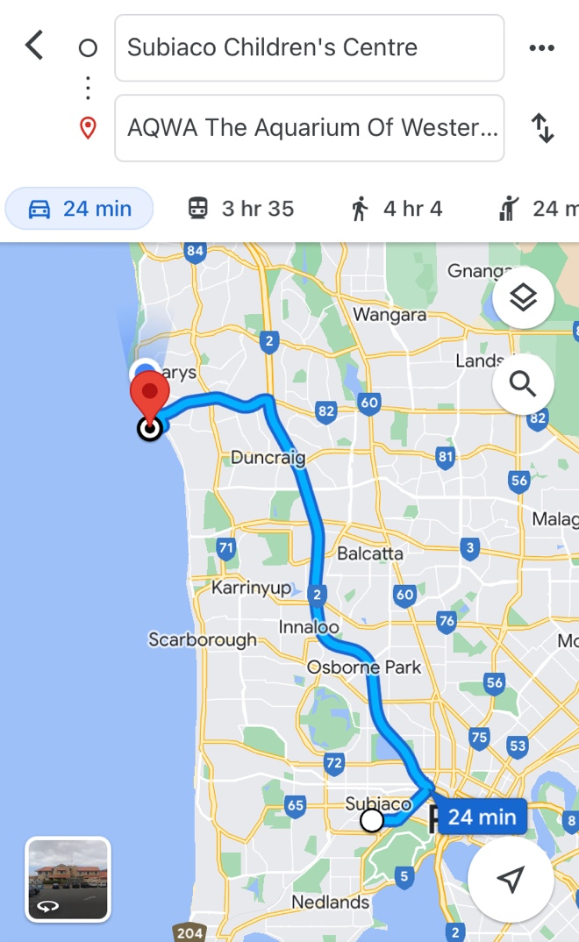  - Bus drops at the front of AQWA  - Children are not required to cross any major roads  - Children are supervised whilst in the carpark area
Name of excursion coordinator | Rafael Banzon
Contact number of excursion coordinator | (SCC MOBILE) 0413 170 223 |  | (EXCURSION NUMBER) 08 9447 7500
Number of children attending | 50 (expected) | Number of educators/parents/volunteers |  | 6/7
Educator to child ratio  1 : 10 |  | Does this excursion warrant a higher ratio?  If yes, please provide details. |  | No
EXCURSION CHECKLIST
- First Aid Kit |  | - List of adults participating in the excursion
- List of Children attending the excursion |  | - Contact information for each adult
- Contact information for each child |  | - Mobile phone/ other means of communicating with the service & emergency services
- Medical Information for each child |  | - Other items, please list

 | Risk Assessment
 | Activity |  | Hazard identified |  | Risk Assessment  (Use matrix) |  | Elimination / control measures |  |  | Who |  | When
Transition from Centre to bus & bus  to excursion |  | Losing children  Children running across the road  Traffic incident |  | Low  Low  Low |  | - Children wear high visibility vests, roll call is done on the mat before lining up in Centre with their partner for the bus.  - Head count is then conducted by at least two staff.  - Staff are dispersed between the line with one staff member in front and one at the back to lock the Centre after everyone leaves.  - Children are escorted to the bus along the footpath out to the public footpath where the bus is to be parked in the parking along the road.  - A staff member is sent up before any children to check the bus and move to the back.  - Headcount then takes place with one staff member doing a headcount on children as they move into the bus.  - For every 10 children the nominated staff counts, another staff member is let onto the bus to keep ratio.  - Children fill up the bus from the back to the front and children are to fasten seatbelts as they sit down which is double-checked by all staff moving throughout the bus.  - A headcount is then repeated with all staff and children on the bus and once everyone has their seatbelts fastened, the bus driver is told he can proceed.  - Transitioning off the bus, a headcount is performed and staff from the back of the bus is let out last in order to ensure no children/ lost property remains on the bus.  - Once we have reached our excursion destination, roll call is done and educators are assigned groups in order to ensure high levels of supervision throughout the excursion.  - Charted bus fitted with seatbelts |  |  | All staff |  | Leaving the centre.
Toilet Breaks |  | Stranger danger  Children get lost |  | Low  Low |  | - Children are escorted by educators in groups to toilets in order to avoid children being alone and in risk of danger. |  |  | All Educators |  | During excursion
Walking around AQWA centre |  | Children wandering off  Children injuring themselves or others. |  | Low  Low |  | - High supervision levels will be kept by educators, and all children will be wearing a high-vis vest for easy identification.  - Head counts are performed every 30 minutes by educators.  - Children will be split into smaller groups to be monitored by specific educators for greater supervision levels.  - Children and educators will be given safety instructions to follow regarding areas of the playground that can and cannot be accessed to lower risk of injury.  - Children will be monitored and encouraged to play in areas that match their outdoor play skills, e.g., not climbing too high.  - A qualified first aider is always on site should an injury occur. The first aid kit, action plans, emergency contacts and anaphylaxis forms are accessible at all times.  - All water areas are out of bounds to minimise risk, however educators with aquatic rescue qualifications will be present for extra precaution. |  |  | All Educators |  | During excursion
 | Returning to the centre via charted bus |  | Losing children  Leaving children behind  Children running across the road  Traffic incident |  | Low  Low  Low  Low |  | - Roll call of the children is done before leaving the venue.  - At least two educators conduct a head count of the line.  - Staff are dispersed between the line with one staff member in front and one at the back.  - Children are escorted to the bus using the safest possible route, with educators blocking roads if necessary for children to cross.  - A staff member is sent up before any children to check the bus and move to the back.  - Headcount then takes place with one staff member doing a headcount on children as they move into the bus.  - For every 10 children the nominated staff counts, another staff member is let onto the bus to keep ratio.  - Children fill up the bus from the back to the front and children are to fasten seatbelts as they sit down which is double-checked by all staff moving throughout the bus.  - A headcount is then repeated with all staff and children on the bus and once everyone has their seatbelts fastened, the bus driver is told he can proceed.  - Transitioning off the bus, a headcount is performed and staff from the back of the bus is let out last in order to ensure no children/ lost property remains on the bus.  - Once we have reached the centre, roll call is done immediately on the mat. |  |  | All Educators |  | Leaving Excursion
 | Plan prepared by |  | Jared Teo |  |  |  | Prepared in consultation with: | Rafael Banzon
 | Communicated to: |  | All staff members on duty |  |  |  | Venue and safety information reviewed and attached | Yes / No  Comment if needed:
 | Reminder: Monitor the effectiveness of controls and change if necessary. Review the risk assessment if an incident or significant change occurs.

INCURSION DETAILS
Date(s) of activity | TUESDAY 24/01/2023 | Activity Time |  | 9:45AM – 2PM
Excursion destination | N/A
Proposed activities | Incursion: Cube Sports AFL  Today CubeSports are back. to teach us all things AFL! It will be a day of sport and activities so be sure to pack a water bottle and hat. |  |  | WATER HAZARDS? NO
Method of transport, including proposed route | N/A
Name of excursion coordinator | Rafael Banzon
Contact number of excursion coordinator | (SCC MOBILE) 0413 170 223 |  | (INCURSION NUMBER) 1300 907 291
Number of children attending | 50 (expected) | Number of educators/parents/volunteers |  | 6/7
Educator to child ratio  1 : 10 |  | Does this excursion warrant a higher ratio?  If yes, please provide details. |  | No
EXCURSION CHECKLIST
- First Aid Kit |  | - List of adults participating in the excursion
- List of Children attending the excursion |  | - Contact information for each adult
- Contact information for each child |  | - Mobile phone/ other means of communicating with the service & emergency services
- Medical Information for each child |  | - Other items, please list

Risk Assessment
Activity | Hazard identified | Risk Assessment  (Use matrix) | Elimination / control measures |  | Who | When
Member of public entering the centre | Unknown person | Low | - Has been requested that incursion personnel have a working with children’s card  - Will report to supervisor to check and record their working with children’s card  - Supervisor will assess if they are in a state fit to be around children |  | Nominated Person in Charge (Supervisor) | Before the incursion begins
AFL | Injury | Low | - Children are closely supervised throughout the activities and if an injury occurs, we have a first aider on duty and first aid kit, contact list and emergency contacts on hand at all times  - Children will be split into smaller groups for this activity.  - Children will be reminded of safety rules regarding the incursion |  | All educators | During incursion
Plan prepared by | Jared Teo |  | Prepared in consultation with: | Rafael Banzon
Communicated to: | All staff members on duty |  | Venue and safety information reviewed and attached | Yes / No  Comment if needed:
Reminder: Monitor the effectiveness of controls and change if necessary. Review the risk assessment if an incident or significant change occurs.

EXCURSION DETAILS
Date(s) of activity | WEDNESDAY 25/01/2023 | Departure & arrival times |  | 9:05PM – 1:45PM
Excursion destination | Pia’s Place, Whiteman Park 6068
Proposed activities | Excursion: Pia’s Place Playground  We are heading to Pia's Place in Whiteman Park to spend the day at the playground. Hopefully we all get to climb the giant lighthouse! |  |  | WATER HAZARDS? NO
Method of transport, including proposed route | 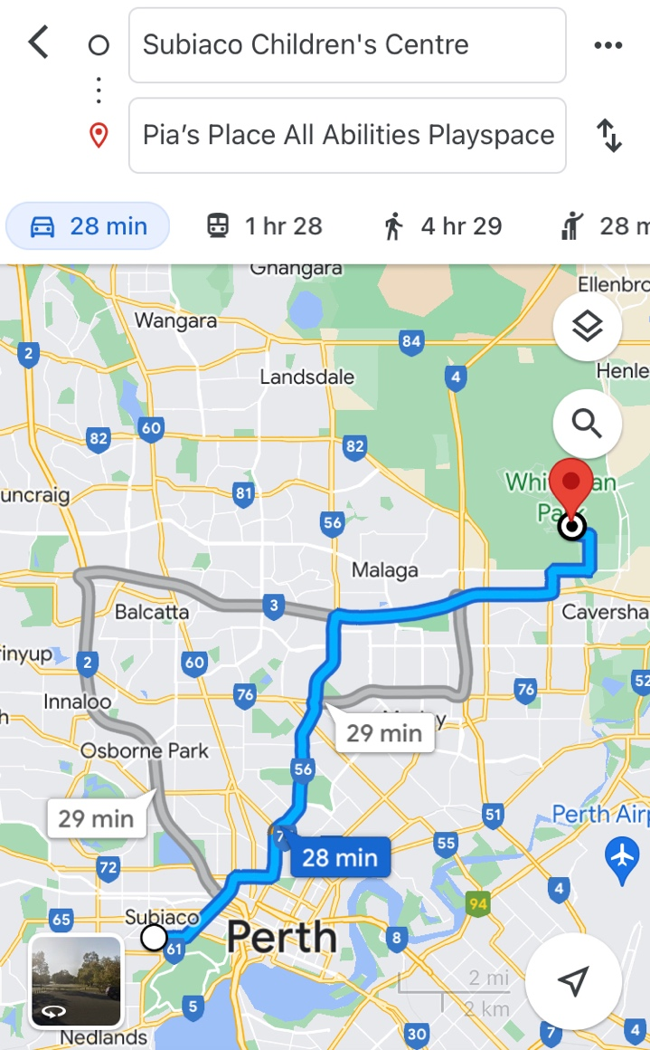  Chartered Bus from BusWest with seatbelts:  - Seats up to 57 passengers  - Bus drops at the front of Pia’s Place  - Children are not required to cross any major roads  - Children are supervised whilst in the carpark area
Name of excursion coordinator | Rafael Banzon
Contact number of excursion coordinator | (SCC MOBILE) 0413 170 223 |  | (INCURSION NUMBER)
Number of children attending | 50 (expected) | Number of educators/parents/volunteers |  | 6/7
Educator to child ratio  1 : 10 |  | Does this excursion warrant a higher ratio?  If yes, please provide details. |  | No
EXCURSION CHECKLIST
- First Aid Kit |  | - List of adults participating in the excursion
- List of Children attending the excursion |  | - Contact information for each adult
- Contact information for each child |  | - Mobile phone/ other means of communicating with the service & emergency services
- Medical Information for each child |  | - Other items, please list

 | Risk Assessment
 | Activity |  | Hazard identified |  | Risk Assessment  (Use matrix) |  | Elimination / control measures |  |  | Who |  | When
Playing in the playground |  | Children wandering off  Children injuring themselves or others  Heat Stroke |  | Low  Low  Low |  | - High supervision levels will be kept by educators, and all children will be wearing a high-vis vest for easy identification.  - Head counts are performed every 30 minutes by educators.  - Children will be split into smaller groups to be monitored by specific educators for greater supervision levels.  - Children and educators will be given safety instructions to follow regarding areas of the playground that can and cannot be accessed to lower risk of injury.  - Children will be monitored and encouraged to play in areas that match their outdoor play skills, e.g., not climbing too high.  - A qualified first aider is always on site should an injury occur. The first aid kit, action plans, emergency contacts and anaphylaxis forms are always accessible.  - Children will have brought their own water bottles or will have water provided to them if they have not brought them. Children will be kept out of direct sunlight during the middle of the day as much as reasonably possible, and will wear sun protective wear (e.g. hats, sunscreen). |  |  | All educators |  | Throughout excursion
Toilet Breaks |  | Stranger Danger  Children getting lost |  | Low |  | Children are escorted by educators in groups to toilets to avoid children being alone and in risk of danger. |  |  | All educators |  | During excursion
Transition from Centre to bus & bus  to excursion |  | Losing children  Children running across the road. |  |  |  | - Children wear high visibility vests, roll call is done on the mat before lining up in Centre with their partner for the bus.  - Head count is then conducted by at least two staff.  - Staff are dispersed between the line with one staff member in front and one at the back to lock the Centre after everyone leaves.  - Children are escorted to the bus along the footpath out to the public footpath where the bus is to be parked in the parking along the road.  - A staff member is sent up before any children to check the bus and move to the back.  - Headcount then takes place with one staff member doing a headcount on children as they move into the bus.  - For every 10 children the nominated staff counts, another staff member is let onto the bus to keep ratio.  - Children fill up the bus from the back to the front and children are to fasten seatbelts as they sit down which is double-checked by all staff moving throughout the bus.  - A headcount is then repeated with all staff and children on the bus and once everyone has their seatbelts fastened, the bus driver is told he can proceed.  - Transitioning off the bus, a headcount is performed and staff from the back of the bus is let out last in order to ensure no children/ lost property remains on the bus.  - Once we have reached our excursion destination, roll call is done and educators are assigned groups in order to ensure high levels of supervision throughout the excursion.  - bCharted bus fitted with seatbelts
 | Plan prepared by |  | Jared Teo |  |  |  | Prepared in consultation with: | Rafael Banzon
 | Communicated to: |  | All staff members on duty |  |  |  | Venue and safety information reviewed and attached | Yes / No  Comment if needed:
 | Reminder: Monitor the effectiveness of controls and change if necessary. Review the risk assessment if an incident or significant change occurs.

IN-CENTRE DETAILS
Date(s) of activity | FRIDAY 27/01/2023 | Activity Time |  | NA
Excursion destination | NA
Proposed activities | In-Centre: Damper  Today we are making damper at SCC! Get ready to learn how to make this ancient indigenous dish. |  |  | WATER HAZARDS? NO
Method of transport, including proposed route | NA
Name of excursion coordinator | Rafael Banzon
Contact number of excursion coordinator | (SCC MOBILE) 0413 170 223 |  | (EXCURSION NUMBER) NA
Number of children attending | 50 (expected) | Number of educators/parents/volunteers |  | 6/7
Educator to child ratio  1 : 10 |  | Does this excursion warrant a higher ratio?  If yes, please provide details. |  | No
EXCURSION CHECKLIST
- First Aid Kit |  | - List of adults participating in the excursion
- List of Children attending the excursion |  | - Contact information for each adult
- Contact information for each child |  | - Mobile phone/ other means of communicating with the service & emergency services
- Medical Information for each child |  | - Other items, please list

Risk Assessment
Activity | Hazard identified | Risk Assessment  (Use matrix) | Elimination / control measures |  | Who | When
Making the Damper | Injury | Low | - Children will participate in the baking activity in small, manageable, and highly supervised groups to ensure all baking equipment is being used safely and appropriately. |  | All Staff | During Activity
 | Food poisoning | Low | - Staff will follow food safety protocols and ensure children are adhering to these procedures. |  | Staff facilitating the activity | During Activity
Plan prepared by | Jared Teo |  | Prepared in consultation with: | Rafael Banzon
Communicated to: | All staff members on duty |  | Venue and safety information reviewed and attached | Yes / No  Comment if needed:
Reminder: Monitor the effectiveness of controls and change if necessary. Review the risk assessment if an incident or significant change occurs.

IN-CENTRE DETAILS
Date(s) of activity | MONDAY 30/01/2023 | Activity Time |  | NA
Excursion destination | NA
Proposed activities | In-Centre: Motorised Inventions  Get ready to make our very own motorised inventions. We get to build them from scratch and watch them move on their own! |  |  | WATER HAZARDS? NO
Method of transport, including proposed route | NA
Name of excursion coordinator | Rafael Banzon
Contact number of excursion coordinator | (SCC MOBILE) 0413 170 223 |  | (EXCURSION NUMBER) NA
Number of children attending | 50 (expected) | Number of educators/parents/volunteers |  | 6/7
Educator to child ratio  1 : 10 |  | Does this excursion warrant a higher ratio?  If yes, please provide details. |  | No
EXCURSION CHECKLIST
- First Aid Kit |  | - List of adults participating in the excursion
- List of Children attending the excursion |  | - Contact information for each adult
- Contact information for each child |  | - Mobile phone/ other means of communicating with the service & emergency services
- Medical Information for each child |  | - Other items, please list

Risk Assessment
Activity | Hazard identified | Risk Assessment  (Use matrix) | Elimination / control measures |  | Who | When
Making the motorized inventions | Injury | Low | - Children will participate in the STEM activity in small, manageable, and highly supervised groups to ensure all equipment is being used safely and appropriately. |  | All Staff | During Activity
Plan prepared by | Jared Teo |  | Prepared in consultation with: | Rafael Banzon
Communicated to: | All staff members on duty |  | Venue and safety information reviewed and attached | Yes / No  Comment if needed:
Reminder: Monitor the effectiveness of controls and change if necessary. Review the risk assessment if an incident or significant change occurs.

EXCURSION DETAILS
Date(s) of activity | TUESDAY 31/01/2023 | Departure & arrival times |  | 9:15PM – 1PM
Excursion destination | 1/16 Aberdeen St, Perth WA 6000
Proposed activities | Excursion: Nostalgia Box  Who loves video games? Come with us to explore all the retro games at Nostalgia Box. |  |  | WATER HAZARDS? NO
Method of transport, including proposed route | Chartered Bus from BusWest with seatbelts:  - Seats up to 57 passengers  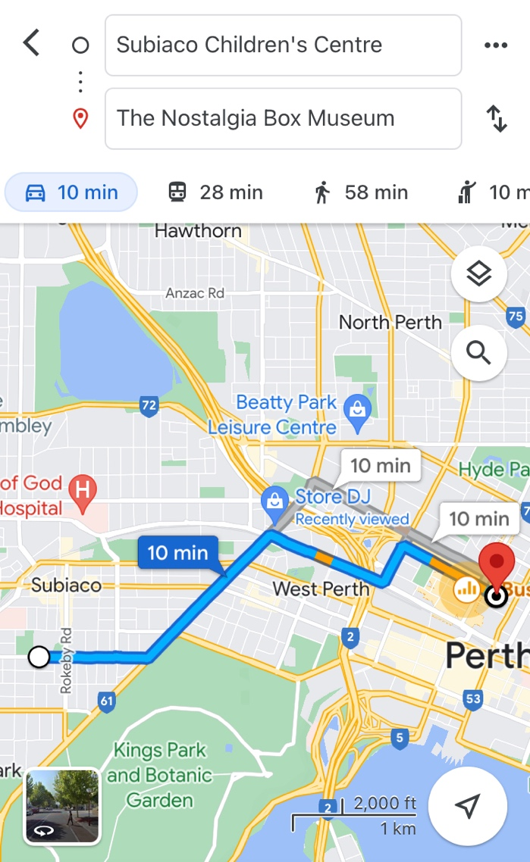  - Bus drops at Francis Street Coach Bus Stop for a 1 minute walk to Nostalgia Box
Name of excursion coordinator | Rafael Banzon
Contact number of excursion coordinator | (SCC MOBILE) 0413 170 223 |  | (EXCURSION NUMBER) 08 9227 7377
Number of children attending | 50 (expected) | Number of educators/parents/volunteers |  | 6/7
Educator to child ratio  1 : 10 |  | Does this excursion warrant a higher ratio?  If yes, please provide details. |  | No
EXCURSION CHECKLIST
- First Aid Kit |  | - List of adults participating in the excursion
- List of Children attending the excursion |  | - Contact information for each adult
- Contact information for each child |  | - Mobile phone/ other means of communicating with the service & emergency services
- Medical Information for each child |  | - Other items, please list

 | Risk Assessment
 | Activity |  | Hazard identified |  | Risk Assessment  (Use matrix) |  | Elimination / control measures |  |  | Who |  | When
Transition from Centre to bus & bus  to excursion |  | Losing children  Children running across the road  Traffic incident |  | Low  Low  Low |  | - Children wear high visibility vests, roll call is done on the mat before lining up in Centre with their partner for the bus.  - Head count is then conducted by at least two staff.  - Staff are dispersed between the line with one staff member in front and one at the back to lock the Centre after everyone leaves.  - Children are escorted to the bus along the footpath out to the public footpath where the bus is to be parked in the parking along the road.  - A staff member is sent up before any children to check the bus and move to the back.  - Headcount then takes place with one staff member doing a headcount on children as they move into the bus.  - For every 10 children the nominated staff counts, another staff member is let onto the bus to keep ratio.  - Children fill up the bus from the back to the front and children are to fasten seatbelts as they sit down which is double-checked by all staff moving throughout the bus.  - A headcount is then repeated with all staff and children on the bus and once everyone has their seatbelts fastened, the bus driver is told he can proceed.  - Transitioning off the bus, a headcount is performed and staff from the back of the bus is let out last in order to ensure no children/ lost property remains on the bus.  - Once we have reached our excursion destination, roll call is done and educators are assigned groups in order to ensure high levels of supervision throughout the excursion.  - Charted bus fitted with seatbelts |  |  | All staff |  | Leaving the centre.
Toilet Breaks |  | Stranger danger  Children get lost |  | Low  Low |  | - Children are escorted by educators in groups to toilets in order to avoid children being alone and in risk of danger. |  |  | All Educators |  | During excursion
Playing at Nostalgia Box |  | Children wandering off  Children injuring themselves or others. |  | Low  Low |  | - High supervision levels will be kept by educators, and all children will be wearing a high-vis vest for easy identification.  - Head counts are performed every 30 minutes by educators.  - Children will be split into smaller groups to be monitored by specific educators for greater supervision levels.  - Children and educators will be given safety instructions to follow regarding areas of the playground that can and cannot be accessed to lower risk of injury.  - Children will be monitored and encouraged to play in areas that match their play skills  - A qualified first aider is always on site should an injury occur. The first aid kit, action plans, emergency contacts and anaphylaxis forms are accessible at all times. |  |  | All Educators |  | During excursion
 | Returning to the centre via charted bus |  | Losing children  Leaving children behind  Children running across the road  Traffic incident |  | Low  Low  Low  Low |  | - Roll call of the children is done before leaving the venue.  - At least two educators conduct a head count of the line.  - Staff are dispersed between the line with one staff member in front and one at the back.  - Children are escorted to the bus using the safest possible route, with educators blocking roads if necessary for children to cross.  - A staff member is sent up before any children to check the bus and move to the back.  - Headcount then takes place with one staff member doing a headcount on children as they move into the bus.  - For every 10 children the nominated staff counts, another staff member is let onto the bus to keep ratio.  - Children fill up the bus from the back to the front and children are to fasten seatbelts as they sit down which is double-checked by all staff moving throughout the bus.  - A headcount is then repeated with all staff and children on the bus and once everyone has their seatbelts fastened, the bus driver is told he can proceed.  - Transitioning off the bus, a headcount is performed and staff from the back of the bus is let out last in order to ensure no children/ lost property remains on the bus.  - Once we have reached the centre, roll call is done immediately on the mat. |  |  | All Educators |  | Leaving Excursion
 | Plan prepared by |  | Jared Teo |  |  |  | Prepared in consultation with: | Rafael Banzon
 | Communicated to: |  | All staff members on duty |  |  |  | Venue and safety information reviewed and attached | Yes / No  Comment if needed:
 | Reminder: Monitor the effectiveness of controls and change if necessary. Review the risk assessment if an incident or significant change occurs.

