RISK MANAGEMENT PLAN
SEPTEMBER/ OCTOBER SCHOOL HOLIDAYS 2023

INCURSION DETAILS
Date(s) of activity | TUESDAY 26/09/2023 | Activity time |  | 10AM – 12PM
Excursion destination | N/A
Proposed activities | Incursion: Cricket  The children will be engaged in learning the basics of cricket skills with Cube Sport and competitions several fun challenges. |  |  | WATER HAZARDS? NO
Method of transport, including proposed route | N/A
Name of incursion coordinator | Rafael Banzon & Bettina Holly
Contact number of incursion coordinator | (SCC MOBILE) 0413 170 223 |  | (INCURSION NUMBER) NA
Number of children attending | 50 (expected) | Number of educators/parents/volunteers |  | 6/7
Educator to child ratio  1 : 10 |  | Does this excursion warrant a higher ratio?  If yes, please provide details. |  | No
EXCURSION CHECKLIST
- First Aid Kit |  | - List of adults participating in the excursion
- List of Children attending the excursion |  | - Contact information for each adult
- Contact information for each child |  | - Mobile phone/ other means of communicating with the service & emergency services
- Medical Information for each child |  | - Other items, please list

Risk Assessment
Activity | Hazard identified | Risk Assessment  (Use matrix) | Elimination / control measures |  | Who | When
Member of public entering the centre | Unknown person | Low | - Has been requested that incursion personnel have a working with children’s card  - Will report to supervisor to check and record their working with children’s card  - Supervisor will assess if they are in a state fit to be around children |  | Nominated Person in Charge (Supervisor) | Before the incursion begins
Cricket | Injury or misuse of equipment | Low | - Children will be encouraged to follow the centre’s safety rules and briefed on the rules of the incursion. Children will be in smaller groups to avoid injury and increase supervision. |  | All Educators | During incursion
Plan prepared by | Bettina Holly |  | Prepared in consultation with: | Rafael Banzon
Communicated to: | All staff members on duty |  | Venue and safety information reviewed and attached | Yes / No  Comment if needed:
Reminder: Monitor the effectiveness of controls and change if necessary. Review the risk assessment if an incident or significant change occurs.

EXCURSION DETAILS
Date(s) of excursion | WEDNESDAY 27/09/2023 | Departure & arrival times |  | 9:00AM – 1:00 PM
Excursion destination | Hoyts, Karrinyup Shopping Centre, 200 Karrinyup Road, Karrinyup 6018
Proposed activities | Excursion: Hoyts, Karrinyup Shopping Centre  PAW Patrol: The Mighty Movie  We are off to the cinema today to watch PAW Patrol: The Mighty Movie. Get ready for popcorn and water and have some fun! |  |  | WATER HAZARDS? NO
Method of transport, including proposed route | Chartered Bus from BusWest with seatbelts:  - Seats up to 57 passengers  - Bus drops at the front of the Karrinyup Shopping Centre.  - Children are not required to cross any major roads.  - Children are supervised whilst in the carpark area.  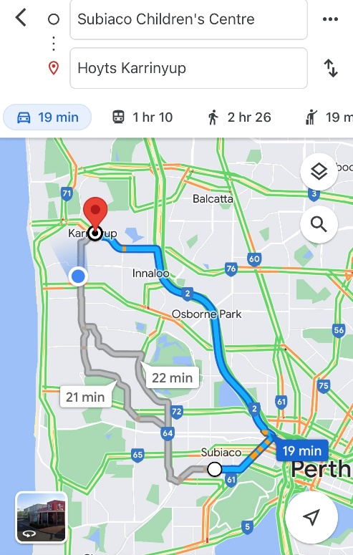
Name of excursion coordinator | Rafael Banzon & Bettina Holly
Contact number of excursion coordinator | (SCC MOBILE) 0413 170 223 |  | (EXCURSION) 0413 170 223
Number of children attending | 50 (expected) | Minimum number of educators on floor |  | 6-7
Minimum Educator to child ratio  1 : 9 |  | Does this excursion warrant a higher ratio?  If yes, please provide details. |  | No
EXCURSION CHECKLIST
- First Aid Kit |  | - List of adults participating in the excursion
- List of Children attending the incursion |  | - Contact information for each adult
- Contact information for each child |  | - Mobile phone/ other means of communicating with the service & emergency services
- Medical Information for each child |  | - Other items: N/A

Risk Assessment
Activity |  | Hazard identified | Risk Assessment  (Use matrix) |  | Elimination / control measures |  | Who | When
Transition from bus to centre  Play & Toilet breaks  Popcorn & Water |  | Losing children  Children running across the road  Traffic incident  Stranger danger  Stranger danger and food allergies | Low  Low  Low  Low  Low |  | - Staff are strategically situated in zones at the theatre to maximise supervision  - Children are to wear blue vests, roll call is done on the mat at the Centre, before lining up with their partner to proceed  - Head count is then conducted by two staff  - Staff are dispersed between the line with one staff member in front and one at the back to lock the Centre after everyone leaves  - Children are escorted to the bus along the footpath out to the public footpath where the bus is to be parked in the parking along the road  - A staff member is sent up before any children to check the bus and move to the back  - Headcount then takes place with one staff member doing a headcount on children as they move into the bus  - For every 10 children counted onto the bus, one new staff member is let onto the bus to keep ratio  - Children fill the bus up from the back to the front and children are to fasten seatbelts as they sit down which is double-checked by all staff moving throughout the bus.  - A headcount is then repeated with all staff and children on the bus and once everyone has their seatbelts fastened, the bus driver is told he can proceed  - Transitioning off the bus, a headcount is performed and staff from the back of the bus is let out last in order to ensure no children/ lost property remains on the bus.  - Once we have reached the venue, roll call is done and staffs are assigned groups or sent to strategic zones in the venue in order to ensure high levels of supervision throughout the excursion.  - Charted bus fitted with seatbelts  - Children escorted by educators in groups to toilets to avoid risk of children being alone and in risk of danger.  - Staff situated around the area in strategic locations to ensure maximum level of supervision  - Staffs are aware of children’s Medical and dietary requirements  - Popcorn and water will be provided during the movie  - Qualified first aider is on duty at all times and first aid kit, action plans, emergency contacts, epi-pens and anaphylaxis forms are accessible at all times |  | All Educators | During active portions of the excursion
Plan prepared by | Bettina Holly |  |  | Prepared in consultation with: |  | Rafael Banzon
Communicated to: | All staff members on duty |  |  | Venue and safety information reviewed and attached |  | Yes / No  Comment if needed:
Reminder: Monitor the effectiveness of controls and change if necessary. Review the risk assessment if an incident or significant change occurs.

INCURSION DETAILS
Date(s) of activity | THURSDAY 28/09/2023 | Activity time |  | 10AM – 12PM
Excursion destination | N/A
Proposed activities | Incursion: Archery  The children will be engaged in learning the basics of archery target shooting with Fit Kids, and let’s not forget the best part of archery it’s just plain fun. |  |  | WATER HAZARDS? NO
Method of transport, including proposed route | N/A
Name of incursion coordinator | Rafael Banzon & Bettina Holly
Contact number of incursion coordinator | (SCC MOBILE) 0413 170 223 |  | (INCURSION NUMBER) NA
Number of children attending | 50 (expected) | Number of educators/parents/volunteers |  | 6/7
Educator to child ratio  1 : 10 |  | Does this excursion warrant a higher ratio?  If yes, please provide details. |  | No
EXCURSION CHECKLIST
- First Aid Kit |  | - List of adults participating in the excursion
- List of Children attending the excursion |  | - Contact information for each adult
- Contact information for each child |  | - Mobile phone/ other means of communicating with the service & emergency services
- Medical Information for each child |  | - Other items, please list

Risk Assessment
Activity | Hazard identified | Risk Assessment  (Use matrix) | Elimination / control measures |  | Who | When
Member of public entering the centre | Unknown person | Low | - Has been requested that incursion personnel have a working with children’s card  - Will report to supervisor to check and record their working with children’s card  - Supervisor will assess if they are in a state fit to be around children |  | Nominated Person in Charge (Supervisor) | Before the incursion begins
Archery | Injury or misuse of equipment | Low | - Children will be encouraged to follow the centre’s safety rules and briefed on the rules of the incursion. Children will be in smaller groups to avoid injury and increase supervision. |  | All Educators | During incursion
Plan prepared by | Bettina Holly |  | Prepared in consultation with: | Rafael Banzon
Communicated to: | All staff members on duty |  | Venue and safety information reviewed and attached | Yes / No  Comment if needed:
Reminder: Monitor the effectiveness of controls and change if necessary. Review the risk assessment if an incident or significant change occurs.

EXCURSION DETAILS
Date(s) of activity | FRIDAY  29/09/2023 | Departure & arrival times |  | 9:30AM – 1:00PM
Excursion destination | Rio Tinto Naturescape Kings Park, May Dr, Kings Park WA 6005
Proposed activities | Excursion: Rio Tinto Naturescape Kings Park  Today we are off to Rio Tinto Naturescape Kings Park to connect with nature and learn to appreciate the unique Western Australian environment and have fun outdoors. We will join to brave the heights of The Bungarra and The Python, wade in the Paperbark Waterhole, get caught in a web in The Tangle, disappear down The Burrow and build your best-ever cubby. |  |  | WATER HAZARDS? NO
Method of transport, including proposed route | Chartered Bus from BusWest with seatbelts:  - Seats up to 57 passengers  - Bus drops at the front of Rio Tinto Naturescape Kings Park  - Children are not required to cross any major roads  - Children are supervised whilst in the carpark area  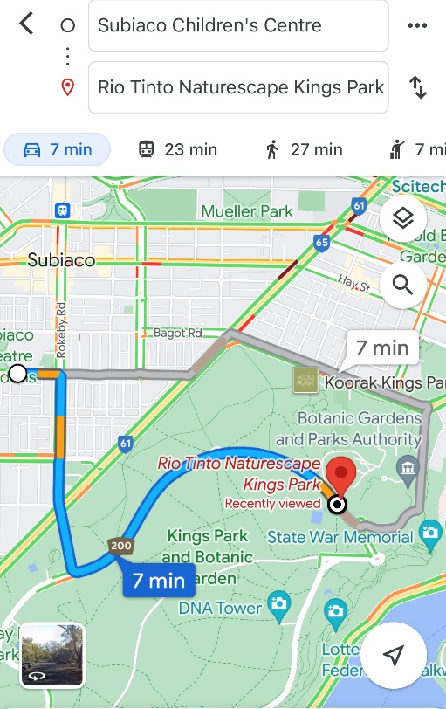
Name of excursion coordinator | Rafael Banzon & Bettina Holly
Contact number of excursion coordinator | (SCC MOBILE) 0413 170 223 |  | (EXCURSION NUMBER) 0413 170 223
Number of children attending | 50 (expected) | Number of educators/parents/volunteers |  | 6/7
Educator to child ratio  1 : 10 |  | Does this excursion warrant a higher ratio?  If yes, please provide details. |  | No
EXCURSION CHECKLIST
- First Aid Kit |  | - List of adults participating in the excursion
- List of Children attending the excursion |  | - Contact information for each adult
- Contact information for each child |  | - Mobile phone/ other means of communicating with the service & emergency services
- Medical Information for each child |  | - Other items, please list

 | Risk Assessment
 | Activity | Hazard identified |  | Risk Assessment  (Use matrix) | Elimination / control measures |  | Who |  | When
Playing in the playground | Children wandering off  Children injuring themselves or others  Heat Stroke |  | Low  Low  Low | - High supervision levels will be kept by educators, and all children will be wearing a high-vis vest for easy identification.  - Head counts are performed every 30 minutes by educators.  - Children will be split into smaller groups to be monitored by specific educators for greater supervision levels.  - Children and educators will be given safety instructions to follow regarding areas of the playground that can and cannot be accessed to lower risk of injury.  - Children will be monitored and encouraged to play in areas that match their outdoor play skills, e.g., not climbing too high.  - A qualified first aider is always on site should an injury occur. The first aid kit, action plans, emergency contacts and anaphylaxis forms are always accessible.  - Children will have brought their own water bottles or will have water provided to them if they have not brought them. Children will be kept out of direct sunlight during the middle of the day as much as reasonably possible, and will wear sun protective wear (e.g. hats, sunscreen). |  | All educators |  | Throughout excursion
Toilet Breaks | Stranger Danger  Children getting lost |  | Low | Children are escorted by educators in groups to toilets to avoid children being alone and in risk of danger. |  | All educators |  | During excursion
Transition from Centre to bus & bus  to excursion | Losing children  Children running across the road. |  |  | - Children wear high visibility vests, roll call is done on the mat before lining up in Centre with their partner for the bus.  - Head count is then conducted by at least two staff.  - Staff are dispersed between the line with one staff member in front and one at the back to lock the Centre after everyone leaves.  - Children are escorted to the bus along the footpath out to the public footpath where the bus is to be parked in the parking along the road.  - A staff member is sent up before any children to check the bus and move to the back.  - Headcount then takes place with one staff member doing a headcount on children as they move into the bus.  - For every 10 children the nominated staff counts, another staff member is let onto the bus to keep ratio.  - Children fill up the bus from the back to the front and children are to fasten seatbelts as they sit down which is double-checked by all staff moving throughout the bus.  - A headcount is then repeated with all staff and children on the bus and once everyone has their seatbelts fastened, the bus driver is told he can proceed.  - Transitioning off the bus, a headcount is performed and staff from the back of the bus is let out last in order to ensure no children/ lost property remains on the bus.  - Once we have reached our excursion destination, roll call is done and educators are assigned groups in order to ensure high levels of supervision throughout the excursion.  - bCharted bus fitted with seatbelts
 | Plan prepared by | Bettina Holly |  |  | Prepared in consultation with: | Rafael Banzon
 | Communicated to: | All staff members on duty |  |  | Venue and safety information reviewed and attached | Yes / No  Comment if needed:
 | Reminder: Monitor the effectiveness of controls and change if necessary. Review the risk assessment if an incident or significant change occurs.

INCURSION DETAILS
Date(s) of activity | MONDAY  02/10/2023 | Activity time |  | 11:00PM – 12:30PM
Excursion destination | N/A
Proposed activities | Incursion: Musical Theatre  The children will develop confidence, creativity, and communication in our musical theatre incursion with Cube Sport. This will help to the children to develop effective social interaction skills. |  |  | WATER HAZARDS? NO
Method of transport, including proposed route | N/A
Name of incursion coordinator | Rafael Banzon & Bettina Holly
Contact number of incursion coordinator | (SCC MOBILE) 0413 170 223 |  | (INCURSION NUMBER) NA
Number of children attending | 50 (expected) | Number of educators/parents/volunteers |  | 6/7
Educator to child ratio  1 : 10 |  | Does this excursion warrant a higher ratio?  If yes, please provide details. |  | No
EXCURSION CHECKLIST
- First Aid Kit |  | - List of adults participating in the excursion
- List of Children attending the excursion |  | - Contact information for each adult
- Contact information for each 0child |  | - Mobile phone/ other means of communicating with the service & emergency services
- Medical Information for each child |  | - Other items, please list

Risk Assessment
Activity | Hazard identified | Risk Assessment  (Use matrix) | Elimination / control measures |  | Who | When
Member of public entering the centre | Unknown person | Low | - Has been requested that incursion personnel have a working with children’s card  - Will report to supervisor to check and record their working with children’s card  - Supervisor will assess if they are in a state fit to be around children |  | Nominated Person in Charge (Supervisor) | Before the incursion begins
Musical Theatre | Injury or misuse of equipment | Low | - Children will be encouraged to follow the centre’s safety rules and briefed on the rules of the incursion. Children will be in smaller groups to avoid injury and increase supervision. |  | All Educators | During incursion
Plan prepared by | Bettina Holly |  | Prepared in consultation with: | Rafael Banzon
Communicated to: | All staff members on duty |  | Venue and safety information reviewed and attached | Yes / No  Comment if needed:
Reminder: Monitor the effectiveness of controls and change if necessary. Review the risk assessment if an incident or significant change occurs.

EXCURSION DETAILS
Date(s) of Excursion | TUESDAY  03/10/2023 | Departure & arrival times |  | 9:15 AM – 1PM
Excursion destination | Wanneroo Botanical Gardens, 25 Dovers Place, Wanneroo
Proposed activities | Excursion: Mini Golf  We are heading to Wanneroo Botanical Gardens to enjoy and play some Mini Golf together! |  |  | WATER HAZARDS? NO
Method of transport, including proposed route | 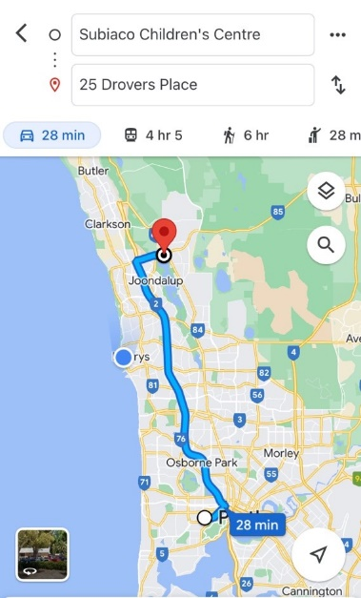  Chartered Bus from BusWest with seatbelts:  - Seats up to 57 passengers  - Bus drops at the front of Wanneroo Botanical Gardens  - Children are not required to cross any major roads  - Children are supervised whilst in the carpark area
Name of excursion coordinator | Rafael Banzon & Bettina Holly
Contact number of excursion coordinator | (SCC MOBILE) 0413 170 223 |  | (EXCURSION NUMBER) 08 9405 1475
Number of children attending | 50 (expected) | Number of educators/parents/volunteers |  | 6/7
Educator to child ratio  1 : 10 |  | Does this incursion warrant a higher ratio?  If yes, please provide details. |  | No
INCURSION CHECKLIST
- First Aid Kit |  | - List of adults participating in the excursion
- List of Children attending the excursion |  | - Contact information for each adult
- Contact information for each child |  | - Mobile phone/ other means of communicating with the service & emergency services
- Medical Information for each child |  | - Other items, please list

 | Risk Assessment
 | Activity | Hazard identified | Risk Assessment  (Use matrix) | Elimination / control measures |  |  | Who | When
Transition from Centre to bus & bus to Botanical Gardens  Bus ride | Losing children  Children running across the road  Traffic Incident | Low  Low  Low | - Children wear high visibility vests, roll call is done on the mat before lining up in the Centre with their partner for the bus  - Head count is then conducted by two staff  - Staff are dispersed between the line with one staff member in front and one at the back to lock the Centre after everyone leaves  - Children are escorted to the bus along the footpath out to the public footpath where the bus is to be parked in the parking along the road  - A staff member is sent up before any children to check the bus and move to the back  - Headcount then takes place with one staff member doing a headcount on children as they move into the bus  - For every 10 children the nominated staff counts, another staff member is let onto the bus to keep ratio  - Children are seated from the back of the bus to the front and children are to fasten seatbelts as they sit down which is double-checked by all staff moving throughout the bus.  - A headcount is then repeated with all staff and children on the bus and once everyone has their seatbelts fastened, the bus driver is told he/she can proceed  - Transitioning off the bus, a headcount is performed and staff from the back of the bus is let out last in order to ensure no children/ lost property remains on the bus.  - Once we have reached our excursion destination, roll call is done and staff are assigned groups in order to ensure high levels of supervision throughout the excursion.  - Charted bus fitted with seatbelts |  |  | All staff | Leaving for excursion and whilst on the bus.
 | Toilet Breaks and walking around | Stranger danger  Children wander off  Injury from game/equipment  Heat Stroke | Low  Low  Low  Low | - Staff will brief the children about the rules around walking around, and asking staff if they need the toilet, SCC staff will be put into groups to ensure sufficient supervision  - Florescent bibs for easy visibility of children under our care and uniforms are worn by staff members to ensure children can easily identify them  - Head count and roll call is to be done upon arrival and before departure  - Children are escorted by staff member and in groups to toilets to avoid children being alone and in risk of danger  - Headcount is done outside the toilet area before returning to ensure all children are accounted for. Ratio is always kept during all excursion activities.  - Children are closely supervised throughout the movie and if an emergency occurs, we have a first aider on duty and first aid kit  - Children are closely supervised throughout the activities and if an injury occurs, we have a first aider on duty and first aid kit, contact list and emergency contacts on hand at all times  - Children will be split into smaller groups for this activity.  - Children will be reminded of safety rules regarding animals and using other equipment on the excursion.  - Children will have brought their own water bottles or will have water provided to them if they have not brought them. Children will be kept out of direct sunlight during the middle of the day as much as reasonably possible, and will wear sun protective wear (e.g. hats, sunscreen). |  |  | All staff members  By qualified staff | At all times during this excursion  At all times during this activity
 | Plan prepared by | Bettina Holly |  | Prepared in consultation with: | Rafael Banzon
 | Communicated to: | All staff members on duty |  | Venue and safety information reviewed and attached | Yes / No  Comment if needed:
 | Reminder: Monitor the effectiveness of controls and change if necessary. Review the risk assessment if an incident or significant change occurs.

IN-CENTRE DETAILS
Date(s) of activity | WEDNESDAY  04/10/2023 | Departure & arrival times |  | NA
Excursion destination | NA
Proposed activities | In-Centre: Dumplings Cooking  Today we are making dumplings with the children. Folding dumplings is great for fine motor skills and learning patience and practice and a wealth of opportunities to explore flavor and aroma. |  |  | WATER HAZARDS? NO
Method of transport, including proposed route | NA
Name of excursion coordinator | Rafael Banzon & Bettina Holly
Contact number of excursion coordinator | (SCC MOBILE) 0413 170 223 |  | (EXCURSION NUMBER) NA
Number of children attending | 50 (expected) | Number of educators/parents/volunteers |  | 6/7
Educator to child ratio  1 : 10 |  | Does this excursion warrant a higher ratio?  If yes, please provide details. |  | No
EXCURSION CHECKLIST
- First Aid Kit |  | - List of adults participating in the excursion
- List of Children attending the excursion |  | - Contact information for each adult
- Contact information for each child |  | - Mobile phone/ other means of communicating with the service & emergency services
- Medical Information for each child |  | - Other items, please list

Risk Assessment
Activity | Hazard identified | Risk Assessment  (Use matrix) | Elimination / control measures |  | Who | When
Popcorn | Food Allergy | Low | - Children’s food allergies will be cross checked with the ingredients of the popcorn. If the food contains an allergen, they will be provided with an alternative option.  - A qualified first aider is always on site should a reaction occur; they will follow the child’s medical plan and administer aid including epi-pens appropriately. The first aid kit, action plans, emergency contacts and anaphylaxis forms are accessible at all times.  - Parents have also considered their child’s allergies when enrolling them for this incursion. |  | All staff members | During the in-centre activity
Plan prepared by | Bettina Holly |  | Prepared in consultation with: | Rafael Banzon
Communicated to: | All staff members on duty |  | Venue and safety information reviewed and attached | Yes / No  Comment if needed:
Reminder: Monitor the effectiveness of controls and change if necessary. Review the risk assessment if an incident or significant change occurs.

INCURSION DETAILS
Date(s) of activity | THURSDAY 05/10/2023 | Activity time |  | 1PM – 3PM
Excursion destination | N/A
Proposed activities | Incursion: Boot Camp 4 Kids  Boot Camp with Fit Kids will boost fitness levels through age-appropriate fitness activities at moderate to high intensity levels. Through the encouragement of teamwork, this class gives a positive workout experience and teaches children to push themselves through the toughest of challenges. |  |  | WATER HAZARDS? NO
Method of transport, including proposed route | N/A
Name of incursion coordinator | Rafael Banzon & Bettina Holly
Contact number of incursion coordinator | (SCC MOBILE) 0413 170 223 |  | (INCURSION NUMBER) NA
Number of children attending | 50 (expected) | Number of educators/parents/volunteers |  | 6/7
Educator to child ratio  1 : 10 |  | Does this excursion warrant a higher ratio?  If yes, please provide details. |  | No
EXCURSION CHECKLIST
- First Aid Kit |  | - List of adults participating in the excursion
- List of Children attending the excursion |  | - Contact information for each adult
- Contact information for each child |  | - Mobile phone/ other means of communicating with the service & emergency services
- Medical Information for each child |  | - Other items, please list

Risk Assessment
Activity | Hazard identified | Risk Assessment  (Use matrix) | Elimination / control measures |  | Who | When
Member of public entering the centre | Unknown person | Low | - Has been requested that incursion personnel have a working with children’s card  - Will report to supervisor to check and record their working with children’s card  - Supervisor will assess if they are in a state fit to be around children |  | Nominated Person in Charge (Supervisor) | Before the incursion begins
Boot Camp 4 Kids | Injury or misuse of equipment | Low | - Children will be encouraged to follow the centre’s safety rules and briefed on the rules of the incursion. Children will be in smaller groups to avoid injury and increase supervision. |  | All Educators | During incursion
Plan prepared by | Bettina Holly |  | Prepared in consultation with: | Rafael Banzon
Communicated to: | All staff members on duty |  | Venue and safety information reviewed and attached | Yes / No  Comment if needed:
Reminder: Monitor the effectiveness of controls and change if necessary. Review the risk assessment if an incident or significant change occurs.

EXCURSION DETAILS
Date(s) of activity | FRIDAY 06/10/2023 | Departure & arrival times |  | 9:00AM – 1:00PM
Excursion destination | Progress Drive, Bibra Lake 6163
Proposed activities | Incursion: Bibra Lake Playground  Today we are off to Bibra Lake Regional Playground to play on the flying fox, trampolines, and aerial rope walk! |  |  | WATER HAZARDS? NO
Method of transport, including proposed route | 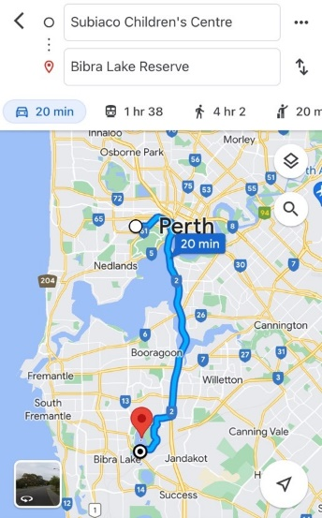  Chartered Bus from BusWest with seatbelts:  - Seats up to 57 passengers  - Bus drops at the front of Bibra Lake Playground  - Children are not required to cross any major roads  - Children are supervised whilst in the carpark area
Name of excursion coordinator | Rafael Banzon & Bettina Holly
Contact number of excursion coordinator | (SCC MOBILE) 0413 170 223 |  | (EXCURSION NUMBER) NA
Number of children attending | 50 (expected) | Number of educators/parents/volunteers |  | 6/7
Educator to child ratio  1 : 10 |  | Does this excursion warrant a higher ratio?  If yes, please provide details. |  | No
EXCURSION CHECKLIST
- First Aid Kit |  | - List of adults participating in the excursion
- List of Children attending the excursion |  | - Contact information for each adult
- Contact information for each child |  | - Mobile phone/ other means of communicating with the service & emergency services
- Medical Information for each child |  | - Other items, please list

 | Risk Assessment
 | Activity | Hazard identified |  | Risk Assessment  (Use matrix) | Elimination / control measures |  | Who |  | When
Playing in the playground | Children wandering off  Children injuring themselves or others  Heat Stroke |  | Low  Low  Low | - High supervision levels will be kept by educators, and all children will be wearing a high-vis vest for easy identification.  - Head counts are performed every 30 minutes by educators.  - Children will be split into smaller groups to be monitored by specific educators for greater supervision levels.  - Children and educators will be given safety instructions to follow regarding areas of the playground that can and cannot be accessed to lower risk of injury.  - Children will be monitored and encouraged to play in areas that match their outdoor play skills, e.g., not climbing too high.  - A qualified first aider is always on site should an injury occur. The first aid kit, action plans, emergency contacts and anaphylaxis forms are always accessible.  - Children will have brought their own water bottles or will have water provided to them if they have not brought them. Children will be kept out of direct sunlight during the middle of the day as much as reasonably possible, and will wear sun protective wear (e.g. hats, sunscreen). |  | All educators |  | Throughout excursion
Toilet Breaks | Stranger Danger  Children getting lost |  | Low | Children are escorted by educators in groups to toilets to avoid children being alone and in risk of danger. |  | All educators |  | During excursion
Transition from Centre to bus & bus  to excursion | Losing children  Children running across the road. |  |  | - Children wear high visibility vests, roll call is done on the mat before lining up in Centre with their partner for the bus.  - Head count is then conducted by at least two staff.  - Staff are dispersed between the line with one staff member in front and one at the back to lock the Centre after everyone leaves.  - Children are escorted to the bus along the footpath out to the public footpath where the bus is to be parked in the parking along the road.  - A staff member is sent up before any children to check the bus and move to the back.  - Headcount then takes place with one staff member doing a headcount on children as they move into the bus.  - For every 10 children the nominated staff counts, another staff member is let onto the bus to keep ratio.  - Children fill up the bus from the back to the front and children are to fasten seatbelts as they sit down which is double-checked by all staff moving throughout the bus.  - A headcount is then repeated with all staff and children on the bus and once everyone has their seatbelts fastened, the bus driver is told he can proceed.  - Transitioning off the bus, a headcount is performed and staff from the back of the bus is let out last in order to ensure no children/ lost property remains on the bus.  - Once we have reached our excursion destination, roll call is done and educators are assigned groups in order to ensure high levels of supervision throughout the excursion.  - Charted bus fitted with seatbelts
 | Plan prepared by | Bettina Holly |  |  | Prepared in consultation with: | Rafael Banzon
 | Communicated to: | All staff members on duty |  |  | Venue and safety information reviewed and attached | Yes / No  Comment if needed:
 | Reminder: Monitor the effectiveness of controls and change if necessary. Review the risk assessment if an incident or significant change occurs.

INCURSION DETAILS
Date(s) of activity | MONDAY 09/10/2023 | Activity time |  | 9AM – 12PM
Excursion destination | N/A
Proposed activities | Incursion: First Aid for Kids  Through a storybook and with St John, children will learn how to identify an emergency, what number to call in an emergency and understand the role of who can help in an emergency and the children also will learn about the First Aid Action Plan. |  |  | WATER HAZARDS? NO
Method of transport, including proposed route | N/A
Name of incursion coordinator | Rafael Banzon & Bettina Holly
Contact number of incursion coordinator | (SCC MOBILE) 0413 170 223 |  | (INCURSION NUMBER) NA
Number of children attending | 50 (expected) | Number of educators/parents/volunteers |  | 6/7
Educator to child ratio  1 : 10 |  | Does this excursion warrant a higher ratio?  If yes, please provide details. |  | No
EXCURSION CHECKLIST
- First Aid Kit |  | - List of adults participating in the excursion
- List of Children attending the excursion |  | - Contact information for each adult
- Contact information for each child |  | - Mobile phone/ other means of communicating with the service & emergency services
- Medical Information for each child |  | - Other items, please list

Risk Assessment
Activity | Hazard identified | Risk Assessment  (Use matrix) | Elimination / control measures |  | Who | When
Member of public entering the centre | Unknown person | Low | - Has been requested that incursion personnel have a working with children’s card  - Will report to supervisor to check and record their working with children’s card  - Supervisor will assess if they are in a state fit to be around children |  | Nominated Person in Charge (Supervisor) | Before the incursion begins
First Aid for Kids | Injury or misuse of equipment | Low | - Children will be encouraged to follow the centre’s safety rules and briefed on the rules of the incursion. Children will be in smaller groups to avoid injury and increase supervision. |  | All Educators | During incursion
Plan prepared by | Bettina Holly |  | Prepared in consultation with: | Rafael Banzon
Communicated to: | All staff members on duty |  | Venue and safety information reviewed and attached | Yes / No  Comment if needed:
Reminder: Monitor the effectiveness of controls and change if necessary. Review the risk assessment if an incident or significant change occurs.

