RISK MANAGEMENT PLAN
APRIL SCHOOL HOLIDAYS 2024

INCURSION DETAILS
Date(s) of activity | TUESDAY 02/04/2024 | Activity time |  | 10AM – 12PM
Excursion destination | N/A
Proposed activities | Incursion: Hip Hop  The children will be engaged in Hip Hop dance incursion with Fun Fit. They bring many good music and teach us some fun movement. |  |  | WATER HAZARDS? NO
Method of transport, including proposed route | N/A
Name of incursion coordinator | Bettina Holly & Rafael Banzon
Contact number of incursion coordinator | (SCC MOBILE) 0413 170 223 |  | (INCURSION NUMBER) NA
Number of children attending | 50 (expected) | Number of educators/parents/volunteers |  | 6/7
Educator to child ratio  1 : 10 |  | Does this excursion warrant a higher ratio?  If yes, please provide details. |  | No
EXCURSION CHECKLIST
- First Aid Kit |  | - List of adults participating in the excursion
- List of Children attending the excursion |  | - Contact information for each adult
- Contact information for each child |  | - Mobile phone/ other means of communicating with the service & emergency services
- Medical Information for each child |  | - Other items, please list

Risk Assessment
Activity | Hazard identified | Risk Assessment  (Use matrix) | Elimination / control measures |  | Who | When
Member of public entering the centre | Unknown person | Low | - Has been requested that incursion personnel have a working with children’s card.  - Will report to supervisor to check and record their working with children’s card.  - Supervisor will assess if they are in a state fit to be around children |  | Nominated Person in Charge (Supervisor) | Before the incursion begins
Hip Hop | Injury or misuse of equipment | Low | - Children will be encouraged to follow the centre’s safety rules and briefed on the rules of the incursion. Children will be in smaller groups to avoid injury and increase supervision. |  | All Educators | During incursion
Plan prepared by | Bettina Holly |  | Prepared in consultation with: | Rafael Banzon
Communicated to: | All staff members on duty |  | Venue and safety information reviewed and attached | Yes / No  Comment if needed:
Reminder: Monitor the effectiveness of controls and change if necessary. Review the risk assessment if an incident or significant change occurs.

EXCURSION DETAILS
Date(s) of activity | FRIDAY  03/04/2024 | Departure & arrival times |  | 9:15AM – 12:45PM
Excursion destination | 4 Elcar Ln, Joondalup WA 6027
Proposed activities | Excursion: Inflatable World  Today, we are off to Inflatable World in Joondalup, the Home to Australia's Biggest Indoor Inflatable Playgrounds. It’s all about having fun! |  |  | WATER HAZARDS? NO
Method of transport, including proposed route | 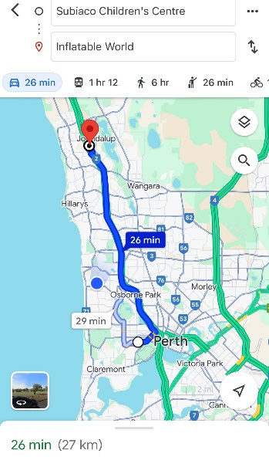  Chartered Bus from BusWest with seatbelts:  - Seats up to 57 passengers  - Bus drops at the front of the Inflatable world  - Children are not required to cross any major  roads.  - Children are supervised whilst in the carpark  area.
Name of excursion coordinator | Rafael Banzon & Bettina Holly
Contact number of excursion coordinator | (SCC MOBILE) 0413 170 223 |  | (EXCURSION NUMBER) 0413 170 223
Number of children attending | 50 (expected) | Number of educators/parents/volunteers |  | 6/7
Educator to child ratio  1 : 10 |  | Does this excursion warrant a higher ratio?  If yes, please provide details. |  | No
EXCURSION CHECKLIST
- First Aid Kit |  | - List of adults participating in the excursion
- List of Children attending the excursion |  | - Contact information for each adult
- Contact information for each child |  | - Mobile phone/ other means of communicating with the service & emergency services
- Medical Information for each child |  | - Other items, please list

 | Risk Assessment
 | Activity | Hazard identified |  | Risk Assessment  (Use matrix) | Elimination / control measures |  | Who |  | When
Playing in the inflatable playground | Children wandering off.  Children injuring themselves or others.  Heat Stroke |  | Low  Low  Low | - High supervision levels will be kept by educators, and all children will be wearing a high-vis vest for easy identification.  - Head counts are performed every 30 minutes by educators.  - Children will be split into smaller groups to be monitored by specific educators for greater supervision levels.  - Children and educators will be given safety instructions to follow regarding areas of the playground that can and cannot be accessed to lower risk of injury.  - Children will be monitored and encouraged to play in areas that match their outdoor play skills, e.g., not climbing too high.  - A qualified first aider is always on site should an injury occur. The first aid kit, action plans, emergency contacts and anaphylaxis forms are always accessible.  - Children will have brought their own water bottles or will have water provided to them if they have not brought them. Children will be kept out of direct sunlight during the middle of the day as much as reasonably possible, and will wear sun protective wear (e.g. hats, sunscreen). |  | All educators |  | Throughout excursion
Toilet Breaks | Stranger Danger  Children getting lost |  | Low | Children are escorted by educators in groups to toilets to avoid children being alone and in risk of danger. |  | All educators |  | During excursion
Transition from Centre to bus & bus  to excursion | Losing children  Children running across the road. |  |  | - Children wear high visibility vests, roll call is done on the mat before lining up in Centre with their partner for the bus.  - Head count is then conducted by at least two staff.  - Staff are dispersed between the line with one staff member in front and one at the back to lock the Centre after everyone leaves.  - Children are escorted to the bus along the footpath out to the public footpath where the bus is to be parked in the parking along the road.  - A staff member is sent up before any children to check the bus and move to the back.  - Headcount then takes place with one staff member doing a headcount on children as they move into the bus.  - For every 10 children the nominated staff counts, another staff member is let onto the bus to keep ratio.  - Children fill up the bus from the back to the front and children are to fasten seatbelts as they sit down which is double-checked by all staff moving throughout the bus.  - A headcount is then repeated with all staff and children on the bus and once everyone has their seatbelts fastened, the bus driver is told he can proceed.  - Transitioning off the bus, a headcount is performed and staff from the back of the bus is let out last in order to ensure no children/ lost property remains on the bus.  - Once we have reached our excursion destination, roll call is made and educators are assigned groups to ensure high levels of supervision throughout the excursion.  - Chartered bus fitted with seatbelts.
 | Plan prepared by | Bettina Holly |  |  | Prepared in consultation with: | Rafael Banzon
 | Communicated to: | All staff members on duty |  |  | Venue and safety information reviewed and attached | Yes / No  Comment if needed:
 | Reminder: Monitor the effectiveness of controls and change if necessary. Review the risk assessment if an incident or significant change occurs.

INCURSION DETAILS
Date(s) of activity | THURSDAY 04/04/2024 | Activity time |  | 10AM – 12PM
Excursion destination | N/A
Proposed activities | Incursion: Bricks 4 Kidz  The children will be engaged in many exciting activities with loads of colourful creative-play LEGO® Bricks. |  |  | WATER HAZARDS? NO
Method of transport, including proposed route | N/A
Name of incursion coordinator | Rafael Banzon & Bettina Holly
Contact number of incursion coordinator | (SCC MOBILE) 0413 170 223 |  | (INCURSION NUMBER) NA
Number of children attending | 50 (expected) | Number of educators/parents/volunteers |  | 6/7
Educator to child ratio  1 : 10 |  | Does this excursion warrant a higher ratio?  If yes, please provide details. |  | No
EXCURSION CHECKLIST
- First Aid Kit |  | - List of adults participating in the excursion
- List of Children attending the excursion |  | - Contact information for each adult
- Contact information for each child |  | - Mobile phone/ other means of communicating with the service & emergency services
- Medical Information for each child |  | - Other items, please list

Risk Assessment
Activity | Hazard identified | Risk Assessment  (Use matrix) | Elimination / control measures |  | Who | When
Member of public entering the centre | Unknown person | Low | - Has been requested that incursion personnel have a working with children’s card.  - Will report to supervisor to check and record their working with children’s card.  - Supervisor will assess if they are in a state fit to be around children |  | Nominated Person in Charge (Supervisor) | Before the incursion begins
Lego blocks | Injury or misuse of equipment | Low | - Children will be encouraged to follow the centre’s safety rules and briefed on the rules of the incursion. Children will be in smaller groups to avoid injury and increase supervision. |  | All Educators | During incursion
Plan prepared by | Bettina Holly |  | Prepared in consultation with: | Rafael Banzon
Communicated to: | All staff members on duty |  | Venue and safety information reviewed and attached | Yes / No  Comment if needed:
Reminder: Monitor the effectiveness of controls and change if necessary. Review the risk assessment if an incident or significant change occurs.

EXCURSION DETAILS
Date(s) of excursion | WEDNESDAY 05/04/2024 | Departure & arrival times |  | 9:30AM – 1:00 PM
Excursion destination | Hoyts, Karrinyup Shopping Centre, 200 Karrinyup Road, Karrinyup 6018
Proposed activities | Excursion: Hoyts, Karrinyup Shopping Centre  Kung Fu Panda 4  We are off to the cinema today to watch Kung Fu Panda 4. Get ready for popcorn and water and have some fun! |  |  | WATER HAZARDS? NO
Method of transport, including proposed route | Chartered Bus from BusWest with seatbelts:  - Seats up to 57 passengers  - The bus drops at the front of the Karrinyup Shopping Centre.  - Children are not required to cross any major roads.  - Children are supervised whilst in the car park area.  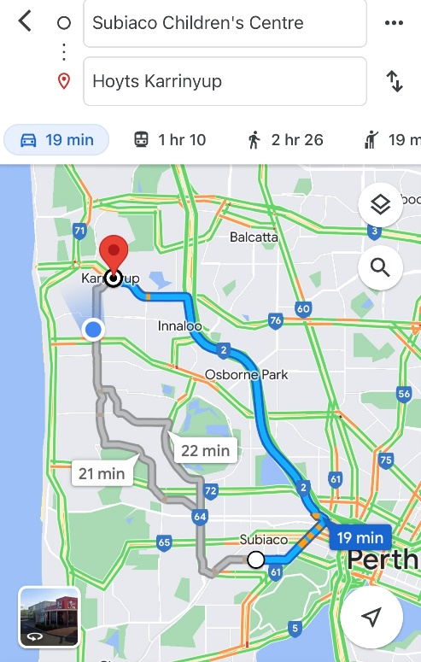
Name of excursion coordinator | Rafael Banzon & Bettina Holly
Contact number of excursion coordinator | (SCC MOBILE) 0413 170 223 |  | (EXCURSION) 0413 170 223
Number of children attending | 50 (expected) | Minimum number of educators on floor |  | 6-7
Minimum Educator to child ratio  1 : 9 |  | Does this excursion warrant a higher ratio?  If yes, please provide details. |  | No
EXCURSION CHECKLIST
- First Aid Kit |  | - List of adults participating in the excursion
- List of Children attending the incursion |  | - Contact information for each adult
- Contact information for each child |  | - Mobile phone/ other means of communicating with the service & emergency services
- Medical Information for each child |  | - Other items: N/A

Risk Assessment
Activity |  | Hazard identified | Risk Assessment  (Use matrix) |  | Elimination / control measures |  | Who | When
Transition from bus to centre.  Play & Toilet breaks.  Popcorn & Water |  | Losing children  Children running across the road  Traffic incident  Stranger danger  Food allergies | Low  Low  Low  Low  Low |  | - Staff are strategically situated in zones at the theatre to maximise supervision.  - Children are to wear blue vests, roll call is done on the mat at the Centre, before lining up with their partner to proceed.  - Head count is then conducted by two staff.  - Staff are dispersed between the line with one staff member in front and one at the back to lock the Centre after everyone leaves.  - Children are escorted to the bus along the footpath out to the public footpath where the bus is to be parked in the parking along the road.  - A staff member is sent up before any children to check the bus and move to the back.  - Headcount then takes place with one staff member doing a headcount on children as they move into the bus.  - For every 10 children counted onto the bus, one new staff member is let onto the bus to keep ratio.  - Children fill the bus up from the back to the front and children are to fasten seatbelts as they sit down which is double-checked by all staff moving throughout the bus.  - A headcount is then repeated with all staff and children on the bus and once everyone has their seatbelts fastened, the bus driver is told he can proceed.  - Transitioning off the bus, a headcount is performed and staff from the back of the bus is let out last to ensure no children/ lost property remains on the bus.  - Once we have reached the venue, roll call is done and staffs are assigned groups or sent to strategic zones in the venue to ensure high levels of supervision throughout the excursion.  - Charted bus fitted with seatbelts.  - Children escorted by educators in groups to toilets to avoid risk of children being alone and in risk of danger.  - Staff situated around the area in strategic locations to ensure maximum level of supervision.  - Staffs are aware of children’s Medical and dietary requirements.  - Popcorn and water will be provided during the movie.  - Qualified first aider is always on duty and first aid kit, action plans, emergency contacts, epi-pens and anaphylaxis forms are accessible at all times |  | All Educators | During active portions of the excursion
Plan prepared by | Bettina Holly |  |  | Prepared in consultation with: |  | Rafael Banzon
Communicated to: | All staff members on duty |  |  | Venue and safety information reviewed and attached |  | Yes / No  Comment if needed:
Reminder: Monitor the effectiveness of controls and change if necessary. Review the risk assessment if an incident or significant change occurs.

INCURSION DETAILS
Date(s) of activity | MONDAY 08/04/2024 | Activity time |  | 9:30AM – 11:45PM
Excursion destination | N/A
Proposed activities | Incursion: Einstein Australia  The children will be engaged in science activities with Einstein Australia and experimenting with chemical reactions, such as the creation of rainbows and tricking your own eyes. |  |  | WATER HAZARDS? NO
Method of transport, including proposed route | N/A
Name of incursion coordinator | Rafael Banzon & Bettina Holly
Contact number of incursion coordinator | (SCC MOBILE) 0413 170 223 |  | (INCURSION NUMBER) NA
Number of children attending | 50 (expected) | Number of educators/parents/volunteers |  | 6/7
Educator to child ratio  1 : 10 |  | Does this excursion warrant a higher ratio?  If yes, please provide details. |  | No
EXCURSION CHECKLIST
- First Aid Kit |  | - List of adults participating in the excursion
- List of Children attending the excursion |  | - Contact information for each adult
- Contact information for each child |  | - Mobile phone/ other means of communicating with the service & emergency services
- Medical Information for each child |  | - Other items, please list

Risk Assessment
Activity | Hazard identified | Risk Assessment  (Use matrix) | Elimination / control measures |  | Who | When
Member of public entering the centre | Unknown person | Low | - Has been requested that incursion personnel have a working with children’s card.  - Will report to supervisor to check and record their working with children’s card.  - Supervisor will assess if they are in a state fit to be around children |  | Nominated Person in Charge (Supervisor) | Before the incursion begins
Science activities | Injury or misuse of equipment | Low | - Children will be encouraged to follow the centre’s safety rules and briefed on the rules of the incursion. Children will be in smaller groups to avoid injury and increase supervision. |  | All Educators | During incursion
Plan prepared by | Bettina Holly |  | Prepared in consultation with: | Rafael Banzon
Communicated to: | All staff members on duty |  | Venue and safety information reviewed and attached | Yes / No  Comment if needed:
Reminder: Monitor the effectiveness of controls and change if necessary. Review the risk assessment if an incident or significant change occurs.

EXCURSION DETAILS
Date(s) of excursion | TUESDAY  09/04/2024 | Departure & arrival times |  | 12:30AM – 2:30PM
Excursion destination | Ellie Eaton Theatre, 1 Graylands Road, Claremont, WA, 6010
Proposed activities | Excursion: Ellie Eaton Theatre in the Claremont Showground.  Spare Puppets Theatre  We are off to the theatre by Spare Puppet to watch the Wilfrid Gordon McDonald Partridge. |  |  | WATER HAZARDS? NO
Method of transport, including proposed route | Chartered Bus from BusWest with seatbelts:  - Seats up to 57 passengers  - Bus drops at the front of the Claremont Showground.  - Children are not required to cross any major roads  - Children are supervised whilst in the carpark area  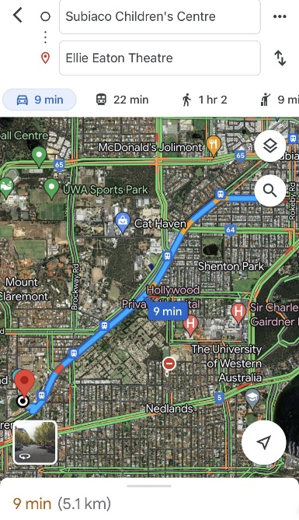
Name of excursion coordinator | Rafael Banzon & Bettina Holly
Contact number of excursion coordinator | (SCC MOBILE) 0413 170 223 |  | (EXCURSION) 0413 170 223
Number of children attending | 50 (expected) | Minimum number of educators on floor |  | 6-7
Minimum Educator to child ratio  1 : 9 |  | Does this excursion warrant a higher ratio?  If yes, please provide details. |  | No
EXCURSION CHECKLIST
- First Aid Kit |  | - List of adults participating in the excursion
- List of Children attending the incursion |  | - Contact information for each adult
- Contact information for each child |  | - Mobile phone/ other means of communicating with the service & emergency services
- Medical Information for each child |  | - Other items: N/A

Risk Assessment
Activity |  | Hazard identified | Risk Assessment  (Use matrix) |  | Elimination / control measures |  | Who | When
Transition from bus to centre  Play & Toilet breaks.  Lunch |  | Losing children  Children running across the road.  Traffic incident  Stranger Danger  Food allergies | Low  Low  Low  Low  Low |  | - Staff are strategically situated in zones at the theatre to maximise supervision.  - Children are to wear blue vests, roll call is made on the mat at the Centre, before lining up with their partner to proceed.  - Head count is then conducted by two staff.  - Staff are dispersed between the line with one staff member in front and one at the back to lock the Centre after everyone leaves.  - Children are escorted to the bus along the footpath out to the public footpath where the bus is to be parked in the parking along the road.  - A staff member is sent up before any children to check the bus and move to the back.  - Headcount then takes place with one staff member doing a headcount on children as they move into the bus.  - For every 10 children counted onto the bus, one new staff member is let onto the bus to keep ratio.  - Children fill the bus up from the back to the front and children are to fasten their seatbelts as they sit down which is double-checked by all staff moving throughout the bus.  - A headcount is then repeated with all staff and children on the bus and once everyone has their seatbelts fastened, the bus driver is told he can proceed.  - Transitioning off the bus, a headcount is performed and staff from the back of the bus is let out last in order to ensure no children/ lost property remains on the bus.  - Once we have reached the venue, roll call is done and staffs are assigned groups or sent to strategic zones in the venue to ensure high levels of supervision throughout the excursion.  - Charted bus fitted with seatbelts.  - Children are escorted by educators in groups to toilets to avoid the risk of children being alone and in risk of danger.  - Staff situated around the area in strategic locations to ensure maximum level of supervision.  - Children will be gathered in one area with all staff during lunch.  - Staff are to observe other children’s lunch closely and remove any child away from high-risk area who are at risk of allergic reaction to allergens found.  - Qualified first aider is always on duty and first aid kit, action plans, emergency contacts, epi-pens and anaphylaxis forms are accessible at all times |  | All Educators | During active portions of the excursion
Plan prepared by | Bettina Holly |  |  | Prepared in consultation with: |  | Rafael Banzon
Communicated to: | All staff members on duty |  |  | Venue and safety information reviewed and attached |  | Yes / No  Comment if needed:
Reminder: Monitor the effectiveness of controls and change if necessary. Review the risk assessment if an incident or significant change occurs.

IN-CENTRE DETAILS
Date(s) of activity | TUESDAY  10/04/2024 | Departure & arrival times |  | NA
Excursion destination | NA
Proposed activities | In-Centre: Sports Day  Today, we are doing sports day today; It will be footy and hockey activities with our dedicated educators, TJ and Lawson. |  |  | WATER HAZARDS? NO
Method of transport, including proposed route | NA
Name of excursion coordinator | Rafael Banzon & Bettina Holly
Contact number of excursion coordinator | (SCC MOBILE) 0413 170 223 |  | (EXCURSION NUMBER) NA
Number of children attending | 50 (expected) | Number of educators/parents/volunteers |  | 6/7
Educator to child ratio  1 : 10 |  | Does this excursion warrant a higher ratio?  If yes, please provide details. |  | No
EXCURSION CHECKLIST
- First Aid Kit |  | - List of adults participating in the excursion
- List of Children attending the excursion |  | - Contact information for each adult
- Contact information for each child |  | - Mobile phone/ other means of communicating with the service & emergency services
- Medical Information for each child |  | - Other items, please list

Risk Assessment
Activity | Hazard identified | Risk Assessment  (Use matrix) | Elimination / control measures |  | Who | When
Footy and hockey | Injury or misuse of equipment | Low | - Children will be encouraged to follow the centre’s safety rules and briefed on the rules of the incursion. Children will be in smaller groups to avoid injury and increase supervision |  | All staff members | During the in-centre activity
Plan prepared by | Bettina Holly |  | Prepared in consultation with: | Rafael Banzon
Communicated to: | All staff members on duty |  | Venue and safety information reviewed and attached | Yes / No  Comment if needed:
Reminder: Monitor the effectiveness of controls and change if necessary. Review the risk assessment if an incident or significant change occurs.

EXCURSION DETAILS
Date(s) of excursion | THURSDAY  19/04/2024 | Departure & arrival times |  | 10:15PM – 1:45PM
Excursion destination | 24 Gympie Way, Willetton WA 6155
Proposed activities | Excursion: Jungle Gym  We are off to Jungle Gym, where we can do jumping, climbing, swinging, rotating and somersaulting, ensuring they have a great work out and a ton of fun at the same time. |  |  | WATER HAZARDS? NO
Method of transport, including proposed route | Chartered Bus from BusWest with seatbelts:  - Seats up to 57 passengers  - Bus drops at the front of Jungle Gym  - Children are not required to cross any major roads  - Children are supervised whilst in the carpark area  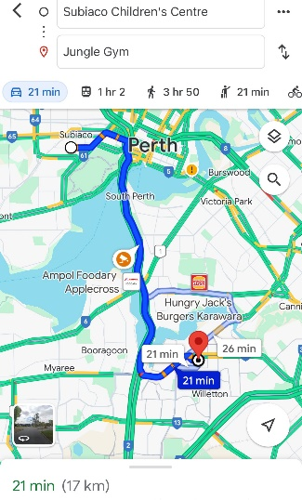
Name of excursion coordinator | Rafael Banzon & Bettina Holly
Contact number of excursion coordinator | (SCC MOBILE) 0413 170 223 |  | (EXCURSION NUMBER) 0413 170 223
Number of children attending | 50 (expected) | Minimum number of educators on floor |  | 6
Minimum Educator to child ratio  1 : 10 |  | Does this excursion warrant a higher ratio?  If yes, please provide details. |  | No
EXCURSION CHECKLIST
- First Aid Kit |  | - List of adults participating in the excursion
- List of Children attending the incursion |  | - Contact information for each adult
- Contact information for each child |  | - Mobile phone/ other means of communicating with the service & emergency services
- Medical Information for each child |  | - Other items: N/A

Risk Assessment
Activity | Hazard identified | Risk Assessment  (Use matrix) | Elimination / control measures |  |  | Who | When
Trampolining, gym activities  Transition from bus to centre  Play & Toilet breaks.  Lunch | Children injuring themselves—slips, sprains, misuse of equipment and facilities.  Stranger Danger  Losing children  Children running across the road.  Traffic incident  Stranger danger  Food allergies | Low  Low  Low  Low  Low  Low  Low | - Staff are there to support and assist children if needed.  - risk of injury is low due to staff strategically situated in areas/zones for maximum supervision.  - Staff will ensure that children in their groups/zones are using the equipment and facilities correctly.  - Staff are strategically situated in zones or groups at the venue to maximise supervision.  - Children are to wear blue vests, roll call is done on the mat at the Centre, before lining up with their partner to proceed.  - Head count is then conducted by two staff.  - Staff are dispersed between the line with one staff member in front and one at the back to lock the Centre after everyone leaves.  - Children are escorted to the bus along the footpath out to the public footpath where the bus is to be parked in the parking along the road.  - A staff member is sent up before any children to check the bus and move to the back  - Headcount then takes place with one staff member doing a headcount on children as they move into the bus  - For every 10 children counted onto the bus, one new staff member is let onto the bus to keep ratio  - Children fill the bus up from the back to the front and children are to fasten their seatbelts as they sit down which is double-checked by all staff moving throughout the bus.  - A headcount is then repeated with all staff and children on the bus and once everyone has their seatbelts fastened, the bus driver is told he can proceed  - Transitioning off the bus, a headcount is performed and staff from the back of the bus is let out last in order to ensure no children/ lost property remains on the bus.  - Once we have reached the venue, role call is done and staffs are assigned groups or sent to strategic zones in the venue in order to ensure high levels of supervision throughout the excursion.  - Charted bus fitted with seatbelts  - Children are escorted by educators in groups to toilets to avoid risk of children being alone and in risk of danger.  - Staff situated around the area in strategic locations to ensure maximum level of supervision.  - Children will be gathered in one area with all staff during lunch.  - Staff are to observe other children’s lunch closely and remove any child away from high-risk area who are at risk of allergic reaction to allergens found.  - Qualified first aider is always on duty and first aid kit, action plans, emergency contacts, epi-pens and anaphylaxis forms are accessible at all times |  |  | All Educators | During active portions of the excursion
Plan prepared by | Bettina Holly |  |  | Prepared in consultation with: | Rafael Banzon
Communicated to: | All staff members on duty and made available to all parent’s prior to booking |  |  | Venue and safety information reviewed and attached | Yes / No  Comment if needed:
Reminder: Monitor the effectiveness of controls and change if necessary. Review the risk assessment if an incident or significant change occurs.

INCURSION DETAILS
Date(s) of activity | THURSDAY  12/04/2024 | Activity time |  | 10:00AM – 12:00PM
Excursion destination | N/A
Proposed activities | Incursion: Messiness Bee Farm  Messiness Bee Farm is visiting us and teaching us about the bees. We will see, touch, hear, taste and smell through the use of play, arts & crafts and hands-on resources. |  |  | WATER HAZARDS? NO
Method of transport, including proposed route | N/A
Name of incursion coordinator | Rafael Banzon & Bettina Holly
Contact number of incursion coordinator | (SCC MOBILE) 0413 170 223 |  | (INCURSION NUMBER) NA
Number of children attending | 50 (expected) | Number of educators/parents/volunteers |  | 6/7
Educator to child ratio  1 : 10 |  | Does this excursion warrant a higher ratio?  If yes, please provide details. |  | No
EXCURSION CHECKLIST
- First Aid Kit |  | - List of adults participating in the excursion
- List of Children attending the excursion |  | - Contact information for each adult
- Contact information for each 0child |  | - Mobile phone/ other means of communicating with the service & emergency services
- Medical Information for each child |  | - Other items, please list

Risk Assessment
Activity | Hazard identified | Risk Assessment  (Use matrix) | Elimination / control measures |  | Who | When
Member of public entering the centre | Unknown person | Low | - Has been requested that incursion personnel have a working with children’s card.  - Will report to supervisor to check and record their working with children’s card.  - Supervisor will assess if they are in a state fit to be around children |  | Nominated Person in Charge (Supervisor) | Before the incursion begins
Messiness Bee Farm education | Injury or misuse of equipment | Low | - Children will be encouraged to follow the centre’s safety rules and briefed on the rules of the incursion. Children will be in smaller groups to avoid injury and increase supervision. |  | All Educators | During incursion
Plan prepared by | Bettina Holly |  | Prepared in consultation with: | Rafael Banzon
Communicated to: | All staff members on duty |  | Venue and safety information reviewed and attached | Yes / No  Comment if needed:
Reminder: Monitor the effectiveness of controls and change if necessary. Review the risk assessment if an incident or significant change occurs.

EXCURSION DETAILS
Date(s) of excursion | FRIDAY  26/04/2024 | Departure & arrival times |  | 9:15PM – 12:45PM
Excursion destination | 6 Halley Rd, Balcatta WA 6021
Proposed activities | Excursion: Beach House  We are off to the Beach house, where we can have lots of fun with the interactive bouncy castle, massive ride-on track, soccer tables, electric air hockey tables etc. |  |  | WATER HAZARDS? NO
Method of transport, including proposed route | Chartered Bus from BusWest with seatbelts:  - Seats up to 57 passengers  - Bus drops at the front of Beach House  - Children are not required to cross any major roads  - Children are supervised whilst in the carpark area  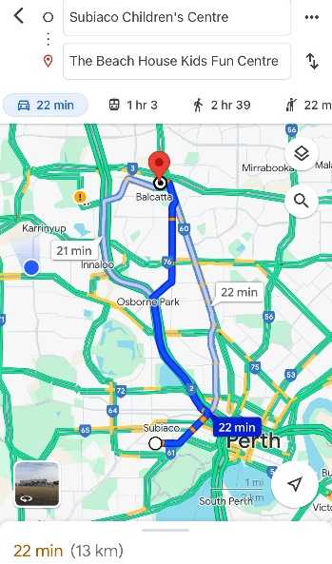
Name of excursion coordinator | Rafael Banzon & Bettina Holly
Contact number of excursion coordinator | (SCC MOBILE) 0413 170 223 |  | (EXCURSION NUMBER) 0413 170 223
Number of children attending | 50 (expected) | Minimum number of educators on floor |  | 6
Minimum Educator to child ratio  1 : 10 |  | Does this excursion warrant a higher ratio?  If yes, please provide details. |  | No
EXCURSION CHECKLIST
- First Aid Kit |  | - List of adults participating in the excursion
- List of Children attending the incursion |  | - Contact information for each adult
- Contact information for each child |  | - Mobile phone/ other means of communicating with the service & emergency services
- Medical Information for each child |  | - Other items: N/A

Risk Assessment
Activity | Hazard identified | Risk Assessment  (Use matrix) | Elimination / control measures |  |  | Who | When
Indoor Playground  Transition from bus to centre  Play & Toilet breaks.  Lunch | Children injuring themselves—slips, sprains, misuse of equipment and facilities.  Stranger Danger  Losing children  Children running across the road  Traffic incident  Stranger danger  Food allergies | Low  Low  Low  Low  Low  Low  Low | - Staff are there to support and assist children if needed.  - risk of injury is low due to staff strategically situated in areas/zones for maximum supervision.  - Staff will ensure that children in their groups/zones are using the equipment and facilities correctly.  - Staff are strategically situated in zones or groups at the venue to maximise supervision.  - Children are to wear blue vests, roll call is done on the mat at the Centre, before lining up with their partner to proceed  - Head count is then conducted by two staff.  - Staff are dispersed between the line with one staff member in front and one at the back to lock the Centre after everyone leaves  - Children are escorted to the bus along the footpath out to the public footpath where the bus is to be parked in the parking along the road  - A staff member is sent up before any children to check the bus and move to the back.  - Headcount then takes place with one staff member doing a headcount on children as they move into the bus .  - For every 10 children counted onto the bus, one new staff member is let onto the bus to keep ratio  - Children fill the bus up from the back to the front and children are to fasten their seatbelts as they sit down which is double-checked by all staff moving throughout the bus.  - A headcount is then repeated with all staff and children on the bus and once everyone has their seatbelts fastened, the bus driver is told he can proceed.  - Transitioning off the bus, a headcount is performed and staff from the back of the bus is let out last in order to ensure no children/ lost property remains on the bus.  - Once we have reached the venue, roll call is done and staff are assigned groups or sent to strategic zones in the venue in order to ensure high levels of supervision throughout the excursion.  - Charted bus fitted with seatbelts.  - Children are escorted by educators in groups to toilets to avoid the risk of children being alone and in risk of danger.  - Staff situated around the area in strategic locations to ensure maximum level of supervision  - Children will be gathered in one area with all staff during lunch  - Staff are to observe other children’s lunch closely and remove any child away from high-risk area who are at risk of allergic reaction to allergens found.  - Qualified first aider is always on duty and first aid kit, action plans, emergency contacts, epi-pens and anaphylaxis forms are accessible at all times |  |  | All Educators | During active portions of the excursion
Plan prepared by | Bettina Holly |  |  | Prepared in consultation with: | Rafael Banzon
Communicated to: | All staff members on duty and made available to all parent’s prior to booking |  |  | Venue and safety information reviewed and attached | Yes / No  Comment if needed:
Reminder: Monitor the effectiveness of controls and change if necessary. Review the risk assessment if an incident or significant change occurs.

