SUBIACO CHILDREN’S CENTRE (SCC)
160 HAMERSLEY ROAD, SUBIACO
Website: www.subicc.com.au
Mobile: 0413 170 223 Email: subicc@iinet.net.au
Opening Hour: 7.30am – 6pm
Booking and Permission December/January Vacation Programme 2020
Child Details
Child 1 Name: _________________________________________
Child 2 Name: _________________________________________
Child 3 Name: _________________________________________
Parent/Guardian Details
Name: ________________________________ Phone Number: _______________________
Name: ________________________________ Phone Number: _______________________
Emergency Contacts/Authorised Persons
Name: ________________________________ Phone Number: _______________________
Name: ________________________________ Phone Number: _______________________

Please tick √ and sign the dates your children will be attending. (Subject to availability)
Date | Destination/ Incursion/ Excursion details | Departure  and Return/ Activities Time | Booking  Please Tick | Bus & Excursion/Incursion  Permission. Please sign each booked day
Friday  18th Dec 20 | Incursion: RAC | 10am to 12pm
Monday  21st Dec 20 | In-Centre: Mosaics | 10am to 3pm
Tuesday  22nd Dec 20 | In-Centre: Craft Day | 10am to 2pm
Wednesday  23rd Dec 20 | In-Centre: Gingerbread Houses | 10am to 2pm
Monday  4th Jan 21 | In-Centre: Sushi Kids in Kitchen | 10am to 1pm
Tuesday  5th Jan 21 | Incursion: Kidz n’ Sport | 10am to 12pm
Wednesday  6th Jan 21 | Excursion: Cinemas The Croods 2 | 9:20am to 1pm
Thursday  7th Jan 21 | Incursion: Robot Building | 10am to 12pm
Friday  8th Jan 21 | Excursion: Outback Splash Maze | 9:10am to 2pm
Monday  11th Jan 21 | Excursion: Cohuna Koala Park | 9:15am to 1:30pm
Tuesday  12th Jan 21 | Incursion: Caricatures | 10am to 1pm
Wednesday  13th Jan 21 | Incursion: Japanese Kites | 10am to 1pm
Thursday  14th Jan 21 | Excursion: AQWA | 9:15am to 1:30pm
Friday  15th Jan 21 | In-Centre: Circus Day | 10am to 1pm
Monday  18th Jan 21 | Excursion: Shipwreck Park Sienna Wood | 9:20am to 1pm
Tuesday  19th Jan 21 | Incursion: Bush Tucker Planting | 9:30am to 11am
Wednesday  20th Jan 21 | Incursion: Supersonic Science | 10am to 1pm
Thursday  21st Jan 21 | Incursion: Educated by Nature Tinkering Zone | 9am to 1pm
Friday  22nd Jan 21 | Excursion: Optus Stadium Tour | 9:20am to 2pm
Monday  25th Jan 21 | Excursion: Jo Wheatley Playground | 9:30am to 1:30pm
Wednesday 27th Jan 21 | Incursion: Wonderful Worm Waste | 10am to 1pm
Thursday  28th Jan 21 | Excursion: Bell Tower | 9:20am to 1pm
Friday  29th Jan 21 | Incursion: Billy Carts | 10am to 1pm

PLEASE NOTE: Please provide us with your 2021 enrolment/re-enrolment form and direct debit form.

*Cinemas (choice of drink): Coke____ Sprite____Water____

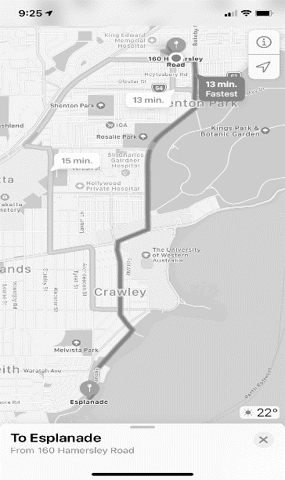
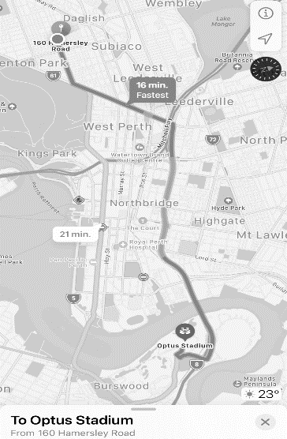
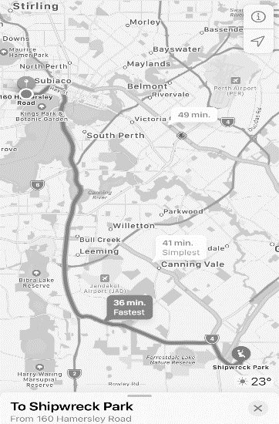
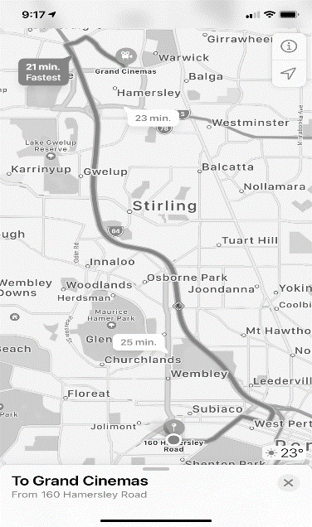
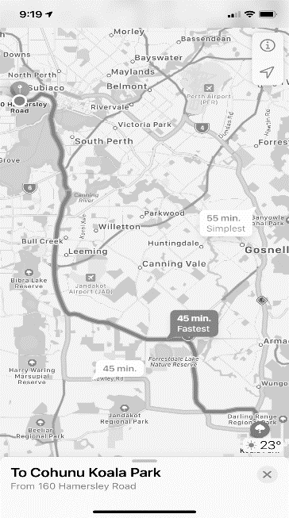
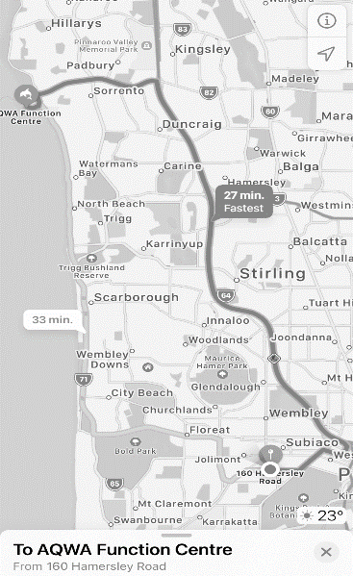
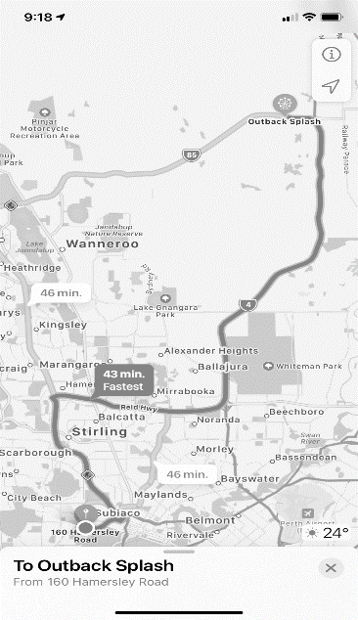
Proposed Bus routes: (Excursions Only)
