RISK MANAGEMENT PLAN
JULY SCHOOL HOLIDAYS 2021
EXCURSION DETAILS
Date(s) of excursion | MONDAY 05/07/2021 | Departure & arrival times |  | 9:35AM – 1PM
Excursion destination | Revolution Sports, 37 Lemnos St Shenton Park WA 6008
Proposed activities | Excursion: Inflatable World  We are headed to inflatable world a massive inflatable indoor playground where children can play participate in activities like devils drop, slam dunking, velcro wall, sliding and battling in the gladiator arena. NO SOCKS – NO PLAY. |  |  | WATER HAZARDS? NO
Method of transport, including proposed route | 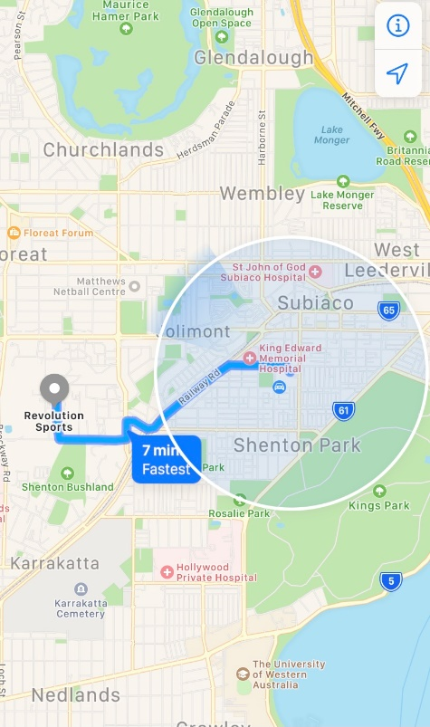  Chartered Bus from BusWest with seatbelts:  - Seats up to 57 passengers  - Bus drops at the front of Revolution sports  - Children are not required to cross any roads  - Children are supervised whilst in the carpark
Name of excursion coordinator | Ji Ni Chooi & Kiara Vivian
Contact number of excursion coordinator | (SCC MOBILE) 0413 170 223 |  | (EXCURSION NUMBER) 08 9388 3430
Number of children attending | 50 (expected) | Number of educators/parents/volunteers |  | 6
Educator to child ratio  1 : 10 |  | Does this excursion warrant a higher ratio?  If yes, please provide details. |  | No
EXCURSION CHECKLIST
- First Aid Kit |  | - List of adults participating in the excursion
- List of Children attending the excursion |  | - Contact information for each adult
- Contact information for each child |  | - Mobile phone/ other means of communicating with the service & emergency services
- Medical Information for each child |  | - Other items, please list

Risk Assessment
Activity | Hazard identified | Risk Assessment  (Use matrix) | Elimination / control measures |  | Who | When
Inflatable Playground | Share with public  Children leaving  Children injuring themselves | Low  Low  Low | - Staff are in the playground area to monitor interactions with the public.  - Playground is fenced, with one entry point to which a staff member will be placed  - Staff will have stations within the playground and at least 1 roaming to optimize vision points and will rotate.  - Children are to be reminded of safe play before leaving for excursion  - Staff will guide children to play safely whilst at the playground  - Playground is inflatable so soft surfaces  - Majority of staff are first aid trained and able to treat if needed |  | All Educators | Leaving for and at excursion venue.
Transition from Centre to bus & bus to Revolution Sports  Bus ride | Losing children  Children running across the road  Traffic Incident | Low  Low  Low | - Children wear high visibility vests, roll call is done on the mat before lining up in the Centre with their partner for the bus  - Head count is then conducted by two staff  - Staff are dispersed between the line with one staff member in front and one at the back to lock the Centre after everyone leaves  - Children are escorted to the bus along the footpath out to the public footpath where the bus is to be parked in the parking along the road  - A staff member is sent up before any children to check the bus and move to the back  - Headcount then takes place with one staff member doing a headcount on children as they move into the bus  - For every 10 children the nominated staff counts, another staff member is let onto the bus to keep ratio  - Children are seated from the back of the bus to the front and children are to fasten seatbelts as they sit down which is double-checked by all staff moving throughout the bus.  - A headcount is then repeated with all staff and children on the bus and once everyone has their seatbelts fastened, the bus driver is told he/she can proceed  - Transitioning off the bus, a headcount is performed and staff from the back of the bus is let out last in order to ensure no children/ lost property remains on the bus.  - Once we have reached our excursion destination, roll call is done and staff are assigned groups in order to ensure high levels of supervision throughout the excursion.  - Charted bus fitted with seatbelts |  | All Educators | Entering and leaving the bus.
Plan prepared by | Kiara Vivian |  | Prepared in consultation with: | Ji Ni Chooi
Communicated to: | All staff members on duty |  | Venue and safety information reviewed and attached | Yes / No  Comment if needed:
Reminder: Monitor the effectiveness of controls and change if necessary. Review the risk assessment if an incident or significant change occurs.

INCURSION DETAILS
Date(s) of excursion | TUESDAY 06/07/2021 | Departure & arrival times |  | 9:30AM – 11:30AM
Excursion destination | N/A
Proposed activities | Incursion: Fitkids Australia Yoga  Today's Incursion sees FitKids Australia here to help us find our inner Zen and teach us some Yoga moves as we work out who has the best balance and inner chi! Today is sure to be fun! |  |  | WATER HAZARDS? NO
Method of transport, including proposed route | N/A
Name of excursion coordinator | Ji Ni Chooi & Kiara Vivian
Contact number of excursion coordinator | (SCC MOBILE) 0413 170 223 |  | (INCURSION NUMBER) 0416 249 513
Number of children attending | 50 (expected) | Number of educators/parents/volunteers |  | 6/7
Educator to child ratio  1 : 10 |  | Does this excursion warrant a higher ratio?  If yes, please provide details. |  | No
EXCURSION CHECKLIST
- First Aid Kit |  | - List of adults participating in the excursion
- List of Children attending the excursion |  | - Contact information for each adult
- Contact information for each child |  | - Mobile phone/ other means of communicating with the service & emergency services
- Medical Information for each child |  | - Other items, please list

Risk Assessment
Activity | Hazard identified | Risk Assessment  (Use matrix) | Elimination / control measures |  | Who | When
Yoga | Children injuring themselves | Low | - All movements are adapted to fit children’s capabilities  - Movements are given under the guidance of a qualified instructor  - Staff are there to support and assist children if needed  - Children are divided into groups of 25 with 3 staff in each group for easier supervision and needed attention |  | All Educators | During Incursion
Public Member entering facility | Unknown person | Low | - Has been requested they have a working with children’s card  - Will report to supervisor to check and record their working with children’s card  - Supervisor will assess if they are in a state fit to be around children. |  | Nominated Person in Charge (Supervisor) | Prior to incursion starting.
Plan prepared by | Kiara Vivian |  | Prepared in consultation with: | Ji Ni Chooi
Communicated to: | All staff members on duty |  | Venue and safety information reviewed and attached | Yes / No  Comment if needed:
Reminder: Monitor the effectiveness of controls and change if necessary. Review the risk assessment if an incident or significant change occurs.

IN-CENTRE DETAILS
Date(s) of excursion | WEDNESDAY 07/07/2021 | Departure & arrival times |  | 10AM – 1PM
Excursion destination | N/A
Proposed activities | In-Centre- Pokemon Day  Gonna Catch Them All! Today we are starting the holidays with a Pokemon themed day where the children will enjoy searching in the Pokeball Hunt, Hatch & Find Pokemon, make your own Pokemon Cards & Pikachu Ears, Enjoy Pokemon Tag and everything else Pokemon! |  |  | WATER HAZARDS? NO
Method of transport, including proposed route | N/A
Name of excursion coordinator | Ji Ni Chooi & Kiara Vivian
Contact number of excursion coordinator | (SCC MOBILE) 0413 170 223 |  | (INCURSION NUMBER) N/A
Number of children attending | 50 (expected) | Number of educators/parents/volunteers |  | 6/7
Educator to child ratio  1 : 10 |  | Does this excursion warrant a higher ratio?  If yes, please provide details. |  | No
EXCURSION CHECKLIST
- First Aid Kit |  | - List of adults participating in the excursion
- List of Children attending the excursion |  | - Contact information for each adult
- Contact information for each child |  | - Mobile phone/ other means of communicating with the service & emergency services
- Medical Information for each child |  | - Other items, please list

Risk Assessment
Activity | Hazard identified | Risk Assessment  (Use matrix) | Elimination / control measures |  | Who | When
Hatching Pokemon Eggs | Allergy  Choking | Low  Low | - No children have any known allergies to products we are using but need to pay attention to skin to ensure no reactions from the bi carb soda.  - Children are to be supervised when handling the eggs and will be in small groups at a time to ensure children do not place Pokémon near mouths. |  | All Staff | During Egg Hatching
Plan prepared by | Kiara Vivian |  | Prepared in consultation with: | Ji Ni Chooi
Communicated to: | All staff members on duty |  | Venue and safety information reviewed and attached | Yes / No  Comment if needed:
Reminder: Monitor the effectiveness of controls and change if necessary. Review the risk assessment if an incident or significant change occurs.

INCURSION DETAILS
Date(s) of excursion | THURSDAY 08/07/2021 | Departure & arrival times |  | 10AM – 12PM
Excursion destination | N/A
Proposed activities | Incursion – Booyi Culutral Program Nyungar Art  arn where ochre comes from and how it is used to create indigenous art. Learn the different art symbols used by Nyungars and what they mean today with Booyi Cultural Program. |  |  | WATER HAZARDS? NO
Method of transport, including proposed route | N/A
Name of excursion coordinator | Ji Ni Chooi & Kiara Vivian
Contact number of excursion coordinator | (SCC MOBILE) 0413 170 223 |  | (INCURSION NUMBER) https://booyi.org.au/
Number of children attending | 50 (expected) | Number of educators/parents/volunteers |  | 6/7
Educator to child ratio  1 : 10 |  | Does this excursion warrant a higher ratio?  If yes, please provide details. |  | No
EXCURSION CHECKLIST
- First Aid Kit |  | - List of adults participating in the excursion
- List of Children attending the excursion |  | - Contact information for each adult
- Contact information for each child |  | - Mobile phone/ other means of communicating with the service & emergency services
- Medical Information for each child |  | - Other items, please list

Risk Assessment
Activity | Hazard identified | Risk Assessment  (Use matrix) | Elimination / control measures |  | Who | When
Painting | Allergy | Low | - No children have any known allergies to products we are using but need to pay attention to skin to ensure no reactions  - Materials used are natural so should eliminate most reactions |  | All Staff | During Painting
Plan prepared by | Kiara Vivian |  | Prepared in consultation with: | Ji Ni Chooi
Communicated to: | All staff members on duty |  | Venue and safety information reviewed and attached | Yes / No  Comment if needed:
Reminder: Monitor the effectiveness of controls and change if necessary. Review the risk assessment if an incident or significant change occurs.

EXCURSION DETAILS
Date(s) of excursion | FRIDAY 09/07/2021 | Departure & arrival times |  | 9.25AM – 3PM
Excursion destination | N/A
Proposed activities | Excursion: Little Things for Tiny Tots  Today we are rolling up our sleeves and helping out at Little Things for Tiny Tots to help struggling mums and families by packing up new born boxes to help welcome their new little ones to the world and have a run around next door at Robinson Reserve. |  |  | WATER HAZARDS? NO
Method of transport, including proposed route | 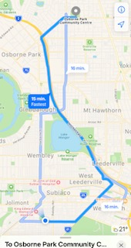  Chartered Bus from BusWest with seatbelts:  - Seats up to 57 passengers  - Bus drops at the front of Revolution sports  - Children are not required to cross any roads  - Children are supervised whilst in the carpark
Name of excursion coordinator | Ji Ni Chooi & Kiara Vivian
Contact number of excursion coordinator | (SCC MOBILE) 0413 170 223 |  | (INCURSION NUMBER) hello@littlethings.org.au
Number of children attending | 50 (expected) | Number of educators/parents/volunteers |  | 7
Educator to child ratio  1 : 10 |  | Does this excursion warrant a higher ratio?  If yes, please provide details. |  | No
EXCURSION CHECKLIST
- First Aid Kit |  | - List of adults participating in the excursion
- List of Children attending the excursion |  | - Contact information for each adult
- Contact information for each child |  | - Mobile phone/ other means of communicating with the service & emergency services
- Medical Information for each child |  | - Other items, please list

Risk Assessment
Activity | Hazard identified | Risk Assessment  (Use matrix) | Elimination / control measures |  | Who | When
Playing on Oval | Not fenced in  Public | Medium  Medium | - Only half the group is to be playing on the oval at once.  - Boundaries to be identified and explained to children before playing and a buffer area to be given between park and road that children are not permitted in.  - Staff to stand close to boundaries  - Only staff will be allowed to retrieve equipment should it go onto the road  - Public people may be using the park so staff to limit interactions when possible with them or if necessary be there to monitor any interactions had with the public. |  | Educators | During Excursion
Transition from Centre to bus & bus to Revolution Sports  Bus ride | Losing children  Children running across the road  Traffic Incident | Low  Low  Low | - Children wear high visibility vests, roll call is done on the mat before lining up in the Centre with their partner for the bus  - Head count is then conducted by two staff  - Staff are dispersed between the line with one staff member in front and one at the back to lock the Centre after everyone leaves  - Children are escorted to the bus along the footpath out to the public footpath where the bus is to be parked in the parking along the road  - A staff member is sent up before any children to check the bus and move to the back  - Headcount then takes place with one staff member doing a headcount on children as they move into the bus  - For every 10 children the nominated staff counts, another staff member is let onto the bus to keep ratio  - Children are seated from the back of the bus to the front and children are to fasten seatbelts as they sit down which is double-checked by all staff moving throughout the bus.  - A headcount is then repeated with all staff and children on the bus and once everyone has their  - Transitioning off the bus, a headcount is performed and staff from the back of the bus is let out last in order to ensure no children/ lost property remains on the bus.  - Once we have reached our excursion destination, roll call is done and staff are assigned groups in order to ensure high levels of supervision throughout the excursion.  - Charted bus fitted with seatbels |  | All Educators | Entering, leaving and whilst on bus
Plan prepared by | Kiara Vivian |  | Prepared in consultation with: | Ji Ni Chooi
Communicated to: | All staff members on duty |  | Venue and safety information reviewed and attached | Yes / No  Comment if needed:
Reminder: Monitor the effectiveness of controls and change if necessary. Review the risk assessment if an incident or significant change occurs.

INCURSION DETAILS
Date(s) of Incursion | MONDAY 12/07/2021 | Departure & arrival times |  | 10AM – 12PM
Incursion destination | 160 HAMERSLEY RD, SUBIACO 6008
Proposed activities | Incursion: Kanyana Wildlife Rehabilitation Centre  Today Kanyana Wildlife Rehabilitation Centre is here to show us some endangered animals and teach us all about wildlife first aid. If we are lucky we might even be able to pet some! |  |  | WATER HAZARDS? NO
Method of transport, including proposed route | N/A
Name of excursion coordinator | Ji Ni Chooi & Kiara Vivian
Contact number of excursion coordinator | (SCC MOBILE) 0413 170 223 |  | (INCURSION NUMBER) 08 9291 3900
Number of children attending | 50 (expected) | Number of educators/parents/volunteers |  | 6/7
Educator to child ratio  1 : 10 |  | Does this incursion warrant a higher ratio?  If yes, please provide details. |  | No
INCURSION CHECKLIST
- First Aid Kit |  | - List of adults participating in the excursion
- List of Children attending the excursion |  | - Contact information for each adult
- Contact information for each child |  | - Mobile phone/ other means of communicating with the service & emergency services
- Medical Information for each child |  | - Other items, please list

Risk Assessment
Activity | Hazard identified | Risk Assessment  (Use matrix) | Elimination / control measures |  | Who | When
Engaging with the wildlife animals during the incursion  Member of public entering the centre | Children being harmed by animals  Allergies  Unknown person | Low  Low  Low | - Children to be supervised and managed in a controlled environment where incursion personnel and educators are aware of all children-animal interactions.  - Allergies and anaphylaxis awareness to be practiced by all educators and the First Aid Kit is to be ready at any moment.  - Has been requested that incursion personnel have a working with children’s card  - Will report to supervisor to check and record their working with children’s card  - Supervisor will assess if they are in a state fit to be around children |  | All Educators  Nominated Person in Charge (Supervisor) | During the incursion  Before the incursion begins
Plan prepared by | Rafael Banzon |  | Prepared in consultation with: | Ji Ni Chooi
Communicated to: | All staff members on duty |  | Venue and safety information reviewed and attached | Yes / No  Comment if needed:
Reminder: Monitor the effectiveness of controls and change if necessary. Review the risk assessment if an incident or significant change occurs.

EXCURSION DETAILS
Date(s) of excursion | TUESDAY 13/07/2021 | Departure & arrival times |  | 9:15AM – 1PM
Excursion destination | GRAND CINEMAS, 639 BEACH RD, WARWICK 6024
Proposed activities | Excursion: Grand Cinemas – Space Jam 2: A New Legacy  We are headed to the movies today to watch Space Jam 2: A New Legacy starring Lebron James who gets trapped in a world of Warner Bros characters. With Bugs Bunny’s help, the pair must defeat the evil AI G through a basketball game. |  |  | WATER HAZARDS? NO
Method of transport, including proposed route | 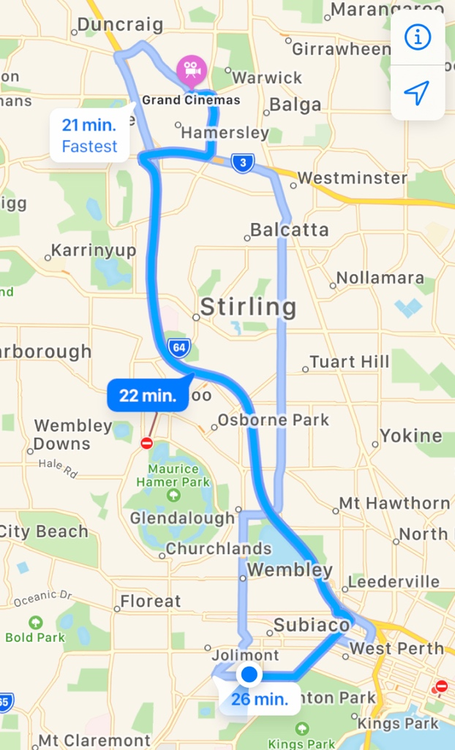  Chartered Bus from BusWest with seatbelts:  - Seats up to 57 passengers  - Bus drops at the front of Grand Cinemas  - Children are not required to cross any major roads  - Children are supervised whilst in the carpark area
Name of excursion coordinator | Ji Ni Chooi & Kiara Vivian
Contact number of excursion coordinator | (SCC MOBILE) 0413 170 223 |  | (EXCURSION NUMBER) 08 9247 7488
Number of children attending | 50 (expected) | Number of educators/parents/volunteers |  | 6/7
Educator to child ratio  1 : 10 |  | Does this excursion warrant a higher ratio?  If yes, please provide details. |  | No
EXCURSION CHECKLIST
- First Aid Kit |  | - List of adults participating in the excursion
- List of Children attending the excursion |  | - Contact information for each adult
- Contact information for each child |  | - Mobile phone/ other means of communicating with the service & emergency services
- Medical Information for each child |  | - Other items, please list

Risk Assessment
Activity | Hazard identified | Risk Assessment  (Use matrix) | Elimination / control measures |  | Who | When
Transition from centre to bus & bus to cinemas  Bus ride | Losing children  Children running across the road  Traffic incident | Low  Low  Low | - Children wear high visibility vests, roll call is done on the mat before lining up in the Centre with their partner for the bus  - Head count is then conducted by two staff  - Staff are dispersed between the line with one staff member in front and one at the back to lock the Centre after everyone leaves  - Children are escorted to the bus along the footpath out to the public footpath where the bus is to be parked in the parking along the road  - A staff member is sent up before any children to check the bus and move to the back  - Headcount then takes place with one staff member doing a headcount on children as they move into the bus  - For every 10 children the nominated staff counts, another staff member is let onto the bus to keep ratio  - Children are seated from the back of the bus to the front and children are to fasten seatbelts as they sit down which is double-checked by all staff moving throughout the bus.  - A headcount is then repeated with all staff and children on the bus and once everyone has their seatbelts fastened, the bus driver is told he/she can proceed  - Transitioning off the bus, a headcount is performed and staff from the back of the bus is let out last in order to ensure no children/ lost property remains on the bus.  - Once we have reached our excursion destination, roll call is done and staff are assigned groups in order to ensure high levels of supervision throughout the excursion.  - Charted bus fitted with seatbelts |  | All Educators | Leaving for and at excursion venue.
Popcorn and drinks at the movie  Toilet breaks and watching the movie | Allergies  Children wandering off  Stranger danger | Low  Low  Low | - All allergies are taken into consideration by parents enrolling their children  - Staff are made aware of these allergies and a qualified first aider will be on duty to assist if any reactions arise  - Staff are dispersed evenly amongst the children during the movie, with a staff member at the end of each row to ensure adequate supervision  - Children are reminded to ask a staff member if they can take them to the toilet, and the staff member will do a headcount before and after each toilet break to ensure that all their children are with them  - Staff will make sure they can see the entry and exits of the bathrooms  - Our centre’s children remain sitting until the movie is over and other patrons have left to ensure a smooth and calm exit from the venue |  | All Educators  First Aider  All educators | Throughout the movie  Throughout the movie
Plan prepared by | Rafael Banzon |  | Prepared in consultation with: | Ji Ni Chooi
Communicated to: | All staff members on duty |  | Venue and safety information reviewed and attached | Yes / No  Comment if needed:
Reminder: Monitor the effectiveness of controls and change if necessary. Review the risk assessment if an incident or significant change occurs.

INCURSION DETAILS
Date(s) of Incursion | WEDNESDAY 14/07/2021 | Departure & arrival times |  | 9:30AM – 11:30AM
Incursion destination | 160 HAMERSLEY RD, SUBIACO 6008
Proposed activities | Incursion: Bricks 4 Kidz  Bricks 4 Kidz is here to help us experience all the thrills of Angry Birds by building different birds with Lego. We will also be building airplanes, racing carts and more! |  |  | WATER HAZARDS? NO
Method of transport, including proposed route | N/A
Name of excursion coordinator | Ji Ni Chooi & Kiara Vivian
Contact number of excursion coordinator | (SCC MOBILE) 0413 170 223 |  | (INCURSION NUMBER) 0415 829 511 (Rachel Koo)
Number of children attending | 50 (expected) | Number of educators/parents/volunteers |  | 6/7
Educator to child ratio  1 : 10 |  | Does this incursion warrant a higher ratio?  If yes, please provide details. |  | No
INCURSION CHECKLIST
- First Aid Kit |  | - List of adults participating in the excursion
- List of Children attending the excursion |  | - Contact information for each adult
- Contact information for each child |  | - Mobile phone/ other means of communicating with the service & emergency services
- Medical Information for each child |  | - Other items, please list

Risk Assessment
Activity | Hazard identified | Risk Assessment  (Use matrix) | Elimination / control measures |  | Who | When
Playing with Lego bricks  Member of public entering the centre | Choking  Unknown person | Low  Low | - Children to be supervised and managed in a controlled environment where incursion personnel and educators are aware of the children’s actions  - Has been requested that incursion personnel have a working with children’s card  - Will report to supervisor to check and record their working with children’s card  - Supervisor will assess if they are in a state fit to be around children |  | All Educators  Nominated Person in Charge (Supervisor) | During the incursion  Before the incursion begins
Plan prepared by | Rafael Banzon |  | Prepared in consultation with: | Ji Ni Chooi
Communicated to: | All staff members on duty |  | Venue and safety information reviewed and attached | Yes / No  Comment if needed:
Reminder: Monitor the effectiveness of controls and change if necessary. Review the risk assessment if an incident or significant change occurs.

EXCURSION DETAILS
Date(s) of excursion | THURSDAY 15/07/2021 | Departure & arrival times |  | 9:10AM – 1PM
Excursion destination | 6 SPHINX WAY, BIBRA LAKE 6163
Proposed activities | Excursion: NINJA WEST  We are putting our ninja skills to the test today as we head to Ninja West and climb their rock climbing walls, show off our parkour on their course and have fun with their gymnastics equipment. |  |  | WATER HAZARDS? NO
Method of transport, including proposed route | 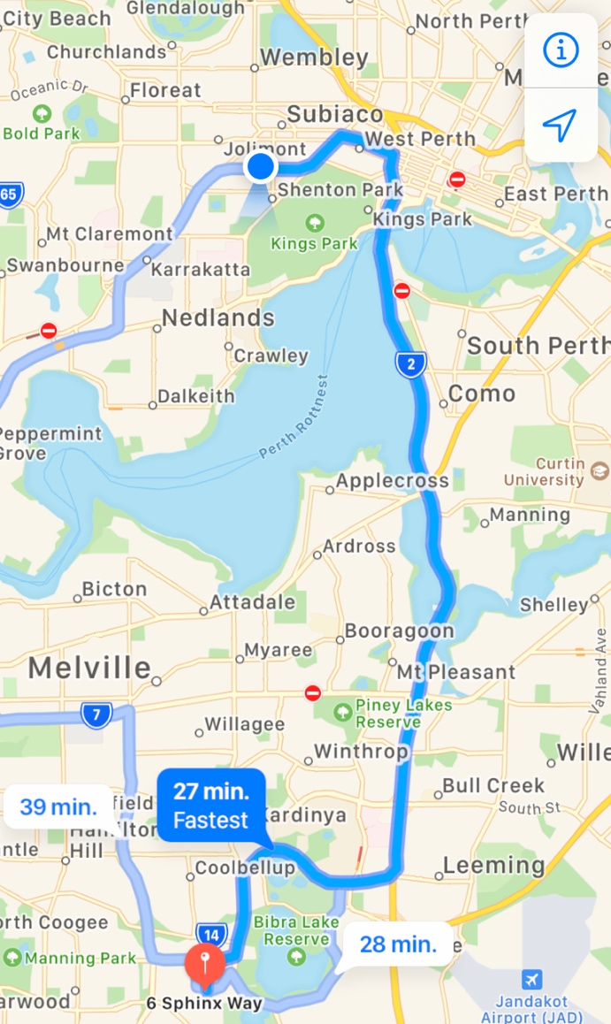  Chartered Bus from BusWest with seatbelts:  - Seats up to 57 passengers  - Bus drops at the front of Ninja West  - Children are not required to cross any major roads  - Children are supervised whilst in the carpark area
Name of excursion coordinator | Ji Ni Chooi & Kiara Vivian
Contact number of excursion coordinator | (SCC MOBILE) 0413 170 223 |  | (EXCURSION NUMBER) 08 9494 2717
Number of children attending | 50 (expected) | Number of educators/parents/volunteers |  | 6/7
Educator to child ratio  1 : 10 |  | Does this excursion warrant a higher ratio?  If yes, please provide details. |  | No
EXCURSION CHECKLIST
- First Aid Kit |  | - List of adults participating in the excursion
- List of Children attending the excursion |  | - Contact information for each adult
- Contact information for each child |  | - Mobile phone/ other means of communicating with the service & emergency services
- Medical Information for each child |  | - Other items, please list

Risk Assessment
Activity | Hazard identified | Risk Assessment  (Use matrix) | Elimination / control measures |  | Who | When
Transition from centre to bus & bus to cinemas  Bus ride | Losing children  Children running across the road  Traffic incident | Low  Low  Low | - Children wear high visibility vests, roll call is done on the mat before lining up in the Centre with their partner for the bus  - Head count is then conducted by two staff  - Staff are dispersed between the line with one staff member in front and one at the back to lock the Centre after everyone leaves  - Children are escorted to the bus along the footpath out to the public footpath where the bus is to be parked in the parking along the road  - A staff member is sent up before any children to check the bus and move to the back  - Headcount then takes place with one staff member doing a headcount on children as they move into the bus  - For every 10 children the nominated staff counts, another staff member is let onto the bus to keep ratio  - Children are seated from the back of the bus to the front and children are to fasten seatbelts as they sit down which is double-checked by all staff moving throughout the bus.  - A headcount is then repeated with all staff and children on the bus and once everyone has their seatbelts fastened, the bus driver is told he/she can proceed  - Transitioning off the bus, a headcount is performed and staff from the back of the bus is let out last in order to ensure no children/ lost property remains on the bus.  - Once we have reached our excursion destination, roll call is done and staff are assigned groups in order to ensure high levels of supervision throughout the excursion.  - Charted bus fitted with seatbelts |  | All Educators | Leaving for and at excursion venue.
Partaking in the activities at Ninja West  Toilet breaks | Injuries  Children wandering off  Stranger danger | Low  Low  Low | - Qualified first aider on duty at all times  - Staff are dispersed evenly amongst the groups of children to ensure adequate supervision (in line with ratio requirements)  - Staff are dispersed evenly amongst the groups of children to ensure adequate supervision  - Children are reminded to ask a staff member if they can take them to the toilet, and the staff member will do a headcount before and after each toilet break to ensure that all their children are with them  - Staff will make sure they can see the entry and exits of the bathrooms |  | All Educators  First Aider  All educators | Throughout the excursion  Throughout the excursion
Plan prepared by | Rafael Banzon |  | Prepared in consultation with: | Ji Ni Chooi
Communicated to: | All staff members on duty |  | Venue and safety information reviewed and attached | Yes / No  Comment if needed:
Reminder: Monitor the effectiveness of controls and change if necessary. Review the risk assessment if an incident or significant change occurs.

IN-CENTRE DETAILS
Date(s) of In-Centre Activity | FRIDAY 16/07/2021 | Departure & arrival times |  | 10AM – 1PM
In-Centre destination | 160 HAMERSLEY RD, SUBIACO 6008
Proposed activities | Incursion: Candle Making and PJ Day  Today is all about getting cosy for winter as we snuggle into our PJs and make candles to help celebrate all the comforts that winter brings! |  |  | WATER HAZARDS? NO
Method of transport, including proposed route | N/A
Name of excursion coordinator | Ji Ni Chooi & Kiara Vivian
Contact number of excursion coordinator | (SCC MOBILE) 0413 170 223 |  | (INCURSION NUMBER) N/A
Number of children attending | 50 (expected) | Number of educators/parents/volunteers |  | 6/7
Educator to child ratio  1 : 10 |  | Does this incursion warrant a higher ratio?  If yes, please provide details. |  | No
IN-CENTRE CHECKLIST
- First Aid Kit |  | - List of adults participating in the excursion
- List of Children attending the excursion |  | - Contact information for each adult
- Contact information for each child |  | - Mobile phone/ other means of communicating with the service & emergency services
- Medical Information for each child |  | - Other items, please list

Risk Assessment
Activity | Hazard identified | Risk Assessment  (Use matrix) | Elimination / control measures |  | Who | When
Making the candles  Member of public entering the centre | Improper handling of candles  Unknown person | Low  Low | - Children to be supervised and managed in a controlled environment in which educators are aware of the children’s actions regarding the candles and wax  - Has been requested that incursion personnel have a working with children’s card  - Will report to supervisor to check and record their working with children’s card  - Supervisor will assess if they are in a state fit to be around children |  | All Educators  Nominated Person in Charge (Supervisor) | During the in-centre activities  Before the in-centre activities begins
Plan prepared by | Rafael Banzon |  | Prepared in consultation with: | Ji Ni Chooi
Communicated to: | All staff members on duty |  | Venue and safety information reviewed and attached | Yes / No  Comment if needed:
Reminder: Monitor the effectiveness of controls and change if necessary. Review the risk assessment if an incident or significant change occurs.

EXCURSION DETAILS
Date(s) of excursion | MONDAY 19/07/2021 | Departure & arrival times |  | 9:20AM – 1PM
Excursion destination | WA MUSEUM, JAMES ST, PERTH 6000
Proposed activities | Excursion: WA Museum Boola Bardip  We are off to the new Boola Bardip Museum to check out their exhibitions ranging from dinosaurs to the First Peoples of Western Australia. We are sure to learn something new today! |  |  | WATER HAZARDS? NO
Method of transport, including proposed route | 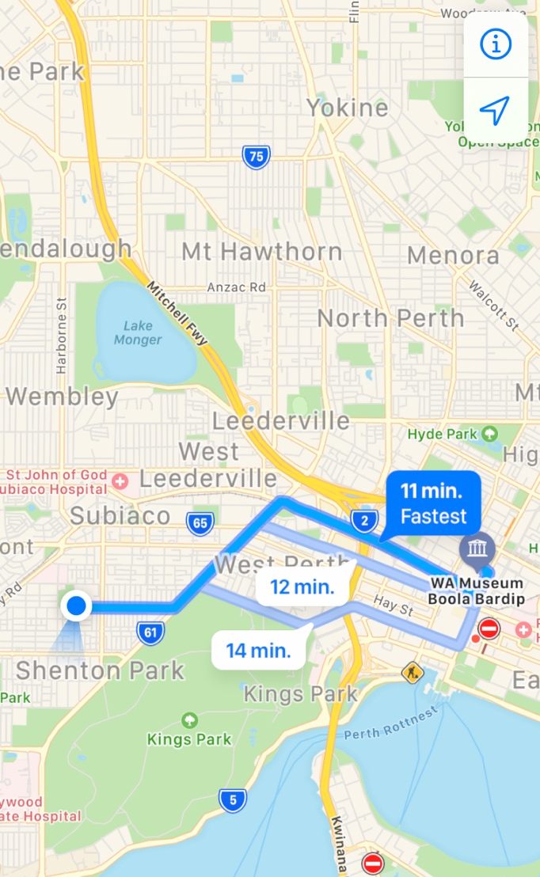  Chartered Bus from BusWest with seatbelts:  - Seats up to 57 passengers  - Bus drops at the front of the Museum  - Children are not required to cross any major roads  - Children are supervised whilst in the carpark area
Name of excursion coordinator | Ji Ni Chooi & Kiara Vivian
Contact number of excursion coordinator | (SCC MOBILE) 0413 170 223 |  | (EXCURSION NUMBER) 1300 134 081
Number of children attending | 50 (expected) | Number of educators/parents/volunteers |  | 6/7
Educator to child ratio  1 : 10 |  | Does this excursion warrant a higher ratio?  If yes, please provide details. |  | No
EXCURSION CHECKLIST
- First Aid Kit |  | - List of adults participating in the excursion
- List of Children attending the excursion |  | - Contact information for each adult
- Contact information for each child |  | - Mobile phone/ other means of communicating with the service & emergency services
- Medical Information for each child |  | - Other items, please list

Risk Assessment
Activity | Hazard identified | Risk Assessment  (Use matrix) | Elimination / control measures |  | Who | When
Transition from centre to bus & bus to cinemas  Bus ride | Losing children  Children running across the road  Traffic incident | Low  Low  Low | - Children wear high visibility vests, roll call is done on the mat before lining up in the Centre with their partner for the bus  - Head count is then conducted by two staff  - Staff are dispersed between the line with one staff member in front and one at the back to lock the Centre after everyone leaves  - Children are escorted to the bus along the footpath out to the public footpath where the bus is to be parked in the parking along the road  - A staff member is sent up before any children to check the bus and move to the back  - Headcount then takes place with one staff member doing a headcount on children as they move into the bus  - For every 10 children the nominated staff counts, another staff member is let onto the bus to keep ratio  - Children are seated from the back of the bus to the front and children are to fasten seatbelts as they sit down which is double-checked by all staff moving throughout the bus.  - A headcount is then repeated with all staff and children on the bus and once everyone has their seatbelts fastened, the bus driver is told he/she can proceed  - Transitioning off the bus, a headcount is performed and staff from the back of the bus is let out last in order to ensure no children/ lost property remains on the bus.  - Once we have reached our excursion destination, roll call is done and staff are assigned groups in order to ensure high levels of supervision throughout the excursion.  - Charted bus fitted with seatbelts |  | All Educators | Leaving for and at excursion venue.
Going through all the exhibits  Toilet breaks | Children wandering off  Children wandering off  Stranger danger | Low  Low  Low | - Staff are dispersed evenly amongst the groups of children to ensure adequate supervision (in line with ratio requirements)  - Staff are dispersed evenly amongst the groups of children to ensure adequate supervision  - Children are reminded to ask a staff member if they can take them to the toilet, and the staff member will do a headcount before and after each toilet break to ensure that all their children are with them  - Staff will make sure they can see the entry and exits of the bathrooms |  | All Educators  All educators | Throughout the excursion  Throughout the excursion
Plan prepared by | Rafael Banzon |  | Prepared in consultation with: | Ji Ni Chooi
Communicated to: | All staff members on duty |  | Venue and safety information reviewed and attached | Yes / No  Comment if needed:
Reminder: Monitor the effectiveness of controls and change if necessary. Review the risk assessment if an incident or significant change occurs.

