RISK MANAGEMENT PLAN
SEPTEMBER/OCTOBER SCHOOL HOLIDAYS 2021

IN-CENTRE DETAILS
Date(s) of excursion | TUESDAY 28/09/2021 | Departure & arrival times |  | 10AM-12PM
Excursion destination | N/A
Proposed activities | In-Centre: Optical Illusion Sand Art  To start the holidays off we are getting creative making optical illusions out of sand art to trick the common eye. |  |  | WATER HAZARDS? NO
Method of transport, including proposed route | N/A
Name of excursion coordinator | Ji Ni Chooi & Kiara Vivian
Contact number of excursion coordinator | (SCC MOBILE) 0413 170 223 |  | (INCURSION NUMBER) N/A
Number of children attending | 50 (expected) | Number of educators/parents/volunteers |  | 6/7
Educator to child ratio  1 : 10 |  | Does this excursion warrant a higher ratio?  If yes, please provide details. |  | No
EXCURSION CHECKLIST
- First Aid Kit |  | - List of adults participating in the excursion
- List of Children attending the excursion |  | - Contact information for each adult
- Contact information for each child |  | - Mobile phone/ other means of communicating with the service & emergency services
- Medical Information for each child |  | - Other items, please list

Risk Assessment
Activity | Hazard identified | Risk Assessment  (Use matrix) | Elimination / control measures |  | Who | When
Sand Art | Children injuring themselves through sand in eyes or ingesting sand | Low | - Staff are there to support and assist children if needed  - Children are divided into groups smaller groups when completing the sand art to ensure adequate supervision and staff are able to monitor interactions with the sand |  | All Educators | During Sand Art Activity
Plan prepared by | Kiara Vivian |  | Prepared in consultation with: | Ji Ni Chooi
Communicated to: | All staff members on duty |  | Venue and safety information reviewed and attached | Yes / No  Comment if needed:
Reminder: Monitor the effectiveness of controls and change if necessary. Review the risk assessment if an incident or significant change occurs.

EXCURSION DETAILS
Date(s) of excursion | WEDNESDAY 29/09/2021 | Departure & arrival times |  | 9:25AM – 1PM
Excursion destination | Revolution Sports, 37 Lemnos St Shenton Park WA 6008
Proposed activities | Excursion: Inflatable World  We are headed to inflatable world a massive inflatable indoor playground where children can play participate in activities like devils drop, slam dunking, velcro wall, sliding and battling in the gladiator arena. NO SOCKS – NO PLAY. |  |  | WATER HAZARDS? NO
Method of transport, including proposed route | 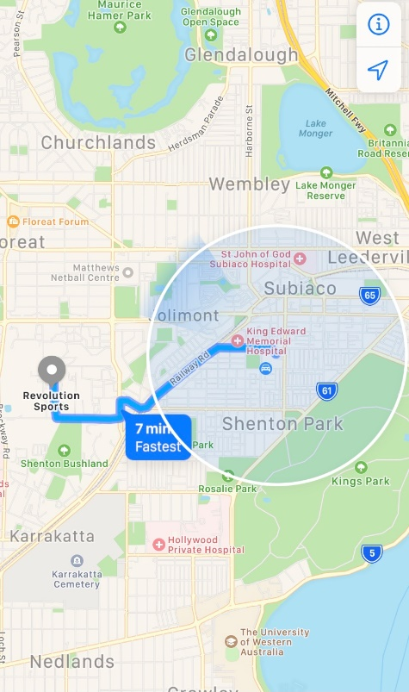  Chartered Bus from BusWest with seatbelts:  - Seats up to 57 passengers  - Bus drops at the front of Revolution sports  - Children are not required to cross any roads  - Children are supervised whilst in the carpark
Name of excursion coordinator | Ji Ni Chooi & Kiara Vivian
Contact number of excursion coordinator | (SCC MOBILE) 0413 170 223 |  | (EXCURSION NUMBER) 08 9388 3430
Number of children attending | 50 (expected) | Number of educators/parents/volunteers |  | 6
Educator to child ratio  1 : 10 |  | Does this excursion warrant a higher ratio?  If yes, please provide details. |  | No
EXCURSION CHECKLIST
- First Aid Kit |  | - List of adults participating in the excursion
- List of Children attending the excursion |  | - Contact information for each adult
- Contact information for each child |  | - Mobile phone/ other means of communicating with the service & emergency services
- Medical Information for each child |  | - Other items, please list

Risk Assessment
Activity | Hazard identified | Risk Assessment  (Use matrix) | Elimination / control measures |  | Who | When
Inflatable Playground | Children leaving  Children injuring themselves | Low  Low | - Playground is fenced, with one entry point to which a staff member will be placed  - Staff will have stations within the playground and at least 1 roaming to optimize vision points and will rotate.  - Children are to be reminded of safe play before leaving for excursion  - Staff will guide children to play safely whilst at the playground  - Playground is inflatable so soft surfaces  - Majority of staff are first aid trained and able to treat if needed |  | All Educators | Leaving for and at excursion venue.
Transition from Centre to bus & bus to Revolution Sports  Bus ride | Losing children  Children running across the road  Traffic Incident | Low  Low  Low | - Children wear high visibility vests, roll call is done on the mat before lining up in the Centre with their partner for the bus  - Head count is then conducted by two staff  - Staff are dispersed between the line with one staff member in front and one at the back to lock the Centre after everyone leaves  - Children are escorted to the bus along the footpath out to the public footpath where the bus is to be parked in the parking along the road  - A staff member is sent up before any children to check the bus and move to the back  - Headcount then takes place with one staff member doing a headcount on children as they move into the bus  - For every 10 children the nominated staff counts, another staff member is let onto the bus to keep ratio  - Children are seated from the back of the bus to the front and children are to fasten seatbelts as they sit down which is double-checked by all staff moving throughout the bus.  - A headcount is then repeated with all staff and children on the bus and once everyone has their seatbelts fastened, the bus driver is told he/she can proceed  - Transitioning off the bus, a headcount is performed and staff from the back of the bus is let out last in order to ensure no children/ lost property remains on the bus.  - Once we have reached our excursion destination, roll call is done and staff are assigned groups in order to ensure high levels of supervision throughout the excursion.  - Charted bus fitted with seatbelts |  | All Educators | Entering and leaving the bus.
Plan prepared by | Kiara Vivian |  | Prepared in consultation with: | Ji Ni Chooi
Communicated to: | All staff members on duty |  | Venue and safety information reviewed and attached | Yes / No  Comment if needed:
Reminder: Monitor the effectiveness of controls and change if necessary. Review the risk assessment if an incident or significant change occurs.

EXCURSION DETAILS
Date(s) of excursion | THURSDAY 30/09/2021 |  | Departure & arrival times |  |  | 9:15AM – 12:30AM
Excursion destination |  | GRAND CINEMAS, 639 BEACH RD, WARWICK 6024
Proposed activities |  | Excursion: Grand Cinemas – Boss Baby 2  Come with us as we are off to watch the sequel to the Boss Baby comedy about a baby secret agent and a new boss baby with a cutting-edge approach serve to bring together two estranged brothers and inspire a new family business. |  |  |  |  | WATER HAZARDS? NO
Method of transport, including proposed route |  | 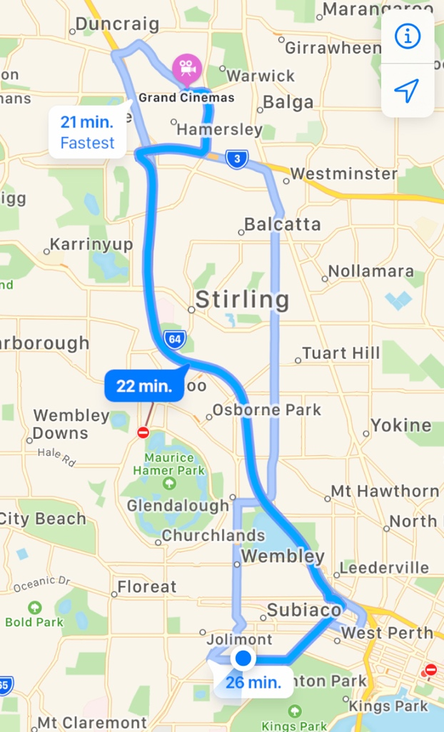  Chartered Bus from BusWest with seatbelts:  - Seats up to 57 passengers  - Bus drops at the front of Grand Cinemas  - Children are not required to cross any major roads  - Children are supervised whilst in the carpark area
Name of excursion coordinator |  | Ji Ni Chooi & Kiara Vivian
Contact number of excursion coordinator |  | (SCC MOBILE) 0413 170 223 |  |  | (EXCURSION NUMBER) 08 9247 7488
Number of children attending |  | 50 (expected) |  | Number of educators/parents/volunteers |  |  | 6
Educator to child ratio  1 : 10 |  |  |  | Does this excursion warrant a higher ratio?  If yes, please provide details. |  |  | No
EXCURSION CHECKLIST
- First Aid Kit |  |  |  | - List of adults participating in the excursion
- List of Children attending the excursion |  |  |  | - Contact information for each adult
- Contact information for each child |  |  |  | - Mobile phone/ other means of communicating with the service & emergency services
- Medical Information for each child |  |  |  | - Other items, please list

Risk Assessment
Activity | Hazard identified | Risk Assessment  (Use matrix) | Elimination / control measures |  | Who | When
Transition from centre to bus & bus to cinemas  Bus ride | Losing children  Children running across the road  Traffic incident | Low  Low  Low | - Children wear high visibility vests, roll call is done on the mat before lining up in the Centre with their partner for the bus  - Head count is then conducted by two staff  - Staff are dispersed between the line with one staff member in front and one at the back to lock the Centre after everyone leaves  - Children are escorted to the bus along the footpath out to the public footpath where the bus is to be parked in the parking along the road  - A staff member is sent up before any children to check the bus and move to the back  - Headcount then takes place with one staff member doing a headcount on children as they move into the bus  - For every 10 children the nominated staff counts, another staff member is let onto the bus to keep ratio  - Children are seated from the back of the bus to the front and children are to fasten seatbelts as they sit down which is double-checked by all staff moving throughout the bus.  - A headcount is then repeated with all staff and children on the bus and once everyone has their seatbelts fastened, the bus driver is told he/she can proceed  - Transitioning off the bus, a headcount is performed and staff from the back of the bus is let out last in order to ensure no children/ lost property remains on the bus.  - Once we have reached our excursion destination, roll call is done and staff are assigned groups in order to ensure high levels of supervision throughout the excursion.  - Charted bus fitted with seatbelts |  | All Educators | Leaving for and at excursion venue.
Popcorn and drinks at the movie  Toilet breaks and watching the movie | Allergies  Children wandering off  Stranger danger | Low  Low  Low | - All allergies are taken into consideration by parents enrolling their children  - Staff are made aware of these allergies and a qualified first aider will be on duty to assist if any reactions arise  - Staff are dispersed evenly amongst the children during the movie, with a staff member at the end of each row to ensure adequate supervision  - Children are reminded to ask a staff member if they can take them to the toilet, and the staff member will do a headcount before and after each toilet break to ensure that all their children are with them  - Staff will make sure they can see the entry and exits of the bathrooms  - Our centre’s children remain sitting until the movie is over and other patrons have left to ensure a smooth and calm exit from the venue |  | All Educators  First Aider  All educators | Throughout the movie  Throughout the movie
Plan prepared by | Kiara Vivian |  | Prepared in consultation with: | Ji Ni Chooi
Communicated to: | All staff members on duty |  | Venue and safety information reviewed and attached | Yes / No  Comment if needed:
Reminder: Monitor the effectiveness of controls and change if necessary. Review the risk assessment if an incident or significant change occurs.

INCURSION DETAILS
Date(s) of excursion | FRIDAY 01/10/2021 | Departure & arrival times |  | 10AM – 12PM
Excursion destination | N/A
Proposed activities | Incursion: Bob ‘Till You Drop Trivia Game Show  Today Bob 'Till You Drop is here to run a trivia game show with us complete with a spinning wheel, buzzers and minute to win it challenges! We will be putting out skills and knowledge to the test today in our very own Subiaco Children's game show. |  |  | WATER HAZARDS? NO
Method of transport, including proposed route | N/A
Name of excursion coordinator | Ji Ni Chooi & Kiara Vivian
Contact number of excursion coordinator | (SCC MOBILE) 0413 170 223 |  | (INCURSION NUMBER) 1300 13 03 13
Number of children attending | 50 (expected) | Number of educators/parents/volunteers |  | 6/7
Educator to child ratio  1 : 10 |  | Does this excursion warrant a higher ratio?  If yes, please provide details. |  | No
EXCURSION CHECKLIST
- First Aid Kit |  | - List of adults participating in the excursion
- List of Children attending the excursion |  | - Contact information for each adult
- Contact information for each child |  | - Mobile phone/ other means of communicating with the service & emergency services
- Medical Information for each child |  | - Other items, please list

Risk Assessment
Activity | Hazard identified | Risk Assessment  (Use matrix) | Elimination / control measures |  | Who | When
Member of public entering the centre | Unknown person | Low | - Has been requested that incursion personnel have a working with children’s card  - Will report to supervisor to check and record their working with children’s card  - Supervisor will assess if they are in a state fit to be around children |  | Nominated Person in Charge (Supervisor) | Before the incursion begins
Plan prepared by | Kiara Vivian |  | Prepared in consultation with: | Ji Ni Chooi
Communicated to: | All staff members on duty |  | Venue and safety information reviewed and attached | Yes / No  Comment if needed:
Reminder: Monitor the effectiveness of controls and change if necessary. Review the risk assessment if an incident or significant change occurs.

IN-CENTRE DETAILS
Date(s) of excursion | MONDAY 04/10/2021 | Departure & arrival times |  | 10AM – 2PM
Excursion destination | N/A
Proposed activities | In-Centre: Mad Hatters Tea Party  Don’t be late for this very important date! We are having a mad hatter’s tea party, baking treats and playing croquet and other fun new lawn games. We will also be making some Alice in Wonderland themed crafts. |  |  | WATER HAZARDS? NO
Method of transport, including proposed route | N/A
Name of excursion coordinator | Ji Ni Chooi & Kiara Vivian
Contact number of excursion coordinator | (SCC MOBILE) 0413 170 223 |  | (INCURSION NUMBER)
Number of children attending | 50 (expected) | Number of educators/parents/volunteers |  | 6/7
Educator to child ratio  1 : 10 |  | Does this excursion warrant a higher ratio?  If yes, please provide details. |  | No
EXCURSION CHECKLIST
- First Aid Kit |  | - List of adults participating in the excursion
- List of Children attending the excursion |  | - Contact information for each adult
- Contact information for each child |  | - Mobile phone/ other means of communicating with the service & emergency services
- Medical Information for each child |  | - Other items, please list

Risk Assessment
Activity | Hazard identified | Risk Assessment  (Use matrix) | Elimination / control measures |  | Who | When
Croquet/Lawn Games | Sun Exposure | Medium | - Children are to not spend more than 45 minutes in the sun at one given time  - Children will be rotated through the outdoor games and inside to limit prolonged sun exposure  - Children will be provided sunscreen  - Children are expected to wear hats at all times whilst in the sun  - Sun safe clothing is suggested |  | All Staff | During Activity
Plan prepared by | Kiara Vivian |  | Prepared in consultation with: | Ji Ni Chooi
Communicated to: | All staff members on duty |  | Venue and safety information reviewed and attached | Yes / No  Comment if needed:
Reminder: Monitor the effectiveness of controls and change if necessary. Review the risk assessment if an incident or significant change occurs.

EXCURSION DETAILS
Date(s) of excursion | TUESDAY 05/10/2021 | Departure & arrival times |  | 9.25AM – 12:30PM
Excursion destination | City West centre, Corner Railway Street & Sutherland Street, Perth WA 6005
Proposed activities | Excursion: Scitech  We are off to Scitech today to watch the stars in their planetarium and explore all the weird and wonderful sides of science. |  |  | WATER HAZARDS? NO
Method of transport, including proposed route | 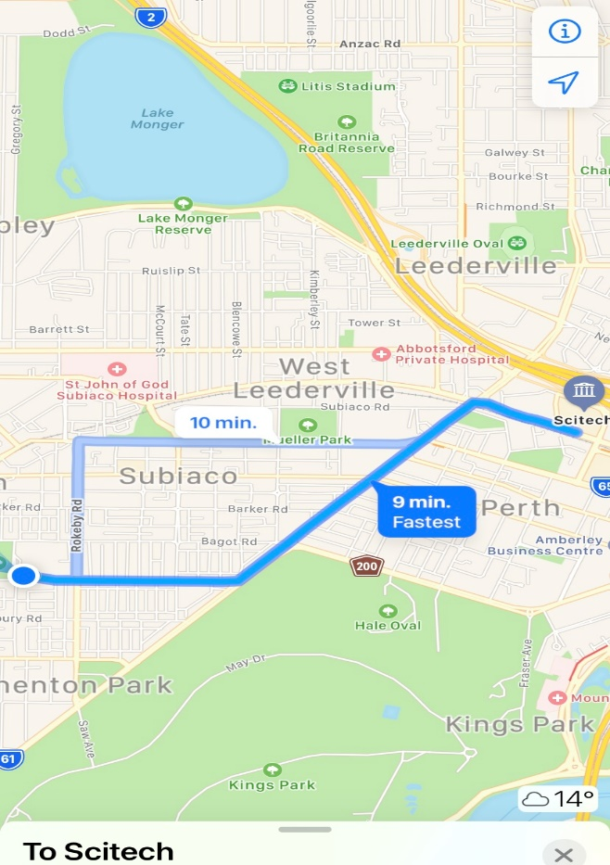  Chartered Bus from BusWest with seatbelts:  - Seats up to 57 passengers  - Bus drops at the front of Revolution sports  - Children are not required to cross any roads  - Children are supervised whilst in the carpark
Name of excursion coordinator | Ji Ni Chooi & Kiara Vivian
Contact number of excursion coordinator | (SCC MOBILE) 0413 170 223 |  | (EXCURSION NUMBER) 9215 0700
Number of children attending | 50 (expected) | Number of educators/parents/volunteers |  | 6/7
Educator to child ratio  1 : 10 |  | Does this excursion warrant a higher ratio?  If yes, please provide details. |  | No
EXCURSION CHECKLIST
- First Aid Kit |  | - List of adults participating in the excursion
- List of Children attending the excursion |  | - Contact information for each adult
- Contact information for each child |  | - Mobile phone/ other means of communicating with the service & emergency services
- Medical Information for each child |  | - Other items, please list

Risk Assessment
Activity | Hazard identified | Risk Assessment  (Use matrix) | Elimination / control measures |  | Who | When
Going through all the exhibits  Toilet breaks | Children wandering off  Children wandering off/  Stranger danger | Low  Low | - Staff are dispersed evenly amongst the groups of children to ensure adequate supervision (in line with ratio requirements)  - Staff are dispersed evenly amongst the groups of children to ensure adequate supervision  - Children are reminded to ask a staff member if they can take them to the toilet, and the staff member will do a headcount before and after each toilet break to ensure that all their children are with them  - Staff will make sure they can see the entry and exits of the bathrooms |  | All Educators  All educators | Throughout the excursion  Throughout the excursion
Transition from Centre to bus & bus to Scitech  Bus ride | Losing children  Children running across the road  Traffic Incident | Low  Low  Low | - Children wear high visibility vests, roll call is done on the mat before lining up in the Centre with their partner for the bus  - Head count is then conducted by two staff  - Staff are dispersed between the line with one staff member in front and one at the back to lock the Centre after everyone leaves  - Children are escorted to the bus along the footpath out to the public footpath where the bus is to be parked in the parking along the road  - A staff member is sent up before any children to check the bus and move to the back  - Headcount then takes place with one staff member doing a headcount on children as they move into the bus  - For every 10 children the nominated staff counts, another staff member is let onto the bus to keep ratio  - Children are seated from the back of the bus to the front and children are to fasten seatbelts as they sit down which is double-checked by all staff moving throughout the bus.  - A headcount is then repeated with all staff and children on the bus and once everyone has their  - Transitioning off the bus, a headcount is performed and staff from the back of the bus is let out last in order to ensure no children/ lost property remains on the bus.  - Once we have reached our excursion destination, roll call is done and staff are assigned groups in order to ensure high levels of supervision throughout the excursion.  - Charted bus fitted with seatbels |  | All Educators | Entering, leaving and whilst on bus
Plan prepared by | Kiara Vivian |  | Prepared in consultation with: | Ji Ni Chooi
Communicated to: | All staff members on duty |  | Venue and safety information reviewed and attached | Yes / No  Comment if needed:
Reminder: Monitor the effectiveness of controls and change if necessary. Review the risk assessment if an incident or significant change occurs.

EXCURSION DETAILS
Date(s) of Incursion | WEDNESDAY 06/10/2021 | Departure & arrival times |  | 10AM – 12PM
Incursion destination | Progress Drive, Just South of Hope Road, Bibra Lake WA 6163
Proposed activities | Excursion: Bibra Lake Playgrond  The Bibra Lake regional playground has something for everyone, from a double flying fox to water squirting bulrushes and giant talking rocks telling local Nyungar stories |  |  | WATER HAZARDS? YES
Method of transport, including proposed route | Chartered Bus from BusWest with seatbelts:  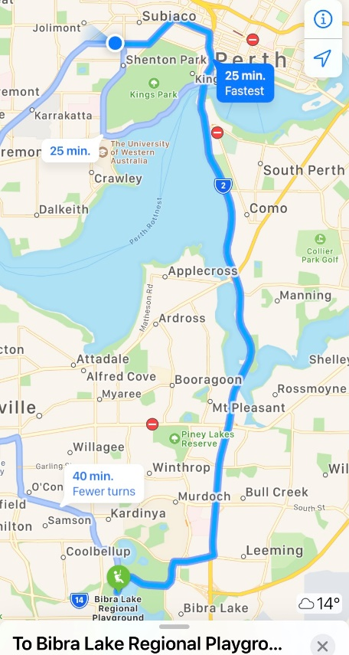  - Seats up to 57 passengers  - Bus drops at the front of Revolution sports  - Children are not required to cross any roads  - Children are supervised whilst in the carpark
Name of excursion coordinator | Ji Ni Chooi & Kiara Vivian
Contact number of excursion coordinator | (SCC MOBILE) 0413 170 223 |  | (EXCURSION NUMBER) N/A
Number of children attending | 50 (expected) | Number of educators/parents/volunteers |  | 6/7
Educator to child ratio  1 : 10 |  | Does this incursion warrant a higher ratio?  If yes, please provide details. |  | No
INCURSION CHECKLIST
- First Aid Kit |  | - List of adults participating in the excursion
- List of Children attending the excursion |  | - Contact information for each adult
- Contact information for each child |  | - Mobile phone/ other means of communicating with the service & emergency services
- Medical Information for each child |  | - Other items, please list

Risk Assessment
Activity | Hazard identified | Risk Assessment  (Use matrix) | Elimination / control measures |  | Who | When
Free play & Toilet Breaks | Stranger danger  Children get lost  Injury | Low  Low  Low | - Florescent coloured vests for easy visibility of children under our care  - Children are escorted by staff member and in groups to toilets in order to avoid children being alone and in risk of danger  - Staff will be allocated areas and rotate keeping an eye on all exists to ensure all children stay within the boundaries  - Children are closely supervised throughout their play and if an injury occurs, we have a first aider on duty and first aid kit, contact list and emergency contacts on hand at all times |  | All staff  By qualified staff | At all times during this excursion  At all times during this activity
Transition from centre to bus & bus to cinemas  Bus ride | Losing children  Children running across the road  Traffic incident | Low  Low  Low | - Children wear high visibility vests, roll call is done on the mat before lining up in the Centre with their partner for the bus  - Head count is then conducted by two staff  - Staff are dispersed between the line with one staff member in front and one at the back to lock the Centre after everyone leaves  - Children are escorted to the bus along the footpath out to the public footpath where the bus is to be parked in the parking along the road  - A staff member is sent up before any children to check the bus and move to the back  - Headcount then takes place with one staff member doing a headcount on children as they move into the bus  - For every 10 children the nominated staff counts, another staff member is let onto the bus to keep ratio  - Children are seated from the back of the bus to the front and children are to fasten seatbelts as they sit down which is double-checked by all staff moving throughout the bus.  - A headcount is then repeated with all staff and children on the bus and once everyone has their seatbelts fastened, the bus driver is told he/she can proceed  - Transitioning off the bus, a headcount is performed and staff from the back of the bus is let out last in order to ensure no children/ lost property remains on the bus.  - Once we have reached our excursion destination, roll call is done and staff are assigned groups in order to ensure high levels of supervision throughout the excursion.  - Charted bus fitted with seatbelts |  | All Educators | Leaving for and at excursion venue.
Plan prepared by | Kiara Vivian |  | Prepared in consultation with: | Ji Ni Chooi
Communicated to: | All staff members on duty |  | Venue and safety information reviewed and attached | Yes / No  Comment if needed:
Reminder: Monitor the effectiveness of controls and change if necessary. Review the risk assessment if an incident or significant change occurs.

INCURSION DETAILS
Date(s) of excursion | THURSDAY 07/10/2021 | Departure & arrival times |  | 10AM – 12PM
Excursion destination | N/A
Proposed activities | Incursion- Dino World  Travel back to a prehistoric error and learn all about dinosaurs as you see real and replica fossils along with posters, pictures and life size elements of dinosaurs, if you are lucky a life size T-rex might even drop by! |  |  | WATER HAZARDS? NO
Method of transport, including proposed route | N/A
Name of excursion coordinator | Ji Ni Chooi & Kiara Vivian
Contact number of excursion coordinator | (SCC MOBILE) 0413 170 223 |  | (INCURSION NUMBER) 0473 737 605
Number of children attending | 50 (expected) | Number of educators/parents/volunteers |  | 6/7
Educator to child ratio  1 : 10 |  | Does this excursion warrant a higher ratio?  If yes, please provide details. |  | No
EXCURSION CHECKLIST
- First Aid Kit |  | - List of adults participating in the excursion
- List of Children attending the excursion |  | - Contact information for each adult
- Contact information for each child |  | - Mobile phone/ other means of communicating with the service & emergency services
- Medical Information for each child |  | - Other items, please list

Risk Assessment
Activity | Hazard identified | Risk Assessment  (Use matrix) | Elimination / control measures |  | Who | When
Member of public entering the centre | Unknown person | Low | - Has been requested that incursion personnel have a working with children’s card  - Will report to supervisor to check and record their working with children’s card  - Supervisor will assess if they are in a state fit to be around children |  | Nominated Person in Charge (Supervisor) | Before the incursion begins
Plan prepared by | Kiara Vivian |  | Prepared in consultation with: | Ji Ni Chooi
Communicated to: | All staff members on duty |  | Venue and safety information reviewed and attached | Yes / No  Comment if needed:
Reminder: Monitor the effectiveness of controls and change if necessary. Review the risk assessment if an incident or significant change occurs.

EXCURSION DETAILS
Date(s) of Incursion | FRIDAY 08/10/2021 | Departure & arrival times |  | 9:15AM – 1PM
Excursion destination | 95 Catherine Street, Morley Western Australia 6062
Proposed activities | Excursion: Morley Rollerdrome  Today we are rolling un over to Morley Rollerdrome to show of our roller-skating skills retro style! |  |  | WATER HAZARDS? NO
Method of transport, including proposed route | Chartered Bus from BusWest with seatbelts:  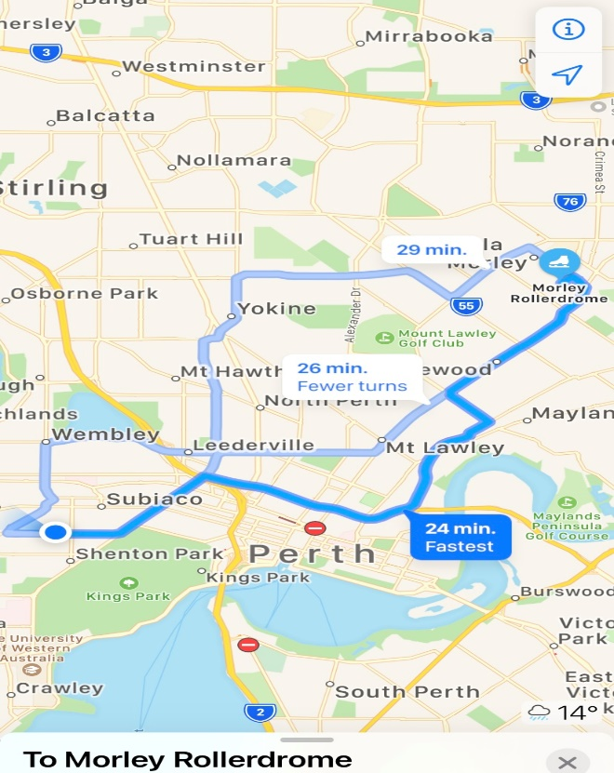  - Seats up to 57 passengers  - Bus drops at the front of Ninja West  - Children are not required to cross any major roads  - Children are supervised whilst in the carpark area
Name of excursion coordinator | Ji Ni Chooi & Kiara Vivian
Contact number of excursion coordinator | (SCC MOBILE) 0413 170 223 |  | (INCURSION NUMBER) 9276 9870
Number of children attending | 50 (expected) | Number of educators/parents/volunteers |  | 6/7
Educator to child ratio  1 : 10 |  | Does this incursion warrant a higher ratio?  If yes, please provide details. |  | No
INCURSION CHECKLIST
- First Aid Kit |  | - List of adults participating in the excursion
- List of Children attending the excursion |  | - Contact information for each adult
- Contact information for each child |  | - Mobile phone/ other means of communicating with the service & emergency services
- Medical Information for each child |  | - Other items, please list

Risk Assessment
Activity | Hazard identified | Risk Assessment  (Use matrix) | Elimination / control measures |  | Who | When
Roller Skating | Tripping | Medium | - Staff will be on the roller rink in flat shoes to assist children with support  - Children are encouraged to go at their own pace and hold onto rails if needed  - First Aid kit on hand in the event of an incident and the majority of staff are first-aid trained  - Children will be encouraged to distance and make sure they have personal space when skating to avoid dragging others down if they fall |  | All Educators | During Excursion
Transition from centre to bus & bus to cinemas  Bus ride | Losing children  Children running across the road  Traffic incident | Low  Low  Low | - Children wear high visibility vests, roll call is done on the mat before lining up in the Centre with their partner for the bus  - Head count is then conducted by two staff  - Staff are dispersed between the line with one staff member in front and one at the back to lock the Centre after everyone leaves  - Children are escorted to the bus along the footpath out to the public footpath where the bus is to be parked in the parking along the road  - A staff member is sent up before any children to check the bus and move to the back  - Headcount then takes place with one staff member doing a headcount on children as they move into the bus  - For every 10 children the nominated staff counts, another staff member is let onto the bus to keep ratio  - Children are seated from the back of the bus to the front and children are to fasten seatbelts as they sit down which is double-checked by all staff moving throughout the bus.  - A headcount is then repeated with all staff and children on the bus and once everyone has their seatbelts fastened, the bus driver is told he/she can proceed  - Transitioning off the bus, a headcount is performed and staff from the back of the bus is let out last in order to ensure no children/ lost property remains on the bus.  - Once we have reached our excursion destination, roll call is done and staff are assigned groups in order to ensure high levels of supervision throughout the excursion.  - Charted bus fitted with seatbelts |  | All Educators | Leaving for and at excursion venue.
Plan prepared by | Kiara Vivian |  | Prepared in consultation with: | Ji Ni Chooi
Communicated to: | All staff members on duty |  | Venue and safety information reviewed and attached | Yes / No  Comment if needed:
Reminder: Monitor the effectiveness of controls and change if necessary. Review the risk assessment if an incident or significant change occurs.

IN-CENTRE DETAILS
Date(s) of excursion | MONDAY 11/10/2021 | Departure & arrival times |  | 10AM – 2PM
Excursion destination | N/A
Proposed activities | In-Centre: Making Monsters  Today is the last day of holidays and we are staying at the centre to model our own crazy monsters out of air dry clay and then painting them to bring them to life |  |  | WATER HAZARDS? NO
Method of transport, including proposed route | N/A
Name of excursion coordinator | Ji Ni Chooi & Kiara Vivian
Contact number of excursion coordinator | (SCC MOBILE) 0413 170 223 |  | (INCURSION NUMBER) N/A
Number of children attending | 50 (expected) | Number of educators/parents/volunteers |  | 6/7
Educator to child ratio  1 : 10 |  | Does this excursion warrant a higher ratio?  If yes, please provide details. |  | No
EXCURSION CHECKLIST
- First Aid Kit |  | - List of adults participating in the excursion
- List of Children attending the excursion |  | - Contact information for each adult
- Contact information for each child |  | - Mobile phone/ other means of communicating with the service & emergency services
- Medical Information for each child |  | - Other items, please list

Risk Assessment
Activity | Hazard identified | Risk Assessment  (Use matrix) | Elimination / control measures |  | Who | When
Modelling Monsters | Overcrowding | Low | - Congestion may cause children to become frustrated with each other so this activity will be spread out and taken with smaller groups at a time  - Modelling of the monster is to be done in the morning with painting in the afternoon after lunch |  | Educators | During Activity
Plan prepared by | Rafael Banzon |  | Prepared in consultation with: | Ji Ni Chooi
Communicated to: | All staff members on duty |  | Venue and safety information reviewed and attached | Yes / No  Comment if needed:
Reminder: Monitor the effectiveness of controls and change if necessary. Review the risk assessment if an incident or significant change occurs.

