RISK MANAGEMENT PLAN
DECEMBER/JANUARY SCHOOL HOLIDAYS 2021
INCURSION DETAILS
Date(s) of incursion | FRIDAY 17/12/2021 | Departure & arrival times |  | 10AM - 2PM
Excursion destination | N/A
Proposed activities | In-Centre: Christmas Stockings  Today we are starting off the holiday season by hand sewing our own foam Christmas stockings and decorating them in holiday spirit. |  |  | WATER HAZARDS? NO
Method of transport, including proposed route | N/A
Name of excursion coordinator | Ji Ni Chooi & Kiara Vivian
Contact number of excursion coordinator | (SCC MOBILE) 0413 170 223 |  | (INCURSION NUMBER) N/A
Number of children attending | 50 (expected) | Number of educators/parents/volunteers |  | 6/7
Educator to child ratio  1 : 10 |  | Does this excursion warrant a higher ratio?  If yes, please provide details. |  | No
EXCURSION CHECKLIST
- First Aid Kit |  | - List of adults participating in the excursion
- List of Children attending the excursion |  | - Contact information for each adult
- Contact information for each child |  | - Mobile phone/ other means of communicating with the service & emergency services
- Medical Information for each child |  | - Other items, please list

Risk Assessment
Activity | Hazard identified | Risk Assessment  (Use matrix) | Elimination / control measures |  | Who | When
Christmas Stocking Making/Sewing | Children injuring themselves during the craft | Low | - Staff are there to support and assist children if needed  - risk of injury is low due to thick plastic needles  - Children are divided into groups smaller groups when completing the craft to ensure adequate supervision and staff can monitor interactions |  | All Educators | During Stocking Making Activity
Plan prepared by | Isabella Biundo |  | Prepared in consultation with: | Ji Ni Chooi
Communicated to: | All staff members on duty |  | Venue and safety information reviewed and attached | Yes / No  Comment if needed:
Reminder: Monitor the effectiveness of controls and change if necessary. Review the risk assessment if an incident or significant change occurs.

EXCURSION DETAILS
Date(s) of excursion | MONDAY 20/12/2021 | Departure & arrival times |  | 9:30AM – 1:30PM
Excursion destination | Herdsman Lake Discovery Centre, Corner of Flynn and Selby Streets, Wembley WA 6018
Proposed activities | Excursion: Herdsman Lake Excursion  We are off to Noogenboro (Herdsman Lake) to learn about the ecological footprint of the traditional owners of the land. We will learn about bush medicine, artefacts, tool making and traditional shelters. |  |  | WATER HAZARDS? YES
Method of transport, including proposed route | Chartered Bus from BusWest with seatbelts:  - Seats up to 57 passengers  - Bus drops at the Discovery Centre  - Children are not required to cross any roads  - Children are supervised whilst in the carpark  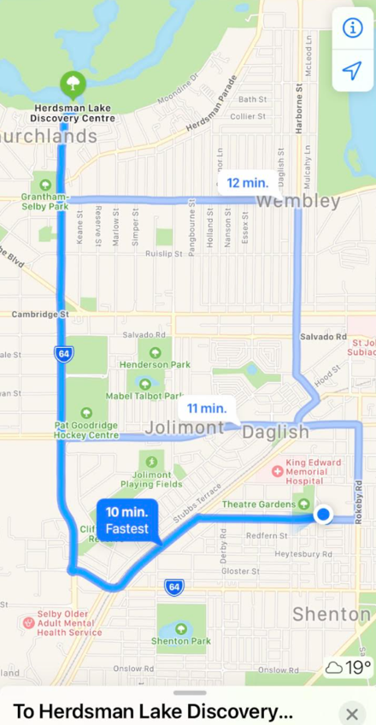
Name of excursion coordinator | Ji Ni Chooi & Kiara Vivian
Contact number of excursion coordinator | (SCC MOBILE) 0413 170 223 |  | (EXCURSION NUMBER) (08) 9387 6079
Number of children attending | 50 (expected) | Number of educators/parents/volunteers |  | 6/7
Educator to child ratio  1 : 10 |  | Does this excursion warrant a higher ratio?  If yes, please provide details. |  | No
EXCURSION CHECKLIST
- First Aid Kit |  | - List of adults participating in the excursion
- List of Children attending the excursion |  | - Contact information for each adult
- Contact information for each child |  | - Mobile phone/ other means of communicating with the service & emergency services
- Medical Information for each child |  | - Other items, please list

Risk Assessment
Activity | Hazard identified | Risk Assessment  (Use matrix) | Elimination / control measures |  | Who | When
Tour around facilities | Children leaving  Children injuring themselves  Water Hazards  Heat Stroke | Low  Low  Low  Low | - The children will be split into smaller groups for greater supervision.  - Children are to be reminded of safe play before leaving for excursion  - Children will be wearing high vis bibs to increase their visibility  - Majority of staff are first aid trained and able to treat if needed  - Children will be kept away from the edge of the lake and reminded that the lake is out of bounds.  - Majority of educators have their Aquatic Rescue Qualifications and First Aid  - Children will have brought their own water bottles or will have water provided to them if they have not brought them. Children will be kept out of direct sunlight during the middle of the day as much as reasonably possible, and will wear sun protective wear (e.g. hats, sunscreen). |  | All Educators | Leaving for and at excursion venue.
Transition from Centre to bus & bus to Revolution Sports  Bus ride | Losing children  Children running across the road  Traffic Incident | Low  Low  Low | - Children wear high visibility vests, roll call is done on the mat before lining up in the Centre with their partner for the bus  - Head count is then conducted by two staff  - Staff are dispersed between the line with one staff member in front and one at the back to lock the Centre after everyone leaves  - Children are escorted to the bus along the footpath out to the public footpath where the bus is to be parked in the parking along the road  - A staff member is sent up before any children to check the bus and move to the back  - Headcount then takes place with one staff member doing a headcount on children as they move into the bus  - For every 10 children the nominated staff counts, another staff member is let onto the bus to keep supervision ratio  - Children are seated from the back of the bus to the front and children are to fasten seatbelts as they sit down which is double-checked by all staff moving throughout the bus.  - A headcount is then repeated with all staff and children on the bus and once everyone has their seatbelts fastened, the bus driver is told he/she can proceed  - Transitioning off the bus, a headcount is performed and staff from the back of the bus is let out last to ensure no children/ lost property remains on the bus.  - Once we have reached our excursion destination, roll call is done and staff are assigned groups to ensure high levels of supervision throughout the excursion.  - Charted bus fitted with seatbelts |  | All Educators | Entering and leaving the bus.
Plan prepared by | Isabella Biundo |  | Prepared in consultation with: | Ji Ni Chooi
Communicated to: | All staff members on duty |  | Venue and safety information reviewed and attached | Yes / No  Comment if needed:
Reminder: Monitor the effectiveness of controls and change if necessary. Review the risk assessment if an incident or significant change occurs.

EXCURSION DETAILS
Date(s) of excursion | TUESDAY 21/12/2021 |  | Departure & arrival times |  |  | 9AM – 1:30AM
Excursion destination |  | Newhaven Robot Park, Cnr of Mason Road & Doryanthes Avenue Piara Waters WA 6112
Proposed activities |  | Excursion: Robot Park Excursion  Featuring a Flying fox, climbing walls, balance beams, water play, basketball court and huge grass area today's trip to the Newhaven Robot Park will be a fantastic chance to run off steam with some friends. |  |  |  |  | WATER HAZARDS? NO
Method of transport, including proposed route |  | Chartered Bus from BusWest with seatbelts:  - Seats up to 57 passengers  - Bus drops at the front of Robot Park  - Children are not required to cross any major roads  - Children are supervised whilst in the carpark area  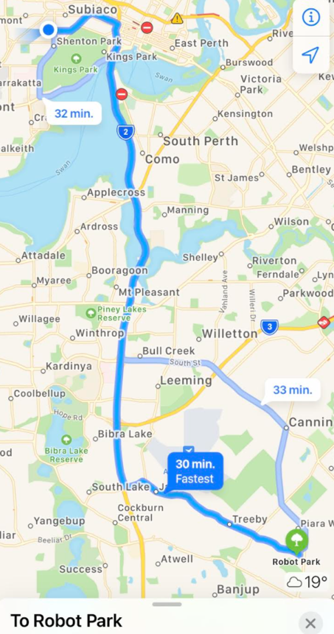
Name of excursion coordinator |  | Ji Ni Chooi & Kiara Vivian
Contact number of excursion coordinator |  | (SCC MOBILE) 0413 170 223 |  |  | (EXCURSION NUMBER) (08) 9394 5000
Number of children attending |  | 50 (expected) |  | Number of educators/parents/volunteers |  |  | 6/7
Educator to child ratio  1 : 10 |  |  |  | Does this excursion warrant a higher ratio?  If yes, please provide details. |  |  | No
EXCURSION CHECKLIST
- First Aid Kit |  |  |  | - List of adults participating in the excursion
- List of Children attending the excursion |  |  |  | - Contact information for each adult
- Contact information for each child |  |  |  | - Mobile phone/ other means of communicating with the service & emergency services
- Medical Information for each child |  |  |  | - Other items, please list

Risk Assessment
Activity | Hazard identified | Risk Assessment  (Use matrix) | Elimination / control measures |  | Who | When
Play on the playground | - Children leaving  Heat Stroke | Low  Low | - Playground is fenced, with one entry point to which a staff member will be placed  - Staff will have stations within the playground and at least 1 roaming to optimize vision points and will rotate.  - Children are to be reminded of safe play before leaving for excursion  - Staff will guide children to play safely whilst at the playground  - Playground is inflatable so soft surfaces  - Majority of staff are first aid trained and able to treat if needed  - Children will have brought their own water bottles or will have water provided to them if they have not brought them. Children will be kept out of direct sunlight during the middle of the day as much as reasonably possible, and will wear sun protective wear (e.g. hats, sunscreen). |  | All educators | During excursion.
Transition from centre to bus & bus to cinemas  Bus ride | Losing children  Children running across the road  Traffic incident | Low  Low  Low | - Children wear high visibility vests, roll call is done on the mat before lining up in the Centre with their partner for the bus  - Head count is then conducted by two staff  - Staff are dispersed between the line with one staff member in front and one at the back to lock the Centre after everyone leaves  - Children are escorted to the bus along the footpath out to the public footpath where the bus is to be parked in the parking along the road  - A staff member is sent up before any children to check the bus and move to the back  - Headcount then takes place with one staff member doing a headcount on children as they move into the bus  - For every 10 children the nominated staff counts, another staff member is let onto the bus to keep ratio  - Children are seated from the back of the bus to the front and children are to fasten seatbelts as they sit down which is double-checked by all staff moving throughout the bus.  - A headcount is then repeated with all staff and children on the bus and once everyone has their seatbelts fastened, the bus driver is told he/she can proceed  - Transitioning off the bus, a headcount is performed and staff from the back of the bus is let out last to ensure no children/ lost property remains on the bus.  - Once we have reached our excursion destination, roll call is done and staff are assigned groups to ensure high levels of supervision throughout the excursion.  - Charted bus fitted with seatbelts |  | All Educators | Leaving for and at excursion venue.
Plan prepared by | Isabella Biundo |  | Prepared in consultation with: | Ji Ni Chooi
Communicated to: | All staff members on duty |  | Venue and safety information reviewed and attached | Yes / No  Comment if needed:
Reminder: Monitor the effectiveness of controls and change if necessary. Review the risk assessment if an incident or significant change occurs.

INCURSION DETAILS
Date(s) of excursion | WEDNESDAY 22/12/2021 | Departure & arrival times |  | 10AM – 2PM
Excursion destination | N/A
Proposed activities | Incursion: Christmas Tie Dye Bags  Today we are testing out our tie dye skills as we make Christmas tree and Christmas themed tie dye bags that we will then decorate and embellish. |  |  | WATER HAZARDS? NO
Method of transport, including proposed route | N/A
Name of excursion coordinator | Ji Ni Chooi & Kiara Vivian
Contact number of excursion coordinator | (SCC MOBILE) 0413 170 223 |  | (INCURSION NUMBER)
Number of children attending | 50 (expected) | Number of educators/parents/volunteers |  | 6/7
Educator to child ratio  1 : 10 |  | Does this excursion warrant a higher ratio?  If yes, please provide details. |  | No
EXCURSION CHECKLIST
- First Aid Kit |  | - List of adults participating in the excursion
- List of Children attending the excursion |  | - Contact information for each adult
- Contact information for each child |  | - Mobile phone/ other means of communicating with the service & emergency services
- Medical Information for each child |  | - Other items, please list

Risk Assessment
Activity | Hazard identified | Risk Assessment  (Use matrix) | Elimination / control measures |  | Who | When
Injury during craft | Ingesting tie-dye chemicals/getting chemicals in eyes | Low | - Children will participate in the craft in small, manageable and highly supervised groups to ensure all craft equipment is being used safely and appropriately. |  | All Educators | During Craft
Plan prepared by | Isabella Biundo |  | Prepared in consultation with: | Ji Ni Chooi
Communicated to: | All staff members on duty |  | Venue and safety information reviewed and attached | Yes / No  Comment if needed:
Reminder: Monitor the effectiveness of controls and change if necessary. Review the risk assessment if an incident or significant change occurs.

IN-CENTRE DETAILS
Date(s) of excursion | THURSDAY 23/12/2021 | Departure & arrival times |  | 10AM – 2PM
Excursion destination | N/A
Proposed activities | In-Centre: Nut-Cracker Puppet Show  To celebrate our last day before Christmas break today we are creating our own nutcracker puppets that we will then put to the test in the afternoon as we create our own puppet shows. |  |  | WATER HAZARDS? NO
Method of transport, including proposed route | N/A
Name of excursion coordinator | Ji Ni Chooi & Kiara Vivian
Contact number of excursion coordinator | (SCC MOBILE) 0413 170 223 |  | (INCURSION NUMBER)
Number of children attending | 50 (expected) | Number of educators/parents/volunteers |  | 6/7
Educator to child ratio  1 : 10 |  | Does this excursion warrant a higher ratio?  If yes, please provide details. |  | No
EXCURSION CHECKLIST
- First Aid Kit |  | - List of adults participating in the excursion
- List of Children attending the excursion |  | - Contact information for each adult
- Contact information for each child |  | - Mobile phone/ other means of communicating with the service & emergency services
- Medical Information for each child |  | - Other items, please list

Risk Assessment
Activity | Hazard identified | Risk Assessment  (Use matrix) | Elimination / control measures |  | Who | When
Puppet Making | Injury | Low | - Children will participate in the craft in small, manageable, and highly supervised groups to ensure all craft equipment is being used safely and appropriately. |  | All Staff | During Activity
Plan prepared by | Isabella Biundo |  | Prepared in consultation with: | Ji Ni Chooi
Communicated to: | All staff members on duty |  | Venue and safety information reviewed and attached | Yes / No  Comment if needed:
Reminder: Monitor the effectiveness of controls and change if necessary. Review the risk assessment if an incident or significant change occurs.

INCURSION DETAILS
Date(s) of excursion | TUESDAY 04/01/2022 | Departure & arrival times |  | 10:00AM – 12:00PM
Excursion destination | N/A
Proposed activities | Incursion: Basketball Incursion  Play 4 Life is here to run a basketball incursion with us today and teach us all the skills we will need on the court to run, dribble, shoot and score! We are having some fun in the sun playing basketball today so will be remembering our hats, sunscreen, and sun safe clothes. We will be in the sun so please bring a hat. |  |  | WATER HAZARDS? NO
Method of transport, including proposed route | N/A
Name of excursion coordinator | Ji Ni Chooi & Kiara Vivian
Contact number of excursion coordinator | (SCC MOBILE) 0413 170 223 |  | (EXCURSION NUMBER)
Number of children attending | 50 (expected) | Number of educators/parents/volunteers |  | 6/7
Educator to child ratio  1 : 10 |  | Does this excursion warrant a higher ratio?  If yes, please provide details. |  | No
EXCURSION CHECKLIST
- First Aid Kit |  | - List of adults participating in the excursion
- List of Children attending the excursion |  | - Contact information for each adult
- Contact information for each child |  | - Mobile phone/ other means of communicating with the service & emergency services
- Medical Information for each child |  | - Other items, please list

Risk Assessment
Activity | Hazard identified | Risk Assessment  (Use matrix) | Elimination / control measures |  | Who | When
Member of the public entering the centre  Going to basketball courts | Unknown person  Children wandering off  Children wandering off/  Stranger danger  Heat Stroke | Low  Low  Medium | - Has been requested that incursion personnel have a working with children’s card  - Will report to supervisor to check and record their working with children’s card  - Supervisor will assess if they are in a state fit to be around children  - Staff are dispersed evenly amongst the groups of children to ensure adequate supervision (in line with ratio requirements)  - Staff are dispersed evenly amongst the groups of children to ensure adequate supervision  - Children are reminded to ask a staff member if they can take them to the toilet, and the staff member will do a headcount before and after each toilet break to ensure that all their children are with them  - Staff will make sure they can see the entry and exits of the bathrooms  - Staff will monitor the entry/exit of the basketball courts  - Children will have access to water and be encouraged to take many water breaks  - All children will have to wear hats and sunscreen whilst outside.  - Effort will be made to spend time in the shade.  - The children will not spend more than 45 minutes in the sun at one given time. |  | Nominated Person in charge  All educators | Before the incursion begins  Throughout the excursion
Plan prepared by | Isabella Biundo |  | Prepared in consultation with: | Ji Ni Chooi
Communicated to: | All staff members on duty |  | Venue and safety information reviewed and attached | Yes / No  Comment if needed:
Reminder: Monitor the effectiveness of controls and change if necessary. Review the risk assessment if an incident or significant change occurs.

EXCURSION DETAILS
Date(s) of Incursion | WEDNESDAY 05/01/2022 | Departure & arrival times |  | 10AM – 3PM
Incursion destination | N/A
Proposed activities | Incursion: Puppy Planter Pots  Today we are designing and painting our own ceramic puppy planter pots so that we can then plant some baby succulents in them later in the afternoon once they have dried. |  |  | WATER HAZARDS? NO
Method of transport, including proposed route | - N/A
Name of excursion coordinator | Ji Ni Chooi & Kiara Vivian
Contact number of excursion coordinator | (SCC MOBILE) 0413 170 223 |  | (EXCURSION NUMBER) N/A
Number of children attending | 50 (expected) | Number of educators/parents/volunteers |  | 6/7
Educator to child ratio  1 : 10 |  | Does this incursion warrant a higher ratio?  If yes, please provide details. |  | No
INCURSION CHECKLIST
- First Aid Kit |  | - List of adults participating in the excursion
- List of Children attending the excursion |  | - Contact information for each adult
- Contact information for each child |  | - Mobile phone/ other means of communicating with the service & emergency services
- Medical Information for each child |  | - Other items, please list

Risk Assessment
Activity | Hazard identified | Risk Assessment  (Use matrix) | Elimination / control measures |  | Who | When
Clay Making | Injury | Low | Children will participate in the craft in small, manageable, and highly supervised groups to ensure all craft equipment is being used safely and appropriately. |  | All Staff | During Activity
Plan prepared by | Isabella Biundo |  | Prepared in consultation with: | Ji Ni Chooi
Communicated to: | All staff members on duty |  | Venue and safety information reviewed and attached | Yes / No  Comment if needed:
Reminder: Monitor the effectiveness of controls and change if necessary. Review the risk assessment if an incident or significant change occurs.

INCURSION DETAILS
Date(s) of excursion | THURSDAY 06/01/2022 | Departure & arrival times |  | 10AM – 1PM
Excursion destination | N/A
Proposed activities | Incursion- Mystery Investigation  Bop 'Till You Drop is back and running a mystery Incursion where you are our detectives that help us solve a spooky mystery. With hidden riddles to find around the centre, you will be running and searching with excitement to get to the bottom of the case. We will also play some super exciting mystery themed team games. You will be on your toes the entire time wanting to know what’s next! |  |  | WATER HAZARDS? NO
Method of transport, including proposed route | N/A
Name of excursion coordinator | Ji Ni Chooi & Kiara Vivian
Contact number of excursion coordinator | (SCC MOBILE) 0413 170 223 |  | (INCURSION NUMBER) 0473 737 605
Number of children attending | 50 (expected) | Number of educators/parents/volunteers |  | 6/7
Educator to child ratio  1 : 10 |  | Does this excursion warrant a higher ratio?  If yes, please provide details. |  | No
EXCURSION CHECKLIST
- First Aid Kit |  | - List of adults participating in the excursion
- List of Children attending the excursion |  | - Contact information for each adult
- Contact information for each child |  | - Mobile phone/ other means of communicating with the service & emergency services
- Medical Information for each child |  | - Other items, please list

Risk Assessment
Activity | Hazard identified | Risk Assessment  (Use matrix) | Elimination / control measures |  | Who | When
Member of public entering the centre | Unknown person | Low | - Has been requested that incursion personnel have a working with children’s card  - Will report to supervisor to check and record their working with children’s card  - Supervisor will assess if they are in a state fit to be around children |  | Nominated Person in Charge (Supervisor) | Before the incursion begins
Mystery Activity | Injury | Low | - Children will be encouraged to follow centre’s safety rules (e.g. no running) and will be in smaller groups to avoid injury and increase supervision. |  | All Educators | During incursion
Plan prepared by | Isabella Biundo |  | Prepared in consultation with: | Ji Ni Chooi
Communicated to: | All staff members on duty |  | Venue and safety information reviewed and attached | Yes / No  Comment if needed:
Reminder: Monitor the effectiveness of controls and change if necessary. Review the risk assessment if an incident or significant change occurs.

EXCURSION DETAILS
Date(s) of Incursion | FRIDAY 07/01/2022 | Departure & arrival times |  | 9:20AM – 1:30PM
Excursion destination | Fremantle Prsion, 1 The Terrace, Fremantle WA 6160
Proposed activities | Excursion: Fremantle Prison  Today we are visiting Fremantle Prison where the children will visit the sites of numerous dramatic escapes from the Prison's history as they themselves plot an escape route for a pretend prisoner back in the day. |  |  | WATER HAZARDS? NO
Method of transport, including proposed route | 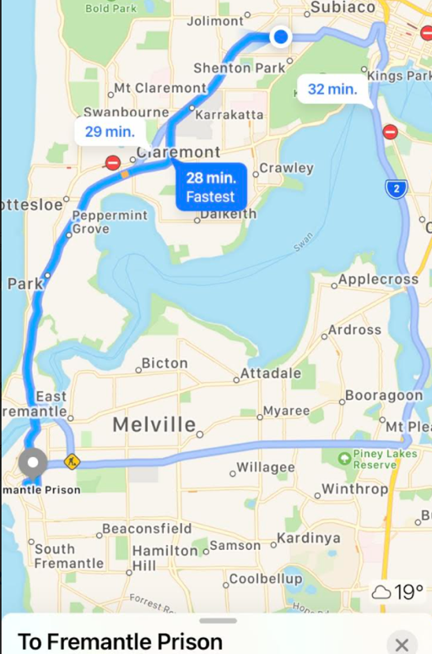  Chartered Bus from BusWest with seatbelts:  - Seats up to 57 passengers  - Bus drops at the front of Fremantle Prison  - Children are not required to cross any major roads  - Children are supervised whilst in the carpark area
Name of excursion coordinator | Ji Ni Chooi & Kiara Vivian
Contact number of excursion coordinator | (SCC MOBILE) 0413 170 223 |  | (INCURSION NUMBER) (08) 9336 9200
Number of children attending | 50 (expected) | Number of educators/parents/volunteers |  | 6/7
Educator to child ratio  1 : 10 |  | Does this incursion warrant a higher ratio?  If yes, please provide details. |  | No
INCURSION CHECKLIST
- First Aid Kit |  | - List of adults participating in the excursion
- List of Children attending the excursion |  | - Contact information for each adult
- Contact information for each child |  | - Mobile phone/ other means of communicating with the service & emergency services
- Medical Information for each child |  | - Other items, please list

Risk Assessment
Activity | Hazard identified | Risk Assessment  (Use matrix) | Elimination / control measures |  | Who | When
Touring around the prison / Toilet breaks | Stranger Danger  Children getting lost  Heat Stroke | Low  Low | - Children are escorted by educators in groups to toilets to avoid children being alone and in risk of danger  - High supervision levels will be kept by educators, and all children will be wearing a high-vis vest for easy identification.  - Head counts are performed every 30 minutes by educators.  - Children will be split into smaller groups to be monitored by specific educators for greater supervision levels.  Children will have brought their own water bottles or will have water provided to them if they have not brought them. Children will be kept out of direct sunlight during the middle of the day as much as reasonably possible, and will wear sun protective wear (e.g. hats, sunscreen). |  | All Educators | During Excursion
Transition from centre to bus & bus to excursion  Bus ride | Losing children  Children running across the road  Traffic incident | Low  Low  Low | - Children wear high visibility vests, roll call is done on the mat before lining up in the Centre with their partner for the bus  - Head count is then conducted by two staff  - Staff are dispersed between the line with one staff member in front and one at the back to lock the Centre after everyone leaves  - Children are escorted to the bus along the footpath out to the public footpath where the bus is to be parked in the parking along the road  - A staff member is sent up before any children to check the bus and move to the back  - Headcount then takes place with one staff member doing a headcount on children as they move into the bus  - For every 10 children the nominated staff counts, another staff member is let onto the bus to keep ratio  - Children are seated from the back of the bus to the front and children are to fasten seatbelts as they sit down which is double-checked by all staff moving throughout the bus.  - A headcount is then repeated with all staff and children on the bus and once everyone has their seatbelts fastened, the bus driver is told he/she can proceed  - Transitioning off the bus, a headcount is performed and staff from the back of the bus is let out last to ensure no children/ lost property remains on the bus.  - Once we have reached our excursion destination, roll call is done and staff are assigned groups to ensure high levels of supervision throughout the excursion.  - Charted bus fitted with seatbelts |  | All Educators | Leaving for and at excursion venue.
Plan prepared by | Isabella Biundo |  | Prepared in consultation with: | Ji Ni Chooi
Communicated to: | All staff members on duty |  | Venue and safety information reviewed and attached | Yes / No  Comment if needed:
Reminder: Monitor the effectiveness of controls and change if necessary. Review the risk assessment if an incident or significant change occurs.

EXCURSION DETAILS
Date(s) of excursion | MONDAY 10/01/2022 | Departure & arrival times |  | 9:10AM – 1:30PM
Excursion destination | Rotary Park, Scenic Drive, Wanneroo WA 6065
Proposed activities | Excursion: Rotary Park Excursion  We are checking out Rotary Park today in Wanneroo with slides, climbing nets, monkey bars and wobbly bridges this shaded playground is a perfect way to get outdoors during the summer. Please remember to stay sun smart today and bring a hat |  |  | WATER HAZARDS? NO
Method of transport, including proposed route | 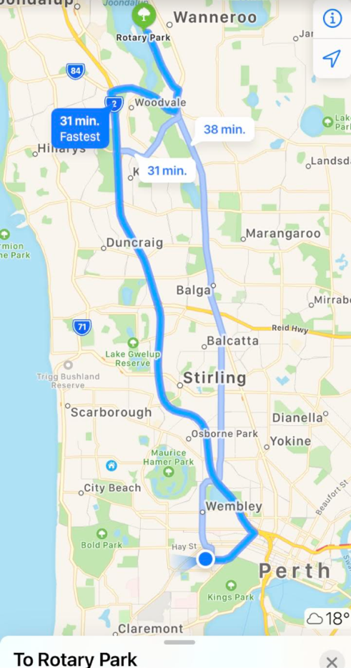  Chartered Bus from BusWest with seatbelts:  - Seats up to 57 passengers  - Bus drops at the front of the park  - Children are not required to cross any major roads  - Children are supervised whilst in the carpark area
Name of excursion coordinator | Ji Ni Chooi & Kiara Vivian
Contact number of excursion coordinator | (SCC MOBILE) 0413 170 223 |  | (INCURSION NUMBER) (08) 9405 5000
Number of children attending | 50 (expected) | Number of educators/parents/volunteers |  | 6/7
Educator to child ratio  1 : 10 |  | Does this excursion warrant a higher ratio?  If yes, please provide details. |  | No
EXCURSION CHECKLIST
- First Aid Kit |  | - List of adults participating in the excursion
- List of Children attending the excursion |  | - Contact information for each adult
- Contact information for each child |  | - Mobile phone/ other means of communicating with the service & emergency services
- Medical Information for each child |  | - Other items, please list

 | Risk Assessment
 | Activity |  | Hazard identified |  | Risk Assessment  (Use matrix) |  | Elimination / control measures |  |  | Who |  | When
Playing in the playground |  | Children wandering off  Children injuring themselves or others  Heat Stroke |  | Low  Low  Low |  | - High supervision levels will be kept by educators, and all children will be wearing a high-vis vest for easy identification.  - Head counts are performed every 30 minutes by educators.  - Children will be split into smaller groups to be monitored by specific educators for greater supervision levels.  - Children and educators will be given safety instructions to follow regarding areas of the playground that can and cannot be accessed to lower risk of injury.  - Children will be monitored and encouraged to play in areas that match their outdoor play skills, e.g., not climbing too high.  - A qualified first aider is always on site should an injury occur. The first aid kit, action plans, emergency contacts and anaphylaxis forms are always accessible.  - Children will have brought their own water bottles or will have water provided to them if they have not brought them. Children will be kept out of direct sunlight during the middle of the day as much as reasonably possible, and will wear sun protective wear (e.g. hats, sunscreen). |  |  | All educators |  | Throughout excursion
Toilet Breaks |  | Stranger Danger  Children getting lost |  | Low |  | Children are escorted by educators in groups to toilets to avoid children being alone and in risk of danger. |  |  | All educators |  | During excursion
Transition from Centre to bus & bus  to excursion |  | Losing children  Children running across the road. |  |  |  | - Children wear high visibility vests, roll call is done on the mat before lining up in Centre with their partner for the bus.  - Head count is then conducted by at least two staff.  - Staff are dispersed between the line with one staff member in front and one at the back to lock the Centre after everyone leaves.  - Children are escorted to the bus along the footpath out to the public footpath where the bus is to be parked in the parking along the road.  - A staff member is sent up before any children to check the bus and move to the back.  - Headcount then takes place with one staff member doing a headcount on children as they move into the bus.  - For every 10 children the nominated staff counts, another staff member is let onto the bus to keep ratio.  - Children fill up the bus from the back to the front and children are to fasten seatbelts as they sit down which is double-checked by all staff moving throughout the bus.  - A headcount is then repeated with all staff and children on the bus and once everyone has their seatbelts fastened, the bus driver is told he can proceed.  - Transitioning off the bus, a headcount is performed and staff from the back of the bus is let out last in order to ensure no children/ lost property remains on the bus.  - Once we have reached our excursion destination, roll call is done and educators are assigned groups in order to ensure high levels of supervision throughout the excursion.  Charted bus fitted with seatbelts
 | Plan prepared by |  | Isabella Biundo |  |  |  | Prepared in consultation with: | Ji Ni Chooi
 | Communicated to: |  | All staff members on duty |  |  |  | Venue and safety information reviewed and attached | Yes / No  Comment if needed:
 | Reminder: Monitor the effectiveness of controls and change if necessary. Review the risk assessment if an incident or significant change occurs.

INCURSION DETAILS
Date(s) of excursion | TUESDAY 11/01/2022 | Departure & arrival times |  | 10AM – 1PM
Excursion destination | N/A
Proposed activities | Incursion: Street Dance Incursion  Cube Sports is coming today to teach us a few moves on the dance floor as we learn all the tricks needed to street dance. Today is sure to be lots of fun! |  |  | WATER HAZARDS? NO
Method of transport, including proposed route | N/A
Name of excursion coordinator | Ji Ni Chooi & Kiara Vivian
Contact number of excursion coordinator | (SCC MOBILE) 0413 170 223 |  | (INCURSION NUMBER)
Number of children attending | 50 (expected) | Number of educators/parents/volunteers |  | 6/7
Educator to child ratio  1 : 10 |  | Does this excursion warrant a higher ratio?  If yes, please provide details. |  | No
EXCURSION CHECKLIST
- First Aid Kit |  | - List of adults participating in the excursion
- List of Children attending the excursion |  | - Contact information for each adult
- Contact information for each child |  | - Mobile phone/ other means of communicating with the service & emergency services
- Medical Information for each child |  | - Other items, please list

Risk Assessment
Activity | Hazard identified | Risk Assessment  (Use matrix) | Elimination / control measures |  | Who | When
Member of public entering the centre | Unknown person | Low | - Has been requested that incursion personnel have a working with children’s card  - Will report to supervisor to check and record their working with children’s card  - Supervisor will assess if they are in a state fit to be around children |  | Nominated Person in Charge (Supervisor) | Before the incursion begins
Dancing | Injury | Low | - Children will be encouraged to follow centre’s safety rules and will be in smaller groups to avoid injury and increase supervision. |  | All Educators | During incursion
Plan prepared by | Isabella Biundo |  | Prepared in consultation with: | Ji Ni Chooi
Communicated to: | All staff members on duty |  | Venue and safety information reviewed and attached | Yes / No  Comment if needed:
Reminder: Monitor the effectiveness of controls and change if necessary. Review the risk assessment if an incident or significant change occurs.

INCURSION DETAILS
Date(s) of excursion | WEDNESDAY 12/01/2022 | Departure & arrival times |  | 10AM – 2PM
Excursion destination | N/A
Proposed activities | Incursion: Masterchef Junior  Put your culinary skills to the test as you make donuts to compete against other junior MasterChef contestants to impress our hungry panel of judges and become the top mini chef. We will also be having Grill'd burgers for lunch today as we are busy cooking up a storm in the kitchen. |  |  | WATER HAZARDS? NO
Method of transport, including proposed route | N/A
Name of excursion coordinator | Ji Ni Chooi & Kiara Vivian
Contact number of excursion coordinator | (SCC MOBILE) 0413 170 223 |  | (INCURSION NUMBER) (Grill’d Subiaco) (08) 9380 9497
Number of children attending | 50 (expected) | Number of educators/parents/volunteers |  | 6/7
Educator to child ratio  1 : 10 |  | Does this excursion warrant a higher ratio?  If yes, please provide details. |  | No
EXCURSION CHECKLIST
- First Aid Kit |  | - List of adults participating in the excursion
- List of Children attending the excursion |  | - Contact information for each adult
- Contact information for each child |  | - Mobile phone/ other means of communicating with the service & emergency services
- Medical Information for each child |  | - Other items, please list

Risk Assessment
Activity | Hazard identified | Risk Assessment  (Use matrix) | Elimination / control measures |  | Who | When
Donut making | Injury | Low | - Children will be split into small groups when prepping their sushi, to ensure high supervision and low risk of injury.  - The children will not be handling any sharp utensils, rather simply assembling the ingredients into their sushi roll.  - A qualified first aider is always on site should an injury occur. The first aid kit, action plans, emergency contacts and anaphylaxis forms are always accessible. |  | All educators | Making donuts
Donut/Grill’d Consumption | Allergic reaction | Low | - All allergies were taken into consideration by parents who have enrolled their child for this excursion thus staff will be aware of any serious allergies  - Children with special dietary requirements on the day as well as allergies will have their ingredients for cooking on a separate table to the rest to ensure no cross contamination takes place  - Epi pens are always checked and in date while child is on our premises as well as any action plans in case of emergency  - Qualified First aider will be always on duty |  | All educators | During lunch/snack times
Plan prepared by | Isabella Biundo |  | Prepared in consultation with: | Ji Ni Chooi
Communicated to: | All staff members on duty |  | Venue and safety information reviewed and attached | Yes / No  Comment if needed:
Reminder: Monitor the effectiveness of controls and change if necessary. Review the risk assessment if an incident or significant change occurs.

EXCURSION DETAILS
Date(s) of excursion | THURSDAY 13/01/2022 | Departure & arrival times |  | 9:10AM – 1:30PM
Excursion destination | Grand Cinemas, 639 Beach Road Warwick WA 6024
Proposed activities | Excursion: CLIFFORD MOVIE  Today we are headed to the cinemas to watch the classic book Clifford The Big Red Dog be transformed into a live action movie all about friendship and magic. |  |  | WATER HAZARDS? NO
Method of transport, including proposed route | 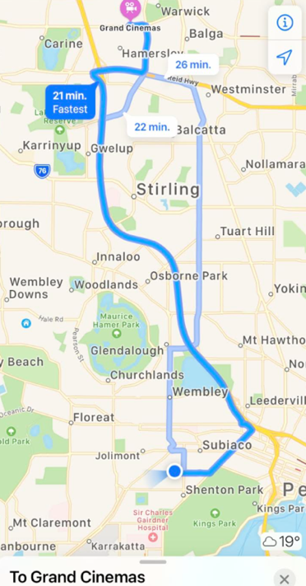  Chartered Bus from BusWest with seatbelts:  - Seats up to 57 passengers  - Bus drops at the front of Grand Cinemas  - Children are not required to cross any major roads  - Children are supervised whilst in the carpark area
Name of excursion coordinator | Ji Ni Chooi & Kiara Vivian
Contact number of excursion coordinator | (SCC MOBILE) 0413 170 223 |  | (EXCURSION NUMBER) (08) 9247 7488
Number of children attending | 50 (expected) | Number of educators/parents/volunteers |  | 6/7
Educator to child ratio  1 : 10 |  | Does this excursion warrant a higher ratio?  If yes, please provide details. |  | No
EXCURSION CHECKLIST
- First Aid Kit |  | - List of adults participating in the excursion
- List of Children attending the excursion |  | - Contact information for each adult
- Contact information for each child |  | - Mobile phone/ other means of communicating with the service & emergency services
- Medical Information for each child |  | - Other items, please list

 | Risk Assessment
 | Activity |  | Hazard identified |  | Risk Assessment  (Use matrix) |  | Elimination / control measures |  |  | Who |  | When
Transition from Centre to bus & bus to Cinemas  Bus ride |  | Losing children  Children running across the road  Traffic Incident |  | Low  Low  Low |  | - Children wear high visibility vests, roll call is done on the mat before lining up in the Centre with their partner for the bus  - Head count is then conducted by two staff  - Staff are dispersed between the line with one staff member in front and one at the back to lock the Centre after everyone leaves  - Children are escorted to the bus along the footpath out to the public footpath where the bus is to be parked in the parking along the road  - A staff member is sent up before any children to check the bus and move to the back  - Headcount then takes place with one staff member doing a headcount on children as they move into the bus  - For every 10 children the nominated staff counts, another staff member is let onto the bus to keep ratio  - Children are seated from the back of the bus to the front and children are to fasten seatbelts as they sit down which is double-checked by all staff moving throughout the bus.  - A headcount is then repeated with all staff and children on the bus and once everyone has their seatbelts fastened, the bus driver is told he/she can proceed  - Transitioning off the bus, a headcount is performed and staff from the back of the bus is let out last in order to ensure no children/ lost property remains on the bus.  - Once we have reached our excursion destination, roll call is done and staff are assigned groups in order to ensure high levels of supervision throughout the excursion.  - Charted bus fitted with seatbelts |  |  | All staff |  | Leaving for excursion and whilst on the bus.
 | Popcorn and drinks handed out at the movie |  | Allergies |  | Low |  | - All allergies were taken into consideration by parents who have enrolled their child for this excursion  - Qualified first aider is on duty at all times and first aid kit, action plans, emergency contacts, epi pens and anaphylaxis forms are accessible at all times |  |  | All staff members  Qualified staff members |  | At all times during this activity
 | Watching The movie & Toilet Breaks |  | Stranger danger  Children wander off  Injury |  | Low  Low  Low |  | - Staff from the cinema, spread across the rows and on the outskirts of the rows to ensure no children wander off and ensure adequate supervision  - Staff will brief the children about the rules around watching the movie and asking staff if they need the toilet, SCC staff will be put into groups in order to ensure sufficient supervision  - Florescent bibs for easy visibility of children under our care and uniforms are worn by staff members to ensure children can easily identify them  - Head count and roll call is to be done upon arrival and before departure  - Children are escorted by staff member and in groups to toilets in order to avoid children being alone and in risk of danger  - Headcount is done outside the toilet area before returning to the cinema to ensure all children are accounted for. Ratio is kept at all times during all excursion activities.  - Children are closely supervised throughout the movie and if an emergency occurs, we have a first aider on duty and first aid kit |  |  | All staff members  By qualified staff |  | At all times during this excursion  At all times during this activity
 | Plan prepared by |  | Isabella Biundo |  |  |  | Prepared in consultation with: | Ji Ni Chooi
 | Communicated to: |  | All staff members on duty |  |  |  | Venue and safety information reviewed and attached | Yes / No  Comment if needed:
 | Reminder: Monitor the effectiveness of controls and change if necessary. Review the risk assessment if an incident or significant change occurs.

INCURSION DETAILS
Date(s) of excursion | FRIDAY 14/01/2022 | Departure & arrival times |  | 12PM – 2PM
Excursion destination | N/A
Proposed activities | Incursion: Gymbus Incursion  The Gym Bus is here today as we get a chance to play in a mobile indoor playground. Today is a chance to run around and burn off some energy whilst staying out of the sun. With its fireman poles, tunnels and slides you will be challenged to hang, climb and slide today! |  |  | WATER HAZARDS? NO
Method of transport, including proposed route | N/A
Name of excursion coordinator | Ji Ni Chooi & Kiara Vivian
Contact number of excursion coordinator | (SCC MOBILE) 0413 170 223 |  | (INCURSION NUMBER) 0429 770 277
Number of children attending | 50 (expected) | Number of educators/parents/volunteers |  | 6/7
Educator to child ratio  1 : 10 |  | Does this excursion warrant a higher ratio?  If yes, please provide details. |  | No
EXCURSION CHECKLIST
- First Aid Kit |  | - List of adults participating in the excursion
- List of Children attending the excursion |  | - Contact information for each adult
- Contact information for each child |  | - Mobile phone/ other means of communicating with the service & emergency services
- Medical Information for each child |  | - Other items, please list

Risk Assessment
Activity | Hazard identified | Risk Assessment  (Use matrix) | Elimination / control measures |  | Who | When
Member of public entering the centre | Unknown person | Low | - Has been requested that incursion personnel have a working with children’s card  - Will report to supervisor to check and record their working with children’s card  - Supervisor will assess if they are in a state fit to be around children |  | Nominated Person in Charge (Supervisor) | Before the incursion begins
Playing in the gym bus | Injury  Heat Stroke | Low  Low | Children are closely supervised throughout their play and if an injury occurs, we have a first aider on duty and first aid kit, contact list and emergency contacts on hand at all times  Children will be split into smaller groups for this activity  Children will have brought their own water bottles or will have water provided to them if they have not brought them. Children will be kept out of direct sunlight during the middle of the day as much as reasonably possible, and will wear sun protective wear (e.g. hats, sunscreen).  Children will be brought back inside to the air conditioning if they are getting too hot in the gymbus. |  | All educators | During incursion
Plan prepared by | Isabella Biundo |  | Prepared in consultation with: | Ji Ni Chooi
Communicated to: | All staff members on duty |  | Venue and safety information reviewed and attached | Yes / No  Comment if needed:
Reminder: Monitor the effectiveness of controls and change if necessary. Review the risk assessment if an incident or significant change occurs.

INCURSION DETAILS
Date(s) of excursion | MONDAY 17/01/2022 | Departure & arrival times |  | 10AM – 12PM
Excursion destination | N/A
Proposed activities | Incursion: Science Alive Incursion  Science Alive is running a science incursion for us today as we learn about boundless energy and play some fabulous games with light, wind, magnetism, chemicals, rockets and more. |  |  | WATER HAZARDS? NO
Method of transport, including proposed route | N/A
Name of excursion coordinator | Ji Ni Chooi & Kiara Vivian
Contact number of excursion coordinator | (SCC MOBILE) 0413 170 223 |  | (INCURSION NUMBER)
Number of children attending | 50 (expected) | Number of educators/parents/volunteers |  | 6/7
Educator to child ratio  1 : 10 |  | Does this excursion warrant a higher ratio?  If yes, please provide details. |  | No
EXCURSION CHECKLIST
- First Aid Kit |  | - List of adults participating in the excursion
- List of Children attending the excursion |  | - Contact information for each adult
- Contact information for each child |  | - Mobile phone/ other means of communicating with the service & emergency services
- Medical Information for each child |  | - Other items, please list

Risk Assessment
Activity | Hazard identified | Risk Assessment  (Use matrix) | Elimination / control measures |  | Who | When
Member of public entering the centre | Unknown person | Low | - Has been requested that incursion personnel have a working with children’s card  - Will report to supervisor to check and record their working with children’s card  - Supervisor will assess if they are in a state fit to be around children |  | Nominated Person in Charge (Supervisor) | Before the incursion begins
Playing in the gym bus | Injury | Low | Children are closely supervised throughout the activities and if an injury occurs, we have a first aider on duty and first aid kit, contact list and emergency contacts on hand at all times  Children will be split into smaller groups for this activity.  Children will be reminded of safety rules regarding science equipment. |  | All educators | During incursion
Plan prepared by | Isabella Biundo |  | Prepared in consultation with: | Ji Ni Chooi
Communicated to: | All staff members on duty |  | Venue and safety information reviewed and attached | Yes / No  Comment if needed:
Reminder: Monitor the effectiveness of controls and change if necessary. Review the risk assessment if an incident or significant change occurs.

EXCURSION DETAILS
Date(s) of excursion | TUESDAY 18/01/2022 | Departure & arrival times |  | 9:10AM – 1:30PM
Excursion destination | 308 South Western Highway, Wungong 6112, WA
Proposed activities | Excursion: Reptile Centre Excursion  We are exploring Armadale reptile centre today which houses a large variety of reptiles and Australian wildlife from snakes, lizards, frogs, turtles, bats, kangaroos, dingos, emus, tawny frogmouths, parrots and bustards. |  |  | WATER HAZARDS? NO
Method of transport, including proposed route | 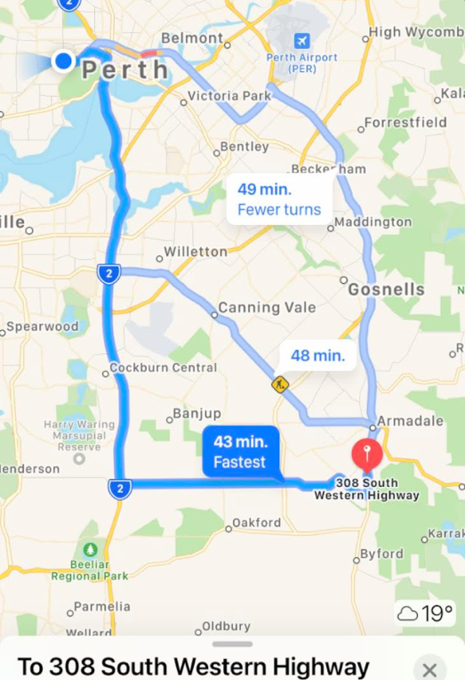  Chartered Bus from BusWest with seatbelts:  - Seats up to 57 passengers  - Bus drops at the front of Reptile Centre  - Children are not required to cross any major roads  - Children are supervised whilst in the carpark area
Name of excursion coordinator | Ji Ni Chooi & Kiara Vivian
Contact number of excursion coordinator | (SCC MOBILE) 0413 170 223 |  | (EXCURSION NUMBER) (08) 9399 6927
Number of children attending | 50 (expected) | Number of educators/parents/volunteers |  | 6/7
Educator to child ratio  1 : 10 |  | Does this excursion warrant a higher ratio?  If yes, please provide details. |  | No
EXCURSION CHECKLIST
- First Aid Kit |  | - List of adults participating in the excursion
- List of Children attending the excursion |  | - Contact information for each adult
- Contact information for each child |  | - Mobile phone/ other means of communicating with the service & emergency services
- Medical Information for each child |  | - Other items, please list

 | Risk Assessment
 | Activity |  | Hazard identified |  | Risk Assessment  (Use matrix) |  | Elimination / control measures |  |  | Who |  | When
Transition from Centre to bus & bus to reptile park  Bus ride |  | Losing children  Children running across the road  Traffic Incident |  | Low  Low  Low |  | - Children wear high visibility vests, roll call is done on the mat before lining up in the Centre with their partner for the bus  - Head count is then conducted by two staff  - Staff are dispersed between the line with one staff member in front and one at the back to lock the Centre after everyone leaves  - Children are escorted to the bus along the footpath out to the public footpath where the bus is to be parked in the parking along the road  - A staff member is sent up before any children to check the bus and move to the back  - Headcount then takes place with one staff member doing a headcount on children as they move into the bus  - For every 10 children the nominated staff counts, another staff member is let onto the bus to keep ratio  - Children are seated from the back of the bus to the front and children are to fasten seatbelts as they sit down which is double-checked by all staff moving throughout the bus.  - A headcount is then repeated with all staff and children on the bus and once everyone has their seatbelts fastened, the bus driver is told he/she can proceed  - Transitioning off the bus, a headcount is performed and staff from the back of the bus is let out last in order to ensure no children/ lost property remains on the bus.  - Once we have reached our excursion destination, roll call is done and staff are assigned groups in order to ensure high levels of supervision throughout the excursion.  - Charted bus fitted with seatbelts |  |  | All staff |  | Leaving for excursion and whilst on the bus.
 | Toilet Breaks and walking around the centre |  | Stranger danger  Children wander off  Injury  Heat Stroke |  | Low  Low  Low  Low |  | - Staff from the cinema, spread across the rows and on the outskirts of the rows to ensure no children wander off and ensure adequate supervision  - Staff will brief the children about the rules around walking around the centre, interacting with the animals, and asking staff if they need the toilet, SCC staff will be put into groups to ensure sufficient supervision  - Florescent bibs for easy visibility of children under our care and uniforms are worn by staff members to ensure children can easily identify them  - Head count and roll call is to be done upon arrival and before departure  - Children are escorted by staff member and in groups to toilets to avoid children being alone and in risk of danger  - Headcount is done outside the toilet area before returning to the cinema to ensure all children are accounted for. Ratio is always kept during all excursion activities.  - Children are closely supervised throughout the movie and if an emergency occurs, we have a first aider on duty and first aid kit  - Children will have brought their own water bottles or will have water provided to them if they have not brought them. Children will be kept out of direct sunlight during the middle of the day as much as reasonably possible, and will wear sun protective wear (e.g. hats, sunscreen). |  |  | All staff members  By qualified staff |  | At all times during this excursion  At all times during this activity
 | Plan prepared by |  | Isabella Biundo |  |  |  | Prepared in consultation with: | Ji Ni Chooi
 | Communicated to: |  | All staff members on duty |  |  |  | Venue and safety information reviewed and attached | Yes / No  Comment if needed:
 | Reminder: Monitor the effectiveness of controls and change if necessary. Review the risk assessment if an incident or significant change occurs.

INCURSION DETAILS
Date(s) of excursion | WEDNESDAY 19/01/2022 | Departure & arrival times |  | 10AM – 11:30AM
Excursion destination | N/A
Proposed activities | Incursion: Learning Pod Incursion  The Learning POD Group is here today to run an incursion with foaming dragons, kinetic sand and explosions! |  |  | WATER HAZARDS? NO
Method of transport, including proposed route | N/A
Name of excursion coordinator | Ji Ni Chooi & Kiara Vivian
Contact number of excursion coordinator | (SCC MOBILE) 0413 170 223 |  | (INCURSION NUMBER) 1300 123 763
Number of children attending | 50 (expected) | Number of educators/parents/volunteers |  | 6/7
Educator to child ratio  1 : 10 |  | Does this excursion warrant a higher ratio?  If yes, please provide details. |  | No
EXCURSION CHECKLIST
- First Aid Kit |  | - List of adults participating in the excursion
- List of Children attending the excursion |  | - Contact information for each adult
- Contact information for each child |  | - Mobile phone/ other means of communicating with the service & emergency services
- Medical Information for each child |  | - Other items, please list

Risk Assessment
Activity | Hazard identified | Risk Assessment  (Use matrix) | Elimination / control measures |  | Who | When
Member of public entering the centre | Unknown person | Low | - Has been requested that incursion personnel have a working with children’s card  - Will report to supervisor to check and record their working with children’s card  - Supervisor will assess if they are in a state fit to be around children |  | Nominated Person in Charge (Supervisor) | Before the incursion begins
Playing with science equipment | Injury | Low | - Children are closely supervised throughout the activities and if an injury occurs, we have a first aider on duty and first aid kit, contact list and emergency contacts on hand at all times  - Children will be split into smaller groups for this activity.  - Children will be reminded of safety rules regarding science equipment. |  | All educators | During incursion
Plan prepared by | Isabella Biundo |  | Prepared in consultation with: | Ji Ni Chooi
Communicated to: | All staff members on duty |  | Venue and safety information reviewed and attached | Yes / No  Comment if needed:
Reminder: Monitor the effectiveness of controls and change if necessary. Review the risk assessment if an incident or significant change occurs.

EXCURSION DETAILS
Date(s) of excursion | THURSDAY 20/01/2022 | Departure & arrival times |  | 9:00AM – 2:00PM
Excursion destination | Swan Valley Cuddly Animal Farm, 128 John St, Perth WA 6055
Proposed activities | Excursion: Swan Valley Cuddly Animal Farm  Today we get opportunity to interact with all the friendly farmyard animals, nurse, pat, bucket and bottle feed the babies at Swan Valley Cuddly Animal Farm and might even get to go on a merry-go-round and tractor ride |  |  | WATER HAZARDS? NO
Method of transport, including proposed route | 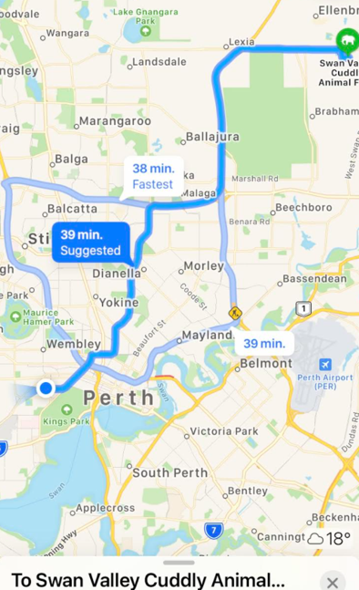  Chartered Bus from BusWest with seatbelts:  - Seats up to 57 passengers  - Bus drops at the front of Animal Farm  - Children are not required to cross any major roads  - Children are supervised whilst in the carpark area
Name of excursion coordinator | Ji Ni Chooi & Kiara Vivian
Contact number of excursion coordinator | (SCC MOBILE) 0413 170 223 |  | (EXCURSION NUMBER) 0424 209 730
Number of children attending | 50 (expected) | Number of educators/parents/volunteers |  | 6/7
Educator to child ratio  1 : 10 |  | Does this excursion warrant a higher ratio?  If yes, please provide details. |  | No
EXCURSION CHECKLIST
- First Aid Kit |  | - List of adults participating in the excursion
- List of Children attending the excursion |  | - Contact information for each adult
- Contact information for each child |  | - Mobile phone/ other means of communicating with the service & emergency services
- Medical Information for each child |  | - Other items, please list

 | Risk Assessment
 | Activity |  | Hazard identified |  | Risk Assessment  (Use matrix) |  | Elimination / control measures |  |  | Who |  | When
Transition from Centre to bus & bus to Animal Farm  Bus ride |  | Losing children  Children running across the road  Traffic Incident |  | Low  Low  Low |  | - Children wear high visibility vests, roll call is done on the mat before lining up in the Centre with their partner for the bus  - Head count is then conducted by two staff  - Staff are dispersed between the line with one staff member in front and one at the back to lock the Centre after everyone leaves  - Children are escorted to the bus along the footpath out to the public footpath where the bus is to be parked in the parking along the road  - A staff member is sent up before any children to check the bus and move to the back  - Headcount then takes place with one staff member doing a headcount on children as they move into the bus  - For every 10 children the nominated staff counts, another staff member is let onto the bus to keep ratio  - Children are seated from the back of the bus to the front and children are to fasten seatbelts as they sit down which is double-checked by all staff moving throughout the bus.  - A headcount is then repeated with all staff and children on the bus and once everyone has their seatbelts fastened, the bus driver is told he/she can proceed  - Transitioning off the bus, a headcount is performed and staff from the back of the bus is let out last in order to ensure no children/ lost property remains on the bus.  - Once we have reached our excursion destination, roll call is done and staff are assigned groups in order to ensure high levels of supervision throughout the excursion.  - Charted bus fitted with seatbelts |  |  | All staff |  | Leaving for excursion and whilst on the bus.
 | Toilet Breaks and walking around |  | Stranger danger  Children wander off  Injury from animal or other equipment  Heat Stroke |  | Low  Low  Low  Low |  | - Staff from the cinema, spread across the rows and on the outskirts of the rows to ensure no children wander off and ensure adequate supervision  - Staff will brief the children about the rules around walking around the centre, interacting with the animals, and asking staff if they need the toilet, SCC staff will be put into groups to ensure sufficient supervision  - Florescent bibs for easy visibility of children under our care and uniforms are worn by staff members to ensure children can easily identify them  - Head count and roll call is to be done upon arrival and before departure  - Children are escorted by staff member and in groups to toilets to avoid children being alone and in risk of danger  - Headcount is done outside the toilet area before returning to the cinema to ensure all children are accounted for. Ratio is always kept during all excursion activities.  - Children are closely supervised throughout the movie and if an emergency occurs, we have a first aider on duty and first aid kit  - Children are closely supervised throughout the activities and if an injury occurs, we have a first aider on duty and first aid kit, contact list and emergency contacts on hand at all times  - Children will be split into smaller groups for this activity.  - Children will be reminded of safety rules regarding animals and using other equipment on the excursion.  Children will have brought their own water bottles or will have water provided to them if they have not brought them. Children will be kept out of direct sunlight during the middle of the day as much as reasonably possible, and will wear sun protective wear (e.g. hats, sunscreen). |  |  | All staff members  By qualified staff |  | At all times during this excursion  At all times during this activity
 | Plan prepared by |  | Isabella Biundo |  |  |  | Prepared in consultation with: | Ji Ni Chooi
 | Communicated to: |  | All staff members on duty |  |  |  | Venue and safety information reviewed and attached | Yes / No  Comment if needed:
 | Reminder: Monitor the effectiveness of controls and change if necessary. Review the risk assessment if an incident or significant change occurs.

INCURSION DETAILS
Date(s) of excursion | FRIDAY 21/01/2022 | Departure & arrival times |  | 10AM – 12PM
Excursion destination | N/A
Proposed activities | Incursion: Galaxy and Space Day  Today is all about space and galaxies! We will be creating our very own galaxy slime and UFO's. We will be finishing off the day with a glow in the dark party. |  |  | WATER HAZARDS? NO
Method of transport, including proposed route | N/A
Name of excursion coordinator | Ji Ni Chooi & Kiara Vivian
Contact number of excursion coordinator | (SCC MOBILE) 0413 170 223 |  | (INCURSION NUMBER)
Number of children attending | 50 (expected) | Number of educators/parents/volunteers |  | 6/7
Educator to child ratio  1 : 10 |  | Does this excursion warrant a higher ratio?  If yes, please provide details. |  | No
EXCURSION CHECKLIST
- First Aid Kit |  | - List of adults participating in the excursion
- List of Children attending the excursion |  | - Contact information for each adult
- Contact information for each child |  | - Mobile phone/ other means of communicating with the service & emergency services
- Medical Information for each child |  | - Other items, please list

Risk Assessment
Activity | Hazard identified | Risk Assessment  (Use matrix) | Elimination / control measures |  | Who | When
Playing with science equipment | Injury | Low | - Children are closely supervised throughout the activities and if an injury occurs, we have a first aider on duty and first aid kit, contact list and emergency contacts on hand at all times  - Children will be split into smaller groups for this activity.  - Children will be reminded of safety rules regarding science equipment. |  | All educators | During incursion
Plan prepared by | Isabella Biundo |  | Prepared in consultation with: | Ji Ni Chooi
Communicated to: | All staff members on duty |  | Venue and safety information reviewed and attached | Yes / No  Comment if needed:
Reminder: Monitor the effectiveness of controls and change if necessary. Review the risk assessment if an incident or significant change occurs.

INCURSION DETAILS
Date(s) of excursion | MONDAY 24/01/2022 | Departure & arrival times |  | 10AM – 2PM
Excursion destination | N/A
Proposed activities | Incursion: 2 Deadly Food and Fitness  2 Deadly Food and Fitness is back today to teach us some new Indigenous games and cook up some Indigenous foods with us as we learn where in Australia we source and find all the ingredients for what we are cooking as well as other uses for these ingredients. |  |  | WATER HAZARDS? NO
Method of transport, including proposed route | N/A
Name of excursion coordinator | Ji Ni Chooi & Kiara Vivian
Contact number of excursion coordinator | (SCC MOBILE) 0413 170 223 |  | (INCURSION NUMBER) 0407 084 304
Number of children attending | 50 (expected) | Number of educators/parents/volunteers |  | 6/7
Educator to child ratio  1 : 10 |  | Does this excursion warrant a higher ratio?  If yes, please provide details. |  | No
EXCURSION CHECKLIST
- First Aid Kit |  | - List of adults participating in the excursion
- List of Children attending the excursion |  | - Contact information for each adult
- Contact information for each child |  | - Mobile phone/ other means of communicating with the service & emergency services
- Medical Information for each child |  | - Other items, please list

Risk Assessment
Activity | Hazard identified | Risk Assessment  (Use matrix) | Elimination / control measures |  | Who | When
Member of public entering the centre | Unknown person | Low | - Has been requested that incursion personnel have a working with children’s card  - Will report to supervisor to check and record their working with children’s card  - Supervisor will assess if they are in a state fit to be around children |  | Nominated Person in Charge (Supervisor) | Before the incursion begins
Cooking and preparing food | Injury  Allergic reaction to food | Low | - Children are closely supervised throughout the activities and if an injury occurs, we have a first aider on duty and first aid kit, contact list and emergency contacts on hand at all times  - Children will be split into smaller groups for this activity.  - Children will be reminded of safety rules regarding science equipment.  - All allergies were taken into consideration by parents who have enrolled their child for this excursion thus staff will be aware of any serious allergies  - Children with special dietary requirements on the day as well as allergies will have their ingredients for cooking on a separate table to the rest to ensure no cross contamination takes place  - Epi pens are always checked and in date while child is on our premises as well as any action plans in case of emergency  - Qualified First aider will be always on duty |  | All educators | During incursion
Plan prepared by | Isabella Biundo |  | Prepared in consultation with: | Ji Ni Chooi
Communicated to: | All staff members on duty |  | Venue and safety information reviewed and attached | Yes / No  Comment if needed:
Reminder: Monitor the effectiveness of controls and change if necessary. Review the risk assessment if an incident or significant change occurs.

INCURSION DETAILS
Date(s) of excursion | TUESDAY 25/01/2022 | Departure & arrival times |  | 1PM – 3:30PM
Excursion destination | N/A
Proposed activities | Incursion: Circus Incursion  Fun Fit is running a circus incursion with us today for some juggling, hula hoops, acrobalance, clowning and more! Today is sure to be lots of fun at our Subi circus. |  |  | WATER HAZARDS? NO
Method of transport, including proposed route | N/A
Name of excursion coordinator | Ji Ni Chooi & Kiara Vivian
Contact number of excursion coordinator | (SCC MOBILE) 0413 170 223 |  | (INCURSION NUMBER)
Number of children attending | 50 (expected) | Number of educators/parents/volunteers |  | 6/7
Educator to child ratio  1 : 10 |  | Does this excursion warrant a higher ratio?  If yes, please provide details. |  | No
EXCURSION CHECKLIST
- First Aid Kit |  | - List of adults participating in the excursion
- List of Children attending the excursion |  | - Contact information for each adult
- Contact information for each child |  | - Mobile phone/ other means of communicating with the service & emergency services
- Medical Information for each child |  | - Other items, please list

Risk Assessment
Activity | Hazard identified | Risk Assessment  (Use matrix) | Elimination / control measures |  | Who | When
Member of public entering the centre | Unknown person | Low | - Has been requested that incursion personnel have a working with children’s card  - Will report to supervisor to check and record their working with children’s card  - Supervisor will assess if they are in a state fit to be around children |  | Nominated Person in Charge (Supervisor) | Before the incursion begins
Circus activities | Injury | Low | - Children are closely supervised throughout the activities and if an injury occurs, we have a first aider on duty and first aid kit, contact list and emergency contacts on hand at all times  - Children will be split into smaller groups for this activity.  - Children will be reminded of safety rules regarding the activities. |  | All educators | During incursion
Plan prepared by | Isabella Biundo |  | Prepared in consultation with: | Ji Ni Chooi
Communicated to: | All staff members on duty |  | Venue and safety information reviewed and attached | Yes / No  Comment if needed:
Reminder: Monitor the effectiveness of controls and change if necessary. Review the risk assessment if an incident or significant change occurs.

INCURSION DETAILS
Date(s) of excursion | THURSDAY 27/01/2022 | Departure & arrival times |  | 1PM – 3:30PM
Excursion destination | N/A
Proposed activities | Incursion: VR Game Truck Incursion  Today Game Truck is here with 30+ video games for us to play including some VR games which are sure to unleash your inner gamer from Xbox, Nintendo to Playstation there is something to play for everyone. |  |  | WATER HAZARDS? NO
Method of transport, including proposed route | N/A
Name of excursion coordinator | Ji Ni Chooi & Kiara Vivian
Contact number of excursion coordinator | (SCC MOBILE) 0413 170 223 |  | (INCURSION NUMBER) 0427 923 137
Number of children attending | 50 (expected) | Number of educators/parents/volunteers |  | 6/7
Educator to child ratio  1 : 10 |  | Does this excursion warrant a higher ratio?  If yes, please provide details. |  | No
EXCURSION CHECKLIST
- First Aid Kit |  | - List of adults participating in the excursion
- List of Children attending the excursion |  | - Contact information for each adult
- Contact information for each child |  | - Mobile phone/ other means of communicating with the service & emergency services
- Medical Information for each child |  | - Other items, please list

Risk Assessment
Activity | Hazard identified | Risk Assessment  (Use matrix) | Elimination / control measures |  | Who | When
Member of public entering the centre | Unknown person | Low | - Has been requested that incursion personnel have a working with children’s card  - Will report to supervisor to check and record their working with children’s card  - Supervisor will assess if they are in a state fit to be around children |  | Nominated Person in Charge (Supervisor) | Before the incursion begins
VR Game | Injury | Low | - Children are closely supervised throughout the activities and if an injury occurs, we have a first aider on duty and first aid kit, contact list and emergency contacts on hand at all times  - Children will be split into smaller groups for this activity.  - Children will be reminded of safety rules regarding the activities. |  | All educators | During incursion
Plan prepared by | Isabella Biundo |  | Prepared in consultation with: | Ji Ni Chooi
Communicated to: | All staff members on duty |  | Venue and safety information reviewed and attached | Yes / No  Comment if needed:
Reminder: Monitor the effectiveness of controls and change if necessary. Review the risk assessment if an incident or significant change occurs.

EXCURSION DETAILS
Date(s) of excursion | FRIDAY 28/01/2022 | Departure & arrival times |  | 9:10AM – 1:30PM
Excursion destination | Wanneroo Botanical Gardens 25 Drovers Pl, Perth WA 6065
Proposed activities | Excursion: Mini Golf  We are headed to the Wanneroo Botanical Gardens today for some fun and mini golf action as well as a chance to walk around and explore the shaded botanical gardens. Make sure to remember your hat and golf skills today! |  |  | WATER HAZARDS? NO
Method of transport, including proposed route | Chartered Bus from BusWest with seatbelts:  - Seats up to 57 passengers  - Bus drops at the front of mini golf  - Children are not required to cross any major roads  - Children are supervised whilst in the carpark area
Name of excursion coordinator | Ji Ni Chooi & Kiara Vivian
Contact number of excursion coordinator | (SCC MOBILE) 0413 170 223 |  | (EXCURSION NUMBER) (08) 9405 1475
Number of children attending | 50 (expected) | Number of educators/parents/volunteers |  | 6/7
Educator to child ratio  1 : 10 |  | Does this excursion warrant a higher ratio?  If yes, please provide details. |  | No
EXCURSION CHECKLIST
- First Aid Kit |  | - List of adults participating in the excursion
- List of Children attending the excursion |  | - Contact information for each adult
- Contact information for each child |  | - Mobile phone/ other means of communicating with the service & emergency services
- Medical Information for each child |  | - Other items, please list

 | Risk Assessment
 | Activity |  | Hazard identified |  | Risk Assessment  (Use matrix) |  | Elimination / control measures |  |  | Who |  | When
Transition from Centre to bus & bus to Botanical Gardens  Bus ride |  | Losing children  Children running across the road  Traffic Incident |  | Low  Low  Low |  | - Children wear high visibility vests, roll call is done on the mat before lining up in the Centre with their partner for the bus  - Head count is then conducted by two staff  - Staff are dispersed between the line with one staff member in front and one at the back to lock the Centre after everyone leaves  - Children are escorted to the bus along the footpath out to the public footpath where the bus is to be parked in the parking along the road  - A staff member is sent up before any children to check the bus and move to the back  - Headcount then takes place with one staff member doing a headcount on children as they move into the bus  - For every 10 children the nominated staff counts, another staff member is let onto the bus to keep ratio  - Children are seated from the back of the bus to the front and children are to fasten seatbelts as they sit down which is double-checked by all staff moving throughout the bus.  - A headcount is then repeated with all staff and children on the bus and once everyone has their seatbelts fastened, the bus driver is told he/she can proceed  - Transitioning off the bus, a headcount is performed and staff from the back of the bus is let out last in order to ensure no children/ lost property remains on the bus.  - Once we have reached our excursion destination, roll call is done and staff are assigned groups in order to ensure high levels of supervision throughout the excursion.  - Charted bus fitted with seatbelts |  |  | All staff |  | Leaving for excursion and whilst on the bus.
 | Toilet Breaks and walking around |  | Stranger danger  Children wander off  Injury from game/equipment  Heat Stroke |  | Low  Low  Low  Low |  | - Staff from the cinema, spread across the rows and on the outskirts of the rows to ensure no children wander off and ensure adequate supervision  - Staff will brief the children about the rules around walking around the centre, interacting with the animals, and asking staff if they need the toilet, SCC staff will be put into groups to ensure sufficient supervision  - Florescent bibs for easy visibility of children under our care and uniforms are worn by staff members to ensure children can easily identify them  - Head count and roll call is to be done upon arrival and before departure  - Children are escorted by staff member and in groups to toilets to avoid children being alone and in risk of danger  - Headcount is done outside the toilet area before returning to the cinema to ensure all children are accounted for. Ratio is always kept during all excursion activities.  - Children are closely supervised throughout the movie and if an emergency occurs, we have a first aider on duty and first aid kit  - Children are closely supervised throughout the activities and if an injury occurs, we have a first aider on duty and first aid kit, contact list and emergency contacts on hand at all times  - Children will be split into smaller groups for this activity.  - Children will be reminded of safety rules regarding animals and using other equipment on the excursion.  Children will have brought their own water bottles or will have water provided to them if they have not brought them. Children will be kept out of direct sunlight during the middle of the day as much as reasonably possible, and will wear sun protective wear (e.g. hats, sunscreen). |  |  | All staff members  By qualified staff |  | At all times during this excursion  At all times during this activity
 | Plan prepared by |  | Isabella Biundo |  |  |  | Prepared in consultation with: | Ji Ni Chooi
 | Communicated to: |  | All staff members on duty |  |  |  | Venue and safety information reviewed and attached | Yes / No  Comment if needed:
 | Reminder: Monitor the effectiveness of controls and change if necessary. Review the risk assessment if an incident or significant change occurs.

