SUBIACO CHILDREN’S CENTRE (SCC)
160 HAMERSLEY ROAD, SUBIACO
Website: www.subicc.com.au
Mobile: 0413 170 223 Email: subicc@iinet.net.au
Opening Hour: 7.30am – 6pm
Booking and Permission April Vacation Programme 2021
Child Details
Child 1 Name: _________________________________________
Child 2 Name: _________________________________________
Child 3 Name: _________________________________________
Parent/Guardian Details
Name: ________________________________ Phone Number: _______________________
Name: ________________________________ Phone Number: _______________________
Emergency Contacts/Authorised Persons
Name: ________________________________ Phone Number: _______________________
Name: ________________________________ Phone Number: _______________________

Please tick √ and sign the dates your children will be attending. (Subject to availability)
Date | Destination/ Incursion/ Excursion details | Departure  and Return/ Activities Time | Booking  Please Tick | Excursion/Incursion/Bus  Permission. Please sign each booked day
Tuesday  6th April 21 | In-Centre: Willy Wonka Day | 10am to 1pm
Wednesday  7th April 21 | Incursion: Cube Sports Soccer | 10am to 12pm
Thursday  8th April 21 | Excursion: Zone Bowling and Timezone | 9:10am to 1pm
Friday  9th April 21 | Excursion: Room on the Broom | 9:15am to 12pm
Monday  12th April 21 | Incursion: RAC workshop | 10am to 12pm
Tuesday  13th April 21 | Excursion: Pia’s Place Playground | 9:15am to 1:30pm
Wednesday  14th April 21 | Incursion: Scitech | 10am to 1pm
Thursday  15th April 21 | Incursion: Indigenous Cooking & Games | 10am to 12pm
Friday  16th April 21 | Excursion: Movies – Raya and the Last Dragon | 9:15am to 12:30pm
Friday  23rd April 21 | Excursion: Perth City Farm | 9:20am to 1.30pm

PLEASE NOTE: For new enrolment, please provide us with 2021 enrolment form and direct debit form.

CINEMAS PLEASE CHOOSE YOUR DRINK: Water_____ Coke_____Sprite_____

Proposed Bus Routes: (Subject to Change)
Zone Bowling | Heath Ledger Theatre | Pia’s Place Playground
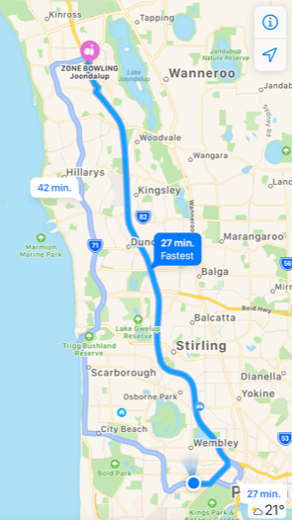 | 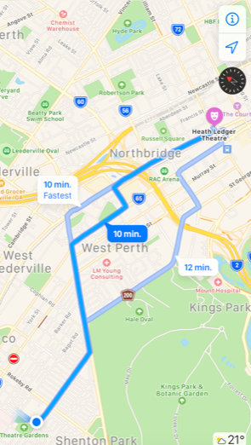 | 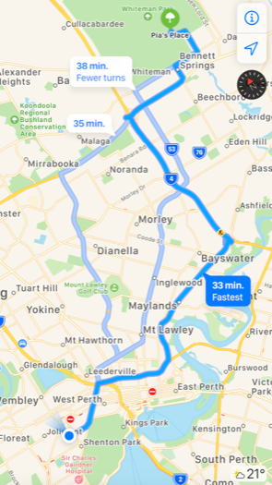
Grand Cinemas | Perth City Farm
